Item Code |  | Item No |  | Picture | Description | Colour | Fabric Specifications (Minimum Quality) | UoM | Unit Price Levy & VAT inclusive
WORKING ATTIRE – GENERAL UNIFORMS
8300101001 |  | UNF/01 |  |  | KPA gents’ Tie | Nautical Blue Pantone No: 19-4050TCX |  | each
  100% WOVEN
  Polyester
8300101084 |  |  |  |  | KPA gents’ Tie | Sky Blue Pantone No. 18-4039TCX |  | Each
8300101002 |  | UNF/02 |  | 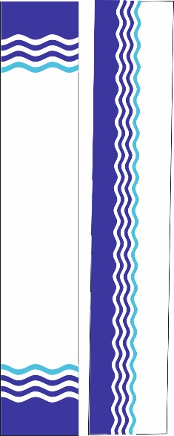 | KPA Ladies’ Scarf  Nautical blue Pantone No: 19-4050TCX Sky Blue Pantone No: 18-4039TCX | White with the KPA wave Logo | 100% silk polyester microfibre  Or  100% silk | Each
8300101063 (S)  8300101064 (M)  8300101065 (L)  8300101066 (XL)  8300101067 (XXL)  8300101068 (XXXL)  8300101069 (XXXXL) |  | UNF/10(A) |  |  | Ladies’ Sweater | NAVY BLUE  Black Iris Pantone No.19-3921TCX | 100% Acrylic blend  400gsm | Each
8300101070 (S)  8300101071 (M)  8300101072 (L)  8300101073 (XL)  8300101074 (XXL)  8300101075 (XXXL)  8300101076 (XXXXL) |  | UNF/10(B) |  |  | UNISEX Sleeveless sweater | NAVY BLUE  Black Iris Pantone No.19-3921TCX | 100% acrylic blend 350gsm
8300101077 (S)  8300101078 (M)  8300101079 (L)  8300101080 (XL)  8300101081 (XXL)  8300101082 (XXXL)  8300101083 (XXXXL) |  | UNF/10(C ) |  |  | Men’s Sweater | NAVY BLUE  Black Iris Pantone No.19-3921TCX | 100% acrylic blend  400gsm | Each
8300201076 (L)  8300201077 (XL)  8300201078 (XXL) |  | UNF/06(C) |  | 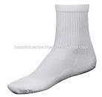  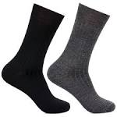 | Socks | WHITE | Cotton / Woolen | Pair
8300201079 (L)  8300201080 (XL)  8300201081 (XXL) |  |  |  |  | Socks | NAVY BLUE | Cotton / Woolen | pair
8300201082 (L)  8300201083 (XL)  8300201084 (XXL) |  |  |  |  | Socks | BLACK | Cotton / Woolen | Pair
8300401015 (S)  8300401016 (M)  8300401017 (L)  8300401018 (XL)  8300401019 (XXL)  8300401020 (XXXL)  8300401021 (XXXXL) |  | UNF/28 |  |  | Spray Suit | NAVY BLUE  Black Iris  Pantone No: 19-3921TCX | 100% Polyester PVC coated waterproof | each
8300601026 (S)  8300601027 (M)  8300601028 (L)  8300601029 (XL)  8300601030 (XXL)  8300601031 (XXXL)  8300601032 (XXXXL) |  | UNF/43(C) |  | 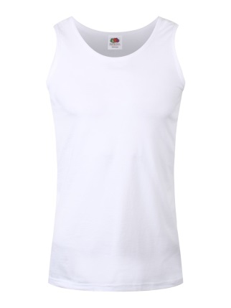 | Vest Round Neck | WHITE/ NAVY BLUE | 100% superior cotton | each
8300701050 |  | UNF/50 |  |  | Apron Smocks Hospital Attendant | HOSPITAL BLUE  HOSPITAL GREEN | 65% polyester, 35% cotton, 245gsm | Each
8300701051 |  | UNF/51 |  |  | Bib Apron Kitchen Hand | WHITE  ROYAL BLUE | 65% polyester, 35% cotton, 245gsm | Each
8300701052 |  | UNF/52 |  |  | Bib Apron Kitchen Hand | NATURAL | polyurethane coating | each

NOTE:
- The images shown in the tender document above are only for illustration purposes and should only act as a guide to branding of items
- Supply of full order will be subject to the approval of a branded physical sample (prototype) by the Uniform Contract Implementation Team (CIT). Branding elements shall be provided by the Uniform & Personal Protective Clothing Management Committee (UPPCMC) to facilitate the prototype.
- All Typeface (Berthold Akzidenz Grotesk and Verdana)
- A clear white space which is 108% larger than the KPA Emblem is mandatory whenever the KPA Emblem is printed on the KPA Deep Blue background.
- Adherence to tendering of uniforms as a complete set as provided in Appendix B.

KPA CORE COLOUR PALETTE

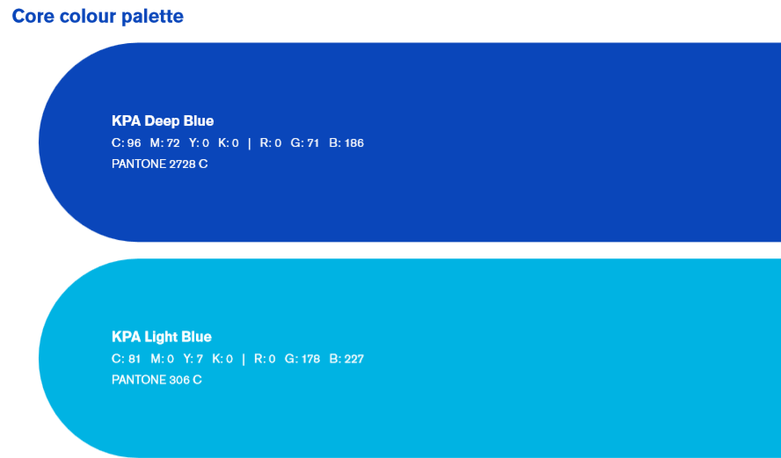
SUPPORTING COLOUR PALETTE

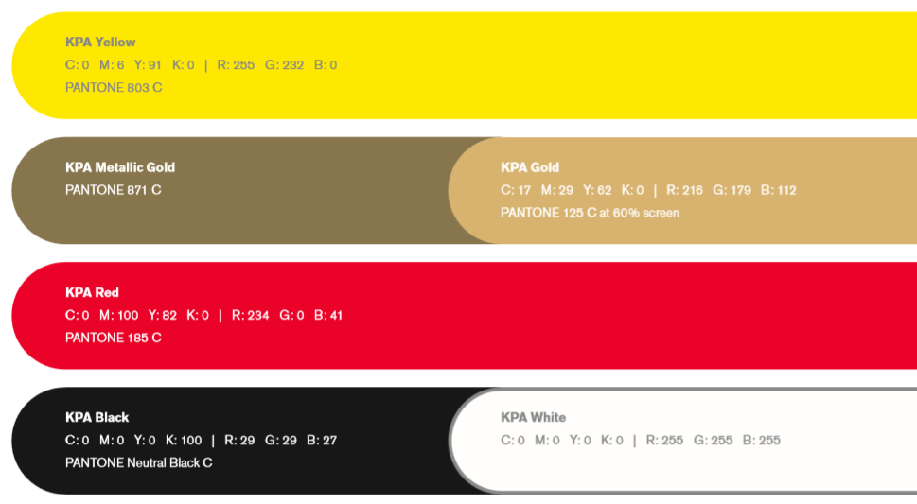

COLOUR DISTRIBUTION

