Item Code | Item No | Picture | Description | Colour | Fabric Specifications (Minimum Quality) | Design Specifications
WORKING ATTIRE – GENERAL UNIFORMS
8300101003 (S)  8300101004 (M)  8300101005 (L)  8300101006 (XL)  8300101007 (XXL)  8300101008 (XXXL)  8300101009 (XXXXL) | UNF/03(A) | 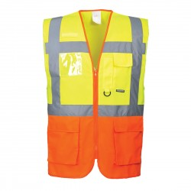 | HI-VIS Retro – Reflective Safety Jacket (Customized for Executive Officers) | Two tone colour combinations of LIME YELLOW and ORANGE | 120 gsm, two tone high visibility fluorescent reflective mesh safety vest with 2” ANSI Silver reflective tape. ISEA 107-2015 Class 2 and 4” contrasting colour  100% polyester with sturdy highly breathable light weight for air circulation and fast drying material. | Nonconductive front zipper closure. KENYA PORTS AUTHORITY prismatic badge on back in KPA Blue KPA logo diameter 8cm embroidered directly onto garment on chest above left pocket.  One external pen chest pocket on left side for quick accessibility. Two external lower front pockets will Velcro fastening
8300101085 (S)  8300101086 (M)  8300101087 (L)  8300101088 (XL)  8300101089 (XXL)  8300101090 (XXXL)  8300101091 (XXXXL) | UNF/03(B) | 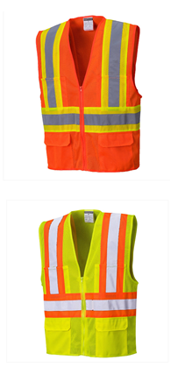 | HI-VIS Retro – Reflective Safety Jacket  (All Other Staff) | ORANGE (Union)
8300101092 (S)  8300101093 (M)  8300101094 (L)  8300101095 (XL)  8300101096 (XXL)  8300101097 (XXXL)  8300101098 (XXXXL) | UNF/03(B) |  | HI-VIS Retro – Reflective Safety Jacket  (All Other Staff) | LIME GREEN  (Managers)
8300101010(S)  8300101011(M)  8300101012(L)  8300101013(XL)  8300101014(XXL)  8300101015(XXXL)  8300101016(XXXXL) | UNF/04(A) | 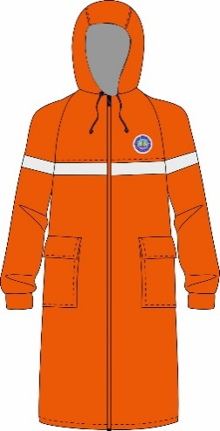 | Raincoat  (All other Staff) | SAFETY ORANGE | 100% PU with tricot backing, waterproof, windproof.  ENV 343 | High Visibility Unisex raincoat. Full seamed taped. Collar hidden hood. Hi-Vis reflective prismatic tape across chest. Two patch hip pockets on front. Front zip closure with button/stud storm flap, Elastic inner wrist cuffs. KPA logo DIAMETER 8CM above reflective prismatic tape. KENYA PORTS AUTHORITY prismatic badge on back in blue.
8300101100(S)  8300101101(M)  8300101102(L)  8300101103(XL)  8300101104(XXL)  8300101105(XXXL)  8300101106(XXXXL) | UNF/04(B) | 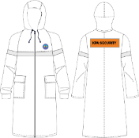 | Raincoat  (Security staff) | NAVY BLUE | 100% PU with tricot backing, waterproof, windproof.  ENV 343 | High Visibility Unisex raincoat. Full seamed taped. Collar hidden hood. Hi-Vis reflective prismatic tape across chest. Two patch hip pockets on front. Front zip closure with button/stud storm flap, Elastic inner wrist cuffs. KPA logo DIAMETER 8CM above reflective prismatic tape. KENYA PORTS AUTHORITY prismatic badge on back in blue.
8300101017(S)  8300101018(M)  8300101019(L)  8300101020(XL)  8300101021(XXL)  8300101022(XXXL)  8300101023(XXXXL) | UNF/05 |  | Overcoat  (Dust coat) | WHITE | 65% polyester, 35% cotton, 245gsm | Long or short sleeve overcoat(dustcoat)  Two hip pockets, chest pocket with pen division  Button front  Back vent  Length 41ins. KPA logo DIAMETER 8CM embroidered directly onto garment on chest above left pocket
8300101033 (Size 4)  8300101034 (Size 5)  8300101035 (Size 6)  8300101036 (Size 7)  8300101037 (Size 8)  8300101038 (Size 9)  8300101039 (Size 10)  8300101040 (Size 11)  8300101041 (Size 12) | UNF/6(A) | 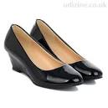 | Leather Shoes Ladies | OXFORD BLACK | 100% Leather | Low heeled without lace
8300101024 (Size 5)  8300101025 (Size 6)  8300101026 (Size 7)  8300101027 (Size 8)  8300101028 (Size 9)  8300101029 (Size 10)  8300101030 (Size 11)  8300101031 (Size 12)  8300101032 (Size 13) | UNF/06(B) | 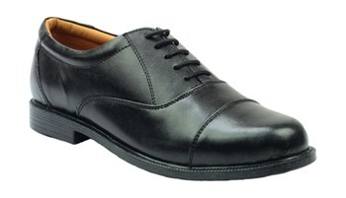 | Leather Shoes Gents | OXFORD BLACK | 100% Leather | Low heeled crafted with a smooth leather upper and soft leather lining.  Slick upper styled with smooth lines  Inner Material: Lining:  Neat overlays bordered with parallel dual stitching accents.  Full lace front with five perforated eyelets and matching laces.  Lightly padded collar for comfort.
8300101042 (S)  8300101043 (M)  8300101044 (L)  8300101045 (XL)  8300101046(XXL)  8300101047 (XXXL)  8300101048 (XXXXL) | UNF/07 | 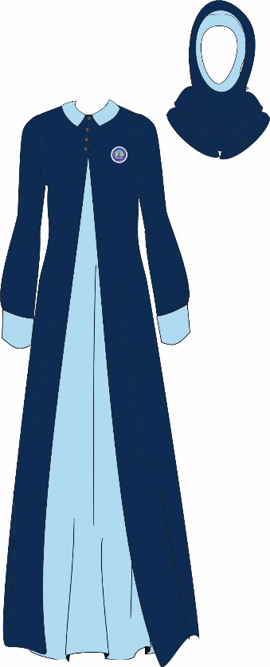 |  | NAVY BLUE  (Black Iris Pantone No. 19-3921  SKY BLUE  Pantone No. 18-4039TCX | 100% silky polyester crepe | Long navy blue jacket with 4 button closure at neck. Contrast Peter Pan collar and cuffs.  To be worn over a long sleeveless dress in contrast colour. (sky blue)  Back neck opening. Princess line shaping  KPA Logo embroidered directly onto garment on left side of chest. 5cm diameter  Hijab scarves, the upper headscarf made with navy blue polyester georgette and the under headscarf made with the contrast sky-blue in polyester crepe
8300101049 (S)  8300101050 (M)  8300101051 (L)  8300101052 (XL)  8300101053 (XXL)  8300101054 (XXXL)  8300101055 (XXXXL) | UNF/08(A) |  | Men's Working Trouser | NAVY BLUE  Black Iris Pantone No.19-3921TCX | 210 gsm, 64% Polyester 34% Viscose 2% Lycra | Gents classic single pleat trouser with slanted side pockets. Single welt pocket on back right side. zipper closing. Belt loops. Comfortably fit.
8300101049 (S)  8300101050 (M)  8300101051 (L)  8300101052 (XL)  8300101053 (XXL)  8300101054 (XXXL)  8300101055 (XXXXL) | UNF/08(B) |  | Men's Working Shirt  (Excluding Pilots & Tug Master) | WHITE & SKY BLUE  Pantone No.18-4039TCX | 145 gsm, crease resist, plain weave,65% Polyester 35% Cotton | Men’s classic short/long sleeve shirt with front pocket with flap. Classic cuff closing. Front button placket. Back yoke with two knife pleats.  KPA Logo embroidered directly above the pocket 6cm diameter.
8300101056 (S)  8300101057 (M)  8300101058 (L)  8300101059 (XL  8300101060 (XXL)  8300101061 (XXXL)  8300101062 (XXXXL) | UNF/09(C ) |  | Ladies Short Sleeve Jacket | NAVY BLUE  Pantone  19-3921TCX | 210 gsm, 64% Polyester 34% Viscose 2% Lycra   | Ladies short sleeve collarless jacket.  V-shaped neckline. Three button closing. Princess cut. Centre back seam, no vent. Shaped hem. Fully lined. KPA FLAG label Logo attached to top left pocket.
8300101056 (S)  8300101057 (M)  8300101058 (L)  8300101059 (XL  8300101060 (XXL)  8300101061 (XXXL)  8300101062 (XXXXL) | UNF/09(D) |  | Ladies Blouse | WHITE  & SKY BLUE  Pantone No.18-4039TCX | 145 gsm, crease resist, plain weave,65% Polyester 35% Cotton | Ladies long and short sleeve blouse. Classic shirt collar. Front button fastening without placket. Front and back waist darts. Shaped hem. KPA logo embroidered directly above garment on left side of chest 6cm diameter.
8300101056 (S)  8300101057 (M)  8300101058 (L)  8300101059 (XL  8300101060 (XXL)  8300101061 (XXXL)  8300101062 (XXXXL) | UNF/09(B) |  | Ladies Working Skirt | NAVY BLUE  Pantone No.19-3921TCX | 210 gsm, 64% Polyester 34% Viscose 2% Lycra | Ladies A-line skirt with inverted center pleat. Narrow waistband with belt loops for slim belt. Centre back seam with concealed zip and button fastening. Fully lined.
8300101056 (S)  8300101057 (M)  8300101058 (L)  8300101059 (XL  8300101060 (XXL)  8300101061 (XXXL)  8300101062 (XXXXL) | UNF/09(A) |  | Ladies Working Trouser | NAVY BLUE  Black Iris Pantone No.19-3921TCX | 210 gsm, 64% Polyester 34% Viscose 2% Lycra | Ladies straight leg trouser with elastic inset at waist. Front fly and zipper closing. Slanting side seam pockets. 7 belt loops. 1/2 lining
8300301015 (S)  8300301016 (M)  8300301017 (L)  8300301018 (XL)  8300301019 (XXL)  8300301020 (XXXL)  8300301021 (XXXXL) | UNF/11(A) |  | Heavy Reinforced Pullover | NAVY BLUE  Black Iris Pantone No.19-3921TCX | 100% acrylic blend  600gsm | Men's long sleeve pullover with V neckline. Poly/cotton shoulder and elbow padded for extra reinforcement and shoulder tabs.  KPA 6cm diameter logo on chest embroidered directly onto garment.
MARINE OPERATIONS & FERRY OPERATIONS
8300201001 (6)  8300201002 (6.25)  8300201003 (6.5)  8300201004 (7)  8300201005 (7.25)  8300201006 (7.5)  8300201007 (8) | UNF/12(A) | 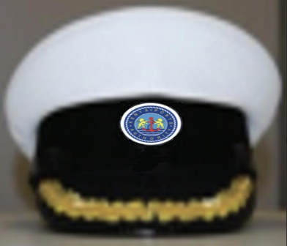 | Ceremonial Peak Cap Pilots and Marine Chief Engineer | WHITE | 210 gsm, 65% Polyester 35% Cotton 2/1 Twill | Master - Merchant Navy White Fixed Top Cap with a black visor rigid standing front flaring laced with gold oak leaf. Black patent leather/ plastic with chin strap grommet positioned to the wearer’s left. Circular rim and blue cap band and mount for attaching KPA emblem. Combination cap chin straps: half inch wide. KPA emblem separately on cap badge.
8300201085 (6)  8300201086 (6.25)  8300201087 (6.5)  8300201088 (7)  8300201089 (7.25)  8300201090 (7.5)  8300201091 (8) | UNF/12(B) | 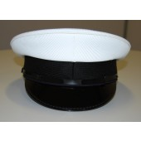 | Ceremonial Peak Cap Tug Masters, Coxswain and Trainee Pilots | WHITE | 210 gsm, 65% Polyester 35% Cotton 2/1 Twill | Merchant Navy White Fixed Top Cap with KPA emblem separately on cap badge. Black visor rigid standing front flaring. Black patent leather/ plastic with chin strap grommet positioned to the wearer’s left. Circular rim and blue cap band and mount for attaching KPA emblem. Combination cap chin straps: half inch wide. KPA emblem separately on cap badge.
8300201028 (6)  8300201029 (6.25)  8300201030 (6.5)  8300201031 (7)  8300201032 (7.25)  8300201033 (7.5) | UNF/12(C ) |  | Ceremonial Cap Sailor | WHITE | 210 gsm, 65% Polyester 35% Cotton 2/1 Twill | As per marine design specifications. KPA 6cm diameter logo embroidered directly onto cap
8300201092 | UNF/14(A) | 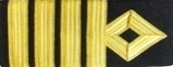 | Harbour Master, Pilots | 4 Gold Bars | Braid: 1/2 inch - Gold wire braid on black board. | Epaulette Backing: Reinforced Black Wool Felt Fitting: Slip on / Slide on Shape: Rectangular  Size: 96mm x 62mm
 |  |  | Marine Chief Engineer | 4 Gold Bars | Braid: 1/2 inch - Gold wire braid on black board with Green stripes
8300201093 (S)  8300201094 (M)  8300201095 (L)  8300201096 (XL)  8300201097 (XXL)  8300201098 (XXXL)  8300201099 (XXXXL) | UNF/15(A) |  | Ceremonial Trouser Men’s Pilot | NAVY BLUE SERGE  Black Iris Pantone No: 19-3921TCX | 404 gsm, 55% Polyester  45% Wool | Gents classic single pleat trouser with slanted side pockets. Single welt pocket on back right side. zipper closing. Belt loops. Comfortably fit.
8300201093 (S)  8300201094 (M)  8300201095 (L)  8300201096 (XL)  8300201097 (XXL)  8300201098 (XXXL)  8300201099 (XXXXL) | UNF/15(B) |  | Ceremonial Shirt Men's Pilot | WHITE | 80/20 Cotton poly plain weave shirting, 125grm, crease resistant, moisture cure | Gents long sleeve shirt, with cuff. Front button fastening with placket. Shoulder tabs. Shaped hem. No pockets. Back yoke. KPA 6cm diameter logo on chest embroidered directly onto garment
8300201093 (S)  8300201094 (M)  8300201095 (L)  8300201096 (XL)  8300201097 (XXL)  8300201098 (XXXL)  8300201099 (XXXXL) | UNF/15(C) |  | Ceremonial Jacket Men's Pilot | NAVY BLUE SERGE Black Iris Pantone No: 19-3921TCX | 404 gsm, 55% Polyester 45% Wool | Men’s ceremonial double breast jacket. Top welt pocket and functional jetted pockets. Gold buttons. Back vent Captains’ Gold ranking on sleeves above the buttons. KPA Flag label directly onto chest above welt pocket left. Eyelets for shoulder boards.
8300201014 (S)  8300201015 (M)  8300201016 (L)  8300201017 (XL)  8300201018 (XXL)  8300201019 (XXXL)  8300201020 (XXXXL) | UNF/16(B) |  | Demi-Official Bush Jacket Men’s’ Pilots | WHITE | 210 gsm, 65% Polyester 35% Cotton 2/1 Twill | Short sleeve Bush jacket with belt and patch pockets as per design, gold buttons big and small. Eyelets on shoulder for shoulder boards.  KPA logo 6cm diameter embroidered on chest directly onto garment 1cm above left chest pocket
 | UNF/16(A) | 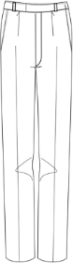 | Demi-Official Trouser Men’s Pilots | WHITE | 210 gsm, 65% Polyester 35% Cotton 2/1 Twill | Gents classic NO pleat trouser with slanted side pockets. Single welt pocket on back right side. zipper closing. Belt loops.  Comfortable fit.
  8300201014 (S)  8300201015 (M)  8300201016 (L)  8300201017 (XL)  8300201018 (XXL)  8300201019 (XXXL)  8300201020 (XXXXL) | UNF/16(A)
8300201021 (S)  8300201022 (M)  8300201023 (L)  8300201024 (XL)  8300201025 (XXL)  8300201026 (XXXL)  8300201027 (XXXXL) | UNF/18(B) |  | Ceremonial Shirt  Sailor | WHITE with Royal blue  Capella | 210 gsm, 65% Polyester 35% Cotton 2/1 Twill | Loose and slightly boxy shirt with royal blue capella with white rank stripes, V neck, with under collar.  KPA 6cm Logo embroidered directly onto shirt chest.  Navy blue rank stripes on sleeves.  Navy blue cravat.
8300201021 (S)  8300201022 (M)  8300201023 (L)  8300201024 (XL)  8300201025 (XXL)  8300201026 (XXXL)  8300201027 (XXXXL) | UNF/18(A) |  | Ceremonial Trouser for  Sailor | WHITE | 210 gsm, 65% Polyester 35% Cotton 2/1 Twill | Gents classic single pleat trouser with slanted side pockets. Single welt pocket on back right side. zipper closing. Belt loops. Comfortably fit.
8300201034 (S)  8300201035 (M)  8300201036 (L)  8300201037 (XL)  8300201038 (XXL)  8300201039 (XXXL)  8300201040 (XXXXL) | UNF/17(C) |  | Ceremonial Jacket Ladies Pilot | NAVY BLUE SERGE  Black Iris Pantone No. 19-3921TCX | 404 gsm, 55% Polyester 45% Wool | Ladies ceremonial double breast jacket with peak collar with gold buttons all big. Princess cut shaping. Front hip pockets with round shaped flaps. Centre back seam and Back double vent approximately 3 inches long. Captains’ Gold ranking on sleeves above gold buttons. KPA Flag label on left side of chest pocket
8300201034 (S)  8300201035 (M)  8300201036 (L)  8300201037 (XL)  8300201038 (XXL)  8300201039 (XXXL)  8300201040 (XXXXL) | UNF/17(A) |  | Ceremonial  Skirt Ladies Pilot | NAVY BLUE SERGE  Black Iris Pantone No. 19-3921TCX | 404 gsm, 55% Polyester 45% Wool | Ladies knee length skirt. Front and back waist darts Centre back zip and button fastening. Centre back seam with vent. Fully lined
8300201034 (S)  8300201035 (M)  8300201036 (L)  8300201037 (XL)  8300201038 (XXL)  8300201039 (XXXL)  8300201040 (XXXXL) | UNF/17(B) |  | Ceremonial  Trouser Ladies Pilot | NAVY BLUE SERGE  Black Iris Pantone No. 19-3921TCX | 404 gsm, 55% Polyester 45% Wool | Ladies straight leg trouser with elastic inset at waist. Front fly and zipper closing. Slanting side seam pockets. 7 belt loops. 1/2 lining
8300201034 (S)  8300201035 (M)  8300201036 (L)  8300201037 (XL)  8300201038 (XXL)  8300201039 (XXXL)  8300201040 (XXXXL) | UNF/17(D) |  | Ceremonial  Shirt Ladies’ | WHITE | 80/20 Cotton poly plain weave shirting, 125gsm, crease resistant, moisture cure | Ladies long sleeve shirt, with cuff. Front button fastening with placket. Shoulder tabs. Shaped hem.  No pocket. KPA 6cm diameter Logo embroidered directly on left side of chest
8300201041 (S)  8300201042 (M)  8300201043 (L)  8300201044 (XL)  8300201045 (XXL)  8300201046 (XXXL)  8300201047 (XXXXL) | UNF/19(A) |  | Working Attire Trouser Men’s Pilot and Tug master | NAVY BLUE  BLACK  GREY | 210 gsm, 65% Polyester 35% Cotton 2/1 Twill | Gents classic single pleat trouser with slanted side pockets. Single welt pocket on back right side. zipper closing. Belt loops. Comfortably fit.
8300201041 (S)  8300201042 (M)  8300201043 (L)  8300201044 (XL)  8300201045 (XXL)  8300201046 (XXXL)  8300201047 (XXXXL) | UNF/19(B) |  | Working Attire Shirt Men’s Pilot and Tug Master | WHITE | 80/20 cotton poly plain weave. 125 gsm, crease resist, moisture cure | Men’s short sleeve shirt, with cuff. Front button fastening with placket. Shoulder tabs. Front patch pockets with pen pocket. Shaped hem. Back yoke with pleat. KPA logo on above left pocket embroidered directly onto garment. 6cm diameter logo.
8300201048 (S)  8300201049 (M)  8300201050 (L)  8300201051 (XL)  8300201052 (XXL)  8300201053 (XXXL)  8300201054 (XXXXL) | UNF/20(B) |  | Working Attire Shirt Ladies’ Pilot and Tugmaster | WHITE | 80/20 cotton poly plain weave.  125 gsm, crease resist, moisture cure  Cotton | Ladies short sleeve shirt, with cuff. Front button fastening with placket. Front round cut patch pockets with flaps and button. Shaped hem. KPA logo on chest above left pocket embroidered directly onto garment. 6cm diameter
8300201048 (S)  8300201049 (M)  8300201050 (L)  8300201051 (XL)  8300201052 (XXL)  8300201053 (XXXL)  8300201054 (XXXXL) | UNF/20(A) |  | Working Attire Trouser Ladies Pilot and Tug master | NAVY BLUE SERGE  BLACK  GREY | 210 gsm, 65% Polyester 35% Cotton 2/1 Twill | Ladies straight leg trouser with elastic inset at waist. Front fly and zipper closing. Slanting side seam pockets. 7 belt loops. 1/2 lining comfortable fit
8300201055 (S)  8300201056 (M)  8300201057 (L)  8300201058 (XL)  8300201059(XXL)  8300201060 (XXXL)  8300201061 (XXXXL) | UNF/21(A) |  | Working Attire Trouser Men’s (marine operations excluding pilots & tug master) | NAVY BLUE with ORANGE highlights | 245 gsm, crease resist, 2/1 twill, 65% Polyester 35% Cotton | Gents cargo pant with front fly and zipper closing and wide belt loops. Cargo pockets on hip level with contrast fabric highlight on inverted pleat with zipper fastening.  Thigh cargo pockets with contrast flap and inverted pleat Top crease stitch on pant.  Optional add knee pad opening
8300201055 (S)  8300201056 (M)  8300201057 (L)  8300201058 (XL)  8300201059(XXL)  8300201060 (XXXL)  8300201061 (XXXXL) | UNF/08(B) |  | Working Attire Shirt Men’s (marine operations excluding pilots & tug master) | SKY BLUE | 145 gsm, crease resist, plain weave,65% Polyester 35% Cotton | Men’s short sleeve shirt, with cuff. Front button fastening with placket. Shoulder tabs. Front patch pockets with pen pocket. Shaped hem. Back yoke with pleat. KPA logo 6cm diameter on above left pocket embroidered directly onto garment. 6cm diameter logo
8300201062 (S)  8300201063 (M)  8300201064 (L)  8300201065 (XL)  8300201066(XXL)  8300201067 (XXXL)  8300201068 (XXXXL) | UNF/22(A) |  | Working Attire Trouser Ladies’ (marine operations excluding pilots & tug master) | NAVY BLUE with ORANGE highlights | 245 gsm, crease resist, 2/1 twill, 65% Polyester 35% Cotton | Ladies cargo pant with front fly and zipper closing. Cargo pockets on hip level with contrast fabric highlight. Wide belt loops & elasticized sides. Thigh cargo pockets with contrast flap. Top crease stitch on pant. Optional add knee pad opening
8300201062 (S)  8300201063 (M)  8300201064 (L)  8300201065 (XL)  8300201066(XXL)  8300201067 (XXXL)  8300201068 (XXXXL) | UNF/08(C) |  | Working Attire Shirt Ladies’ (marine operations excluding pilots & tug master) | SKY BLUE  Pantone No. 18-4039TCX | 145 gsm, crease resist, plain weave,65% Polyester 35% Cotton | Ladies short sleeve shirt, with cuff. Front button fastening with placket. Front round cut patch pockets with flaps and button. Shaped hem. KPA logo 6cm diameter on chest above left pocket embroidered directly onto garment.
8300201069 (S)  8300201070(M)  8300201071 (L)  8300201072 (XL)  8300201073 (XXL)  8300201074 (XXXL)  8300201075 (XXXXL) | UNF/23 |  | Foul Weather Jacket and Trouser  Tug-Master  Coxswain  Sailor | ORANGE | 100% Polyester  PVC coated  EN ISO 20471  EN 343 | Fully lined, waterproof, with concealed hood.  High quality polyester. with middle membrane to ensure that the jacket is breathable and the inside polyester knit layer  Two front zipped bellows pockets with 25mm Velcro storm flaps and a concealed hood in the jacket collar. Quick access to under layers is achieved via a clever chest zip. Velcro storm cuffs and elastic cord and locks make the cuffs and hem fully adjustable.  Multi storage pockets.  Designed to keep the wearer, visible, safe and dry in foul weather conditions. KPA logo on chest above left embroidered directly onto garment.  KENYA PORTS AUTHORITY prismatic badge on back in black.
TERMINAL OPERATIONS & CONVENTIONAL CARGO OPERATIONS
8300201055 (S)  8300201056 (M)  8300201057 (L)  8300201058 (XL)  8300201059(XXL)  8300201060 (XXXL)  8300201061 (XXXXL) | UNF/21(A) |  | Working Attire Trouser Men’s | NAVY BLUE with ORANGE highlights | 245 gsm, crease resist, 2/1 twill, 65% Polyester 35% Cotton | Gents cargo pant with front fly and zipper closing and wide belt loops. Cargo pockets on hip level with contrast fabric highlight. Thigh cargo pockets with contrast flap. Top crease stitch on pant.  Optional add knee pad opening
8300201062 (S)  8300201063 (M)  8300201064 (L)  8300201065 (XL)  8300201066(XXL)  8300201067 (XXXL)  8300201068 (XXXXL) | UNF/08(C) |  | Ladies working Shirt | SKY BLUE  Pantone No. 18-4039TCX | 145 gsm, crease resist, plain weave,65% Polyester 35% Cotton | Ladies short sleeve shirt, with cuff. Front button fastening with placket. Front round cut patch pockets with flaps and button. Shaped hem. KPA logo 6cm diameter embroidered on chest directly onto the garment 1cm above left chest pocket..
8300201062 (S)  8300201063 (M)  8300201064 (L)  8300201065 (XL)  8300201066(XXL)  8300201067 (XXXL)  8300201068 (XXXXL) | UNF/22(A) |  | Working Attire Trouser Ladies’ | NAVY BLUE with ORANGE highlights | 245 gsm, crease resist, 2/1 twill, 65% Polyester 35% Cotton | Ladies cargo pant with front fly and zipper closing. Cargo pockets on hip level with contrast fabric highlight. Wide belt loops & elasticized sides. Thigh cargo pockets with contrast flap. Top crease stitch on pant. Optional add knee pad opening
8300301001 (S)  8300301002 (M)  8300301003 (L)  8300301004 (XL)  8300301005 (XXL)  8300301006 (XXXL)  8300301007 (XXXXL) | UNF/24(A) |  | OVERALL MEN’S | ORANGE  with SKYBLUE Highlights | 245 gsm, crease resist, 2/1 twill shrink proof.  60% cotton  40% polyester  High visibility EN 20471  (or equivalent) | Gents short sleeve overall with multi storage pockets in contrast fabric. Hi-Vis reflective tape on shoulder, sleeves and trouser hem. KPA logo 8.5cm diameter on chest above left pocket embroidered directly onto garment.  KENYA PORTS AUTHORITY prismatic badge on back in Blue
8300301008 (S)  8300301009 (M)  8300301010 (L)  8300301011 (XL)  8300301012 (XXL)  8300301013 (XXXL)  8300301014 (XXXXL) | UNF/26(B) |  | WORK WEAR LADIE’S | ORANGE with SKYBLUE Highlights | 245 gsm, crease resist, 2/1 twill satin finish, shrink proof  60% cotton  40% polyester  High visibility  EN 20471 (or equivalent | Ladies short Sleeve work jacket with stand collar. Multi storage pockets on front and sleeve with contrast fabric detail. Full length front zip fastening. Hi-Vis prismatic tape  With matching cargo trousers. KPA logo 8.5cm diameter on chest pocket embroidered directly onto garment.  KENYA PORTS AUTHORITY prismatic badge on back in black.
8300301089 (S)  8300301090 (M)  8300301091 (L)  8300301092 (XL)  8300301093 (XXL)  8300301094 (XXXL)  8300301095 (XXXXL) | UNF/25(A) | 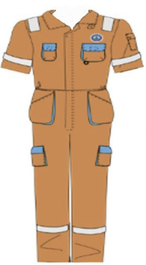 | OVERALL LADIES  Marine Operations | ORANGE  with SKYBLUE Highlights | 245 gsm, crease resist, 2/1 twill shrink proof.  60% cotton  40% polyester  High visibility EN 20471  (or equivalent) | Ladies short sleeve overall with multi storage pockets in contrast fabric. Hi-Vis scotch light reflective tape on shoulder, sleeves and trouser hem. KPA 8.5cm diameter logo on chest left pocket embroidered directly onto garment.  KENYA PORTS AUTHORITY prismatic badge on back in black.
INFRASTRUCTURE & ENGINEERING SERVICES
8300301036 (S)  8300301037 (M)  8300301038 (L)  8300301039 (XL)  8300301040 (XXL)  8300301041 (XXXL)  8300301042 (XXXXL) | UNF/24(A) |  | OVERALL MEN’S | ORANGE  with SKYBLUE Highlights | 245 gsm, crease resist, 2/1 twill shrink proof.  60% cotton  40% polyester  High visibility EN 20471  (or equivalent) | Gents short sleeve overall with multi storage pockets in contrast fabric. Hi-Vis reflective tape on shoulder, sleeves and trouser hem. KPA 8.5cm diameter logo on chest on left pocket embroidered directly onto garment.  KENYA PORTS AUTHORITY prismatic badge on back in black.
8300301043 (S)  8300301044 (M)  8300301045 (L)  8300301046 (XL)  8300301047 (XXL)  8300301048 (XXXL)  8300301049 (XXXXL) | UNF/24(B) |  | OVERALL MEN’S | NAVY BLUE with SKYBLUE Highlights | 245 gsm, crease resist, 2/1 twill, 65% Polyester 35% Cotton | Gents short sleeve overall with multi storage pockets in contrast fabric. Hi-Vis reflective tape on shoulder, sleeves and trouser hem. KPA 8.5cm diameter logo on chest left pocket embroidered directly onto garment.  KENYA PORTS AUTHORITY prismatic badge on back in black.
8300301050 (S)  8300301051 (M)  8300301052 (L)  8300301053 (XL)  8300301054 (XXL)  8300301055 (XXXL)  8300301056 (XXXXL) | UNF/24(C) |  | OVERALL MEN’S | NAVY BLUE with KHAKI Highlights | 245 gsm, crease resist, 2/1 twill, 65% Polyester 35% Cotton
8300301057 (S)  8300301058 (M)  8300301059 (L)  8300301060 (XL)  8300301061 (XXL)  8300301062 (XXXL)  8300301063 (XXXXL) | UNF/24(D) |  | OVERALL MEN’S | WHITE | 245 gsm, crease resist, 2/1 twill, 65% Polyester 35% Cotton
8300401001 (S)  8300401002 (M)  8300401003 (L)  8300401004 (XL)  8300401005 (XXL)  8300401006 (XXXL)  8300401007 (XXXXL) | UNF/27 |  | Men’s Plain T-shirt | WHITE | 100% Superior Cotton | Plain T shirt. Comfortable, casual and loose fitting. Made from 6.0 oz., pre-shrunk 100% cotton. Double needle stitched bottom and sleeve hems for extra durability.
8300401008 (S)  8300401009 (M)  8300401010 (L)  8300401011 (XL)  8300401012 (XXL)  8300401013 (XXXL)  8300401014 (XXXXL) | UNF/26(A) |  | WORK WEAR MEN’S | NAVY BLUE with KHAKI Highlights | 245 gsm, crease resist, 2/1 twill satin finish, shrink proof  60% cotton  40% polyester  High visibility  EN 20471 (or equivalent | Gents short Sleeve work jacket with stand collar. Multi storage pockets on front and sleeve with contrast fabric detail. Full length front zip fastening. Hi-Vis prismatic tape  WITH matching cargo trousers. KPA logo 8.5 cm diameter on chest above left pocket embroidered directly onto garment.  KENYA PORTS AUTHORITY prismatic badge on back in black.
8300301064 (S)  8300301065 (M)  8300301066 (L)  8300301067 (XL)  8300301068 (XXL)  8300301069 (XXXL)  8300301070 (XXXXL) | UNF/25(B) |  | WORK WEAR LADIE’S | ORANGE WITH SKYBLUE HIGHLIGHT | 245 gsm, crease resist, 2/1 twill satin finish, shrink proof  60% cotton  40% polyester  High visibility  EN 20471 (or equivalent | Ladies short Sleeve work jacket with stand collar. Multi storage pockets on front and sleeve with contrast fabric detail. Full length front zip fastening. Hi-Vis prismatic tape  WITH matching cargo trousers.  KPA logo 8.5cm diameter on chest on left pocket embroidered directly onto garment.  KENYA PORTS AUTHORITY prismatic badge on back in black.
8300201055 (S)  8300201056 (M)  8300201057 (L)  8300201058 (XL)  8300201059(XXL)  8300201060 (XXXL)  8300201061 (XXXXL) | UNF/21(A)  UNF/21(D) |  | Working Attire Men’s Trouser | NAVY BLUE with ORANGE highlights  NAVY BLUE with KHAKI Highlights | 245 gsm, crease resist, 2/1 twill, 65% Polyester 35% Cotton | Gents cargo pant with front fly and button closing and wide belt loops. Cargo pockets on hip level with contrast fabric highlight. Thigh cargo pockets with contrast flap. Top crease stitch on pant.  Optional add knee pad opening
8300201055 (S)  8300201056 (M)  8300201057 (L)  8300201058 (XL)  8300201059(XXL)  8300201060 (XXXL)  8300201061 (XXXXL) | UNF/08(B) |  | Working Attire Men’s Shirt | SKY BLUE | 145 gsm, crease resist, plain weave,65% Polyester 35% Cotton | Men’s short sleeve shirt, with cuff. Front button fastening with placket. Front square cut patch pockets with flaps and button closing. Shaped hem. Back yoke with box pleat. KPA 6cm diameter logo on chest above left pocket embroidered directly onto garment
8300201062 (S)  8300201063 (M)  8300201064 (L)  8300201065 (XL)  8300201066(XXL)  8300201067 (XXXL)  8300201068 (XXXXL) | UNF/22(A) |  | Working Attire Ladies’ Trouser | NAVY BLUE with ORANGE Highlights  NAVY BLUE with KHAKI Highlight | 245 gsm, crease resist, 2/1 twill, 65% Polyester 35% Cotton | Ladies cargo pant with front fly and zipper closing. Cargo pockets on hip level with contrast fabric highlight. Wide belt loops & elasticized sides. Thigh cargo pockets with contrast flap. Top crease stitch on pant. Optional add knee pad opening
8300201062 (S)  8300201063 (M)  8300201064 (L)  8300201065 (XL)  8300201066(XXL)  8300201067 (XXXL)  8300201068 (XXXXL) | UNF/08(C) |  | Ladies’ Working Attire Ladies’ Blouse  Working Shirt (excluding pilots & tug master) | SKY BLUE  Pantone No: 18-4039TCX | 145 gsm, crease resist, plain weave,65% Polyester 35% Cotton | Ladies short sleeve shirt, with cuff. Front button fastening with placket. Front round cut patch pockets with flaps and button. Shaped hem. KPA 6cm diameter logo on chest above left pocket embroidered directly onto garment.
PORT SECURITY SERVICES
8300501001 (S)  8300501002 (M)  8300501003 (L)  8300501004 (XL)  8300501005 (XXL)  8300501006 (XXXL)  8300501007 (XXXXL | UNF/29(A) |  | Ceremonial Jacket  Men's | NAVY BLUE SERGE  Black Iris Pantone No: 19-3921TCX | 404 gsm, 55% Polyester 45% Wool | Gents ceremonial single breast jacket 4 button jacket with silver buttons. Pockets as per design. Shoulder flaps for epaulette. Front waist darts. Centre back seam and center back vent. Silver embroidered badge on jacket sleeve. KPA 6cm diameter logo above pocket left on chest embroidered directly onto garment.
8300501001 (S)  8300501002 (M)  8300501003 (L)  8300501004 (XL)  8300501005 (XXL)  8300501006 (XXXL)  8300501007 (XXXXL | UNF/15(A) |  | Ceremonial Trouser Men's | NAVY BLUE SERGE  Black Iris Pantone No: 19-3921TCX | 404 gsm, 55% Polyester 45% Wool | Gents classic single pleat trouser with slanted side pockets. Single welt pocket on back right side. zipper closing. Belt loops. Comfortably fit.
8300501001 (S)  8300501002 (M)  8300501003 (L)  8300501004 (XL)  8300501005 (XXL)  8300501006 (XXXL)  8300501007 (XXXXL | UNF/15(B) |  | Ceremonial Shirt  Men's | WHITE | 80/20 Cotton poly plain weave shirting, 125grm, crease resistant, moisture cure | Gents long sleeve shirt, with cuff. Front button fastening with placket. Shoulder tabs. Back yoke with box pleat.  No pockets. KPA 6cm diameter logo above pocket embroidered directly onto garment.
8300501008 (6)  8300501009 (6.25)  8300501010 (6.5)  8300501011 (7)  8300501012 (7.25)  8300501013 (7.5)  8300501014 (8) | UNF/30(A) |  | Ceremonial Peak Cap | NAVY BLUE SERGE  Black Iris Pantone No: 19-3921TCX |  | Security peak cap with embroidered KPA emblem mounted on a navy-blue velvet cloth background and two row of twisted oak leaf gold lace detail embroidered.  (For Manager Security Services/PFSO & Principal Port Security  Officers)
8300501068 (6)  8300501069 (6.25)  8300501070 (6.5)  8300501071 (7)  8300501072 (7.25)  8300501073 (7.5)  8300501074 (8) | UNF/30(B) |  | Ceremonial Peak Cap | NAVY BLUE SERGE  Black Iris Pantone No: 19-3921TCX |  | Security peak cap with embroidered KPA emblem mounted on a navy-blue velvet cloth background and one row of twisted oak leaf gold lace detail embroidered.  (For Senior Port Security Officers)
8300501089 (6)  8300501091 (6.25)  8300501092 (6.5)  8300501093 (7)  8300501094 (7.25)  8300501095 (7.5)  8300501096 (8) | UNF/30(C) | 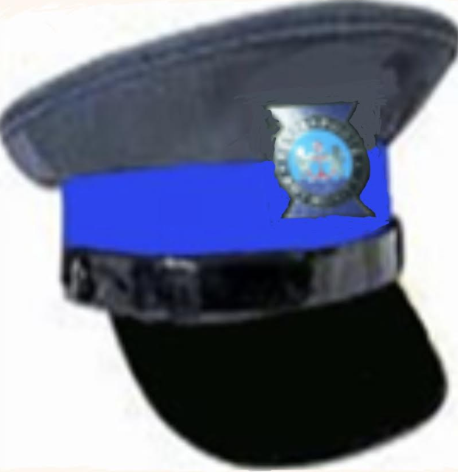 | Ceremonial Peak Cap | NAVY BLUE SERGE  Black Iris Pantone No: 19-3921TCX |  | Security peak cap with embroidered KPA emblem mounted on a navy-blue velvet cloth background and one row of twisted oak leaf gold lace detail embroidered.  (For other Security Officers)
8300501075 (L)  8300501076 (XL)  8300501077 (XXL)  8300501078 (XXXL)  8300501079 (XXXXL) | UNF/31 | 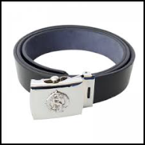 | Ceremonial Belt |  | BLACK LEATHER SILVER BUCKLE | Leather belt with shiny silver buckle and KPA emblem embossed on buckle.
8300501015 | UNF/32 (A) | 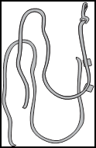 | Ceremonial Lanyard | KPA brand colours. | LANYARD | Twisted multi-coloured braid security lanyards in KPA brand colours.
8300501090 | UNF/32(C) | 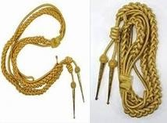 | CEREMONIAL AIGUILLETTES | Gold in colors. | LANYARD | Gold-coloured aiguillettes when wearing a ceremonial dress. (For Manager Security Services/PFSO &  Principal Port Security  Officers)
8300501016 (S)  8300501017 (M)  8300501018 (L)  8300501019 (XL)  8300501020 (XXL)  8300501021 (XXXL)  8300501022 (XXXXL) | UNF/29(B) |  | Ceremonial Jacket  Ladies’ | NAVY BLUE SERGE  Black Iris Pantone No: 19-3921TCX | 404 gsm, 55% Polyester 45% Wool   | Ladies ceremonial single breast jacket. Pockets as per design. Shoulder flaps. Princess dart from shoulder to waist. Centre back seam and center back vent.  Silver buttons. Silver embroidered badge on jacket sleeve. KPA 6cm diameter logo above pocket embroidered directly onto garment.
8300501016 (S)  8300501017 (M)  8300501018 (L)  8300501019 (XL)  8300501020 (XXL)  8300501021 (XXXL)  8300501022 (XXXXL) | UNF/17(D) | 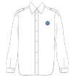 | Ceremonial Shirt Ladies’ | WHITE | 80/20 Cotton poly plain weave shirting, 125grm, crease resistant, moisture cure | Ladies long sleeve shirt, with cuff. Front button fastening with placket. Shoulder tabs.. Shaped hem.  No pocket. KPA 6cm diameter Logo embroidered directly on left side of chest
8300501016 (S)  8300501017 (M)  8300501018 (L)  8300501019 (XL)  8300501020 (XXL)  8300501021 (XXXL)  8300501022 (XXXXL) | UNF/17(B) |  | Ceremonial Trouser  Ladies | NAVY BLUE SERGE  Black Iris Pantone No: 19-3921TCX | 404 gsm, 55% Polyester 45% Wool | Ladies straight leg trouser with elastic inset at waist. Front fly and button closing. Slanting side seam pockets. 7 belt loops. 1/2 lining
8300501016 (S)  8300501017 (M)  8300501018 (L)  8300501019 (XL)  8300501020 (XXL)  8300501021 (XXXL)  8300501022 (XXXXL) | UNF/17(A) |  | Ceremonial  Ladies’ Skirt | NAVY BLUE SERGE  Black Iris Pantone No: 19-3921TCX | 404 gsm, 55% Polyester 45% Wool | Ladies knee length skirt. Front and back waist darts Centre back zip and button fastening. Centre back seam with vent. Fully lined
8300501080  8300501082  8300501083  8300501084  8300501085  8300501086  8300501087  8300501088 | UNF/33  UNF/34 (A)  UNF/34 (B)  UNF/34 (C)  UNF/34 (D)  UNF/34 (E)  UNF/34 (F)  UNF/34 (G) | 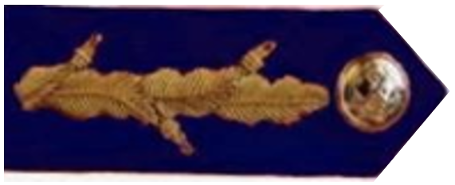  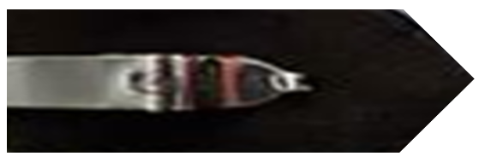  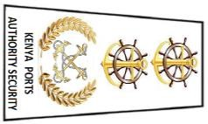  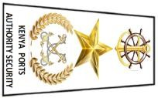  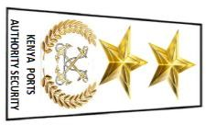  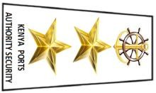    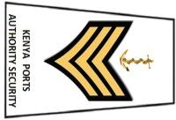  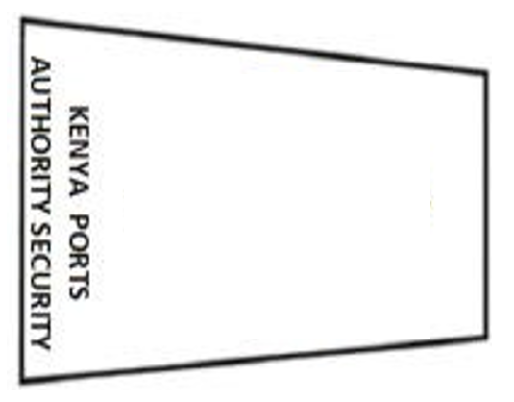 | SHOULDER GEORGETTE  RANK SHOULDER BADGE  RANK SHOULDER BADGE  RANK SHOULDER BADGE  RANK SHOULDER BADGE  RANK SHOULDER BADGE  RANK SHOULDER BADGE  RANK SHOULDER BADGE | NAVY BLUE with gold decoration  NAVY BLUE material with gold decorations (Working wear)  Aluminum Golden crossed anchors surrounded by a laurel wreath, surmounted by two nautical  emblems with golden anchor (Ceremonial)  NAVY BLUE material with gold decorations (Working wear)  Aluminum Golden crossed anchors surrounded by a laurel wreath, surmounted by one golden military pattern star and nautical emblems with golden anchor (Ceremonial)  NAVY BLUE material with gold decorations (Working wear)  Aluminum Golden crossed anchors surrounded by a laurel wreath, surmounted by two golden military pattern stars  (Ceremonial)  NAVY BLUE material with gold decorations (Working wear)  Two Aluminum Golden military pattern stars, surmounted by one nautical emblem with  golden anchor (Ceremonial)  NAVY BLUE material with gold decorations (Working wear)  Three Aluminum Golden military pattern stars (Ceremonial)  NAVY BLUE material with gold decorations (Working wear)  Three worsted gold aluminum chevrons, surmounted by one golden anchor (Ceremonial)  NAVY BLUE material without any decorations (Working wear)  Nothing for (Ceremonial) | 404 gsm,  55% Polyester  45% Wool  404 gsm,  55% Polyester  45% Wool  404 gsm,  55% Polyester  45% Wool  404 gsm,  55% Polyester  45% Wool  404 gsm,  55% Polyester  45% Wool  404 gsm,  55% Polyester  45% Wool  404 gsm,  55% Polyester  45% Wool  404 gsm,  55% Polyester  45% Wool | Navy blue velvet, 4 cm wide and 9.5 cm long pointed at the top with one vertical row of three gold embroidered oak leaves (without acorn), small golden Authority button 2 cm from point of the patch. (For Manager Security Services/PFSO, Principal Port Security Officers & Senior Port Security  Officers)  Golden crossed anchors surrounded by a laurel wreath, surmounted by two nautical emblems with golden anchors all in gold. The name ‘KENYA PORTS AUTHORITY SECURITY’ in gold is  inscribed at the base of the cloth badge. (For Manager Security Services/PFSO)  Golden crossed anchors surrounded by a laurel wreath, surmounted by a gold military star and a nautical emblem with a golden anchor all in gold. The name ‘KENYA PORTS AUTHORITY SECURITY’ in gold is  inscribed at the base of the cloth badge. (For Principal Port Security Officers)  Golden crossed anchors surrounded by a laurel wreath, surmounted by two golden military pattern stars all in gold. The name ‘KENYA PORTS AUTHORITY SECURITY’ in gold is inscribed at the base of the cloth badge.  (For Senior Port Security Officers)  Two gold military pattern stars surmounted by a nautical emblem with a golden anchor all in gold. The name ‘KENYA PORTS AUTHORITY SECURITY’ in gold is inscribed at the base of the cloth badge.  (For Port Security Officers)  Three gold military pattern stars. The name  ‘KENYA PORTS AUTHORITY  SECURITY’ in gold is inscribed at the  base of the cloth badge. (For Assistance Port Security Officers)  Three bars worsted gold chevrons  with a golden anchor embroidered on a dark blue cloth above the chevrons mounted on a dark blue Melton cloth extending 1 cm larger than the badge. The name ‘KENYA PORTS AUTHORITY SECURITY’ in gold is inscribed at the base of the cloth badge. (For Senior Security Operatives)  NAVY BLUE material without any decorations. The name ‘KENYA PORTS AUTHORITY SECURITY’ in gold is inscribed at the base of the cloth badge. (For Security Operatives)
8300301015 (S)  8300301016 (M)  8300301017 (L)  8300301018 (XL)  8300301019 (XXL)  8300301020 (XXXL)  8300301021 (XXXXL) | UNF/11(B) | 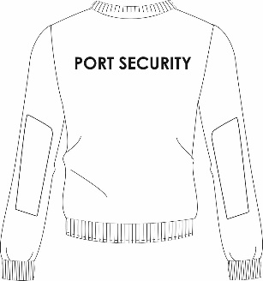 | Unisex Pullover | NAVY BLUE  Black Iris Pantone No: 19-3921TCX | 100% ACRYLIC | Security type pullover with poly/cotton patches on shoulder and elbows. Shoulder flaps. PORT SECURITY embroidered on the back. KPA 6cm diameter Logo embroidered directly on left side of chest.
8300301024 (5)  8300301025 (6)  8300301026 (7)  8300301027 (8)  8300301028 (9)  8300301029 (10)  8300301030 (11)  8300301031 (12)  8300301032 (13) | UNF/35 | 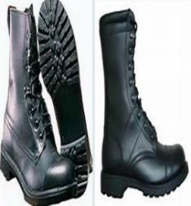 | Working Boot Gents’ | BLACK | Outer material 100% Leather  Lining material: 90% Polyester, 10% Cotton  Boot height (approx): 9" (22.9cm) | Lightweight and comfortable combat boots  8-point lacing design  Thinsulate lining for added comfort and warmth  Padded tongue  Reinforced toe cap and heel  High traction anti-slip rubber sole for extra grip  Additional soft padding to protect ankles  Lacing trap system with eyelets and hooks  Durable Nylon laces  Removable insole
8300301033 (4)  8300301034 (5)  8300301035 (6)  8300301036 (7)  8300301037 (8)  8300301038 (9)  8300301039 (10)  8300301040 (11)  8300301041 (12) | UNF/36 | 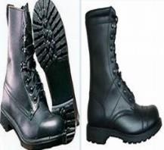 | Working Boot Ladies’ | BLACK |  | mid cut has a black full grain glove soft leather upper, comfort weave lining, a removable poly-pillow insole, and a Vibram enforcer slip and abrasion-resisting rubber outsole.
8300101100 (S)  8300101101 (M)  8300101102 (L)  8300101103 (XL)  8300101104 (XXL)  8300101105 (XXXL)  8300101106 (XXXXL) | UNF/04(B) |  | Port Security High Visibility Unisex raincoat working attire | NAVY BLUE  Black Iris Pantone No: 19-3921TCX | 100% PU with tricot backing, waterproof, windproof.  ENV 343 | High Visibility Unisex raincoat. Full seamed taped. Collar hidden hood. Hi-Vis reflective prismatic tape across chest. Two concealed hip pockets on front. Front zip closure with button/stud storm flap, Elastic inner wrist cuffs.  KPA 8.5cm logo done front with heat transfer.  PORT SECURITY prismatic badge on back in orange
8300201055 (S)  8300201056 (M)  8300201057 (L)  8300201058 (XL)  8300201059(XXL)  8300201060 (XXXL)  8300201061 (XXXXL) | UNF/37(A) |  | Port Security Men working attire | SKY BLUE  Pantone No: 18-4039TCX | 145 gsm, crease resist, plain weave,65% Polyester 35% Cotton | Gents short sleeve shirt, with cuff. Front button fastening with placket. Shoulder tabs. Front square cut patch pockets with flaps and button closing. Shaped hem. Back yoke with action-back pleat. KPA 6cm diameter logo embroidered directly onto garment above pocket. Silver embroidery onto sleeve
8300201055 (S)  8300201056 (M)  8300201057 (L)  8300201058 (XL)  8300201059(XXL)  8300201060 (XXXL)  8300201061 (XXXXL) | UNF/21(B) | 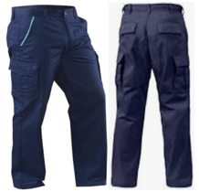 | Port Security Working Trouser | NAVY BLUE with SKY BLUE Highlights  Black Iris Pantone No: 19-3921TCX | 245 gsm, crease resist, 2/1 twill, 65% Polyester 35% Cotton | Pro IX9 II Men Military Tactical Pants Combat Trousers. Crossover Pocket design and wide belt loops. Ergonomic Design in Knee Horseshoe Design in leg large capacity hip pocket Side pocket design  Covert hip pocket  Large capacity side pocket.
8300301071 (L)  8300301072 (XL)  8300301073 (XXL)  8300301074 (XXXL) | UNF/38 | 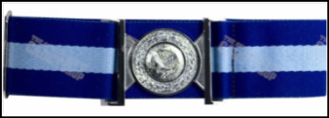 | Working Attire Belt | NAVY & SKY BLUE | Blend polyester | Security staple belt made with high quality woven material in KPA colours. Shiny silver buckle and KPA emblem embossed on buckle
8300301075 (6)  8300301076 (6.25)  8300301077 (6.5)  8300301078 (7)  8300301079 (7.25)  8300301080 (7.5)  8300301081 (8) | UNF/39 |  | Working Attire Beret | Navy blue  Black Iris Pantone No: 19-3921TCX | Melton wool | Standard security design with KPA logo
8300301082 (S)  8300301083 (M)  8300301084 (L)  8300301085 (XL)  8300301086 (XXL)  8300301087 (XXXL)  8300301088 (XXXXL) | UNF/40 |  | Endurance Weather Jacket | HI-VIS ORANGE & NAVY BLUE | 100% polyester  PVC coated  EN ISO 20471  EN 343 | Two tone long sleeve hooded foul weather jacket with Hi-Vis reflective prismatic tape embossed. Multi storage pockets.  Designed to keep the wearer, visible, safe and dry in foul weather conditions KPA logo embroidered directly onto garment on chest above left pocket. PORT SECURITY prismatic badge on back.
8300201062 (S)  8300201063 (M)  8300201064 (L)  8300201065 (XL)  8300201066(XXL)  8300201067 (XXXL)  8300201068 (XXXXL) | UNF/22(C ) |  | Ladies’ Trouser | NAVY BLUE with SKY BLUE Highlights  Black Iris Pantone No: 19-3921TCX | 245 gsm, crease resist, 2/1 twill, 65% Polyester 35% Cotton | Pro IX9 II Ladies Military Tactical Pants Combat Trouser. Crossover Pocket design and wide belt loops. Ergonomic Design in Knee Horseshoe Design in leg large capacity hip pocket Side pocket design  Covert hip pocket  Large capacity side pocket.
8300201062 (S)  8300201063 (M)  8300201064 (L)  8300201065 (XL)  8300201066(XXL)  8300201067 (XXXL)  8300201068 (XXXXL) | UNF/37(B) | 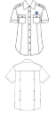 | Ladies’ Shirt | SKY BLUE  Pantone No: 18-4039TCX | 145 gsm, crease resist, plain weave,  65% Polyester 35% Cotton | Ladies short sleeve shirt, with cuff. Front button fastening with placket. Shoulder tabs. Front round cut patch pockets with flaps and button closing. Shaped hem. KPA logo 6cm diameter embroidered directly onto garment on chest above left pocket.
8300201062 (S)  8300201063 (M)  8300201064 (L)  8300201065 (XL)  8300201066(XXL)  8300201067 (XXXL)  8300201068 (XXXXL) | UNF/22(D) |  | Ladies’ Blouse | NAVY BLUE with SKY BLUE Highlights  Black Iris Pantone No: 19-3921TCX | 245 gsm, crease resist, 2/1 twill, 65% Polyester 35% Cotton | Ladies straight skirt, with side pockets, fly zip front, top stitching, and elasticated adjustable waist inset. Piping on pocket. Fully lined
PORT FIRE SERVICES
8300601008 (6)  8300601009 (6.25)  8300601010 (6.5)  8300601011 (7)  8300601012 (7.25)  8300601013 (7.5)  8300601014 (8) | UNF/41(B) |  | Ceremonial Peak Cap | NAVY BLUE  Black Iris Pantone No: 19-3921TCX | 404 gsm, 55% Polyester 45% Wool | Security peak cap with KPA emblem and shiny silver oak leaf detail  (for Port Fire Officer)
8300601001 (S)  8300601002 (M)  8300601003 (L)  8300601004 (XL)  8300601005 (XXL)  8300601006 (XXXL)  8300601007 (XXXXL) | UNF/15(A) |  | Ceremonial Trouser Men's | NAVY BLUE SERGE  Black Iris Pantone No: 19-3921TCX | 404 gsm, 55% Polyester 45% Wool | Gents classic single pleat trouser with slanted side pockets. Single welt pocket on back right side. zipper closing. Belt loops. Comfortably fit.
8300601001 (S)  8300601002 (M)  8300601003 (L)  8300601004 (XL)  8300601005 (XXL)  8300601006 (XXXL)  8300601007 (XXXXL) | UNF/43(A) |  | Ceremonial Jacket  Men's | NAVY BLUE SERGE  Black Iris Pantone No: 19-3921TCX | 404 gsm, 55% Polyester 45% Wool | Gents ceremonial single breast jacket 4 button jacket with silver buttons. Pockets as per design. Shoulder flaps for epaulette. Front waist darts Centre back seam and centre back vent.  RED piping. KPA logo embroidered directly onto garment on chest above left pocket.
8300601001 (S)  8300601002 (M)  8300601003 (L)  8300601004 (XL)  8300601005 (XXL)  8300601006 (XXXL)  8300601007 (XXXXL) | UNF/15(B) |  | Ceremonial Shirt  Men's | WHITE | 80/20 Cotton poly plain weave shirting, 125grm, crease resistant, moisture cure | Gents long sleeve shirt, with cuff. Front button fastening with placket Shaped hem. Back yoke with box pleat.  NO POCKETS. KPA logo embroidered directly onto garment on chest above left.
8300601008 (6)  8300601009 (6.25)  8300601010 (6.5)  8300601011 (7)  8300601012 (7.25)  8300601013 (7.5)  8300601014 (8) | UNF/41(A) | 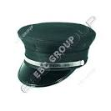 | Ceremonial Peak Cap | NAVY BLUE  Black Iris Pantone No: 19-3921TCX | 404 gsm, 55% Polyester 45% Wool | Security peak cap with KPA emblem
8300601015 (L)  8300601016 (XL)  8300601017 (XXL)  8300601018 (XXXL) | UNF/42 |  | Ceremonial Belt |  | BLACK LEATHER SILVER KPA BUCKLE | Leather belt with shiny silver buckle and KPA emblem embossed on buckle.
8300601019 (S)  8300601020 (M)  8300601021 (L)  8300601022 (XL)  8300601023 (XXL)  8300601024 (XXXL)  8300601025 (XXXXL) | UNF/43(B) |  | Ceremonial  Jacket Ladies’ | NAVY BLUE SERGE  Black Iris Pantone No: 19-3921TCX | 404 gsm, 55% Polyester 45% Wool | Ladies ceremonial single breast jacket. Pockets as per design. Shoulder flaps. Princess dart from shoulder to waist. Centre back seam and centre back vent.  KPA logo embroidered directly onto garment on chest above left pocket.
8300601019 (S)  8300601020 (M)  8300601021 (L)  8300601022 (XL)  8300601023 (XXL)  8300601024 (XXXL)  8300601025 (XXXXL) | UNF/17(D) |  | Ceremonial  Shirt Ladies’ | WHITE | 80/20 Cotton poly plain weave shirting, 125grm, crease resistant, moisture cure | Ladies long sleeve shirt, with cuff. Front button fastening with placket. Shoulder tabs. Shaped hem.  No pocket. KPA 6cm diameter Logo embroidered directly on left side of chest
8300601019 (S)  8300601020 (M)  8300601021 (L)  8300601022 (XL)  8300601023 (XXL)  8300601024 (XXXL)  8300601025 (XXXXL) | UNF/17(B) |  | Ceremonial  Trouser Ladies’ | NAVY BLUE SERGE  Black Iris Pantone No: 19-3921TCX | 404 gsm, 55% Polyester 45% Wool | Ladies straight leg trouser with elastic inset at waist. Front fly and button closing. Slanting side seam pockets. 7 belt loops. 1/2 lining
8300601019 (S)  8300601020 (M)  8300601021 (L)  8300601022 (XL)  8300601023 (XXL)  8300601024 (XXXL)  8300601025 (XXXXL) | UNF/17(A) |  | Ceremonial Skirt  Ladies’ | NAVY BLUE SERGE  Black Iris Pantone No: 19-3921TCX | 404 gsm, 55% Polyester 45% Wool | Ladies knee length skirt. Front and back waist darts Centre back zip and button fastening. Centre back seam with vent. Fully lined
8300201062 (S)  8300201063 (M)  8300201064 (L)  8300201065 (XL)  8300201066(XXL)  8300201067 (XXXL)  8300201068 (XXXXL) | UNF/22( C) |  | Working Attire Trouser Ladies’ | NAVY BLUE with RED Highlights  Black Iris Pantone No: 19-3921TCX | 245 gsm, crease resist, 2/1 twill, 65% Polyester 35% Cotton | Ladies cargo pant with front fly and button closing. Cargo pockets on hip level with contrast fabric highlight. Wide belt loops & elasticized sides. Thigh cargo pockets with contrast flap. Top crease stitch on pant. Option to add knee pad opening
8300201062 (S)  8300201063 (M)  8300201064 (L)  8300201065 (XL)  8300201066(XXL)  8300201067 (XXXL)  8300201068 (XXXXL) | UNF/22( C) |  | Working Attire Skirt Ladies’ | NAVY BLUE with RED Highlights  Black Iris Pantone No: 19-3921TCX | 245 gsm, crease resist, 2/1 twill, 65% Polyester 35% Cotton | Ladies straight skirt, with side pockets, fly zip front, top stitching, and elasticated adjustable waist inset. Piping on pocket. Fully lined
8300201062 (S)  8300201063 (M)  8300201064 (L)  8300201065 (XL)  8300201066(XXL)  8300201067 (XXXL)  8300201068 (XXXXL) | UNF/37(B) | 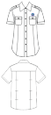 | Working Attire Shirt Ladies’ | SKY BLUE  Pantone No: 18-4039TCX | 145 gsm, crease resist, plain weave, poly cotton (65/35) | Ladies short sleeve shirt, with cuff. Front button fastening with placket. Pockets as per design. Shoulder tabs. Shaped hem. KPA logo embroidered directly onto garment on chest above left pocket.
8300201055 (S)  8300201056 (M)  8300201057 (L)  8300201058 (XL)  8300201059 (XXL)  8300201060 (XXXL)  8300201061 (XXXXL) | UNF/37(A) |  | Working Attire Shirt Men’s | SKY BLUE & WHITE  Pantone No: 18-4039TCX | 145 gsm, crease resist, plain weave,65% Polyester 35% Cotton | Gents short sleeve shirt, with cuff. Front button fastening with placket. Shoulder tabs. Front square cut patch pockets with flaps and button closing. Shaped hem. Back yoke with box pleat. KPA logo embroidered directly onto garment on chest above left pocket.
8300201055 (S)  8300201056 (M)  8300201057 (L)  8300201058 (XL)  8300201059 (XXL)  8300201060 (XXXL)  8300201061 (XXXXL) | UNF/21( C) |  | Working Attire Trouser Men’s | NAVY BLUE with RED highlight  Black Iris Pantone No: 19-3921TCX | 245 gsm, crease resist, 2/1 twill, 65% Polyester 35% Cotton | Gents cargo pant with front fly and button closing and wide belt loops. Cargo pockets on hip level with contrast fabric highlight. Thigh cargo pockets with contrast flap. Top crease stitch on pant.  Optional add knee pads
MEDICAL DEPARTMENT

8300701001 (S)  8300701002 (M)  8300701003 (L)  8300701004 (XL)  8300701005 (XXL)  8300701006 (XXXL)  8300701007 (XXXXL) | UNF/44(A) |  | Ceremonial Jacket Mens’ | - GREY  Chief Nursing Officer  - NAVY BLUE  Senior Nursing Officer | 210 gsm, polyester Viscose Lycra (64/34/2) | Gents single breasted two buttoned suit jacket. Two Functional jetted pockets, top welt pocket. Double vent on back for a more contemporary look. KPA flag label logo on the welt pocket.
8300701001 (S)  8300701002 (M)  8300701003 (L)  8300701004 (XL)  8300701005 (XXL)  8300701006 (XXXL)  8300701007 (XXXXL) | UNF/44(B) |  | Ceremonial Trouser Mens’ | - GREY-  Chief Nursing Officer  - NAVY BLUE- Senior Nursing Officer | 210 gsm, polyester Viscose Lycra (64/34/2) | Gents classic single pleat trouser with slanted side pockets. Single welt pocket on back right side. zipper closing. Belt loops. Comfortably fit.
8300701001 (S)  8300701002 (M)  8300701003 (L)  8300701004 (XL)  8300701005 (XXL)  8300701006 (XXXL)  8300701007 (XXXXL) | UNF/15(B) |  | Ceremonial Shirt Mens’ | WHITE | 80/20 Cotton poly plain weave shirting, 125gsm, crease resistant, moisture cure | Men’s classic long sleeve shirt. Classic cuff closing. Front button fastening with placket. Back yoke with two knife pleats. No pocket. KPA 6cm logo embroidered directly onto garment on chest above left.
8300701008 (S)  8300701009 (M)  8300701010 (L)  8300701011 (XL)  8300701012 (XXL)  8300701013 (XXXL)  8300701014 (XXXXL) | UNF/45  (A&B) |  | Ceremonial Jacket Ladies  Ceremonial Skirt Ladies’ | - GREY-  Chief Nursing Officer  - NAVY BLUE- Senior Nursing Officer | 210 gsm, polyester Viscose Lycra (64/34/2) | Ladies long sleeve collarless jacket.  V-shaped neckline. Three button closing. Angled single welt pockets. Princess cut. Hip length. Fully lined Centre back seam, no vent. KPA flag logo onthe welt pocket.  Ladies A-line skirt with inverted center pleat. Narrow waistband with 1'' belt loops for slim belt. Centre back seam with concealed zip and button fastening.  Fully lined
8300701008 (S)  8300701009 (M)  8300701010 (L)  8300701011 (XL)  8300701012 (XXL)  8300701013 (XXXL)  8300701014 (XXXXL) | UNF/45(C ) |  | Ceremonial Ladies Blouse | WHITE  & SKY BLUE  Pantone No: 18-4039TCX | 145 gsm, crease resist, plain weave,65% Polyester 35% Cotton | Ladies long and short sleeve blouse. Classic shirt collar. Front button fastening without placket. Front and back waist darts. Shaped hem. KPA logo embroidered directly onto garment on left side of chest 5cm diameter.
8300701008 (S)  8300701009 (M)  8300701010 (L)  8300701011 (XL)  8300701012 (XXL)  8300701013 (XXXL)  8300701014 (XXXXL) | UNF/45(D) |  | Ceremonial Trouser Ladies’ | - GREY-  Chief Nursing Officer  - NAVY BLUE- Senior Nursing Officer | 210 gsm, polyester Viscose Lycra (64/34/2) | Ladies straight leg trouser with elastic inset at waist. Front fly and button closing. Slanting side seam pockets. 7 belt loops. 1/2 lining
8300701015 (S)  8300701016 (M)  8300701017 (L)  8300701018 (XL)  8300701019 (XXL)  8300701020 (XXXL)  8300701021 (XXXXL) | UNF/46(A) |  | Lab Coat Ladies’ | WHITE | Super Soft  65% polyester, 35% cotton, | Long sleeved lab coat.  Women’s button front coat. Back vent for comfort and ease of movement and pockets for practicality. Two hip pockets, chest pocket with pen division.  KPA logo embroidered directly onto garment on chest above the left pocket.
8300701022 (S)  8300701023 (M)  8300701024 (L)  8300701025 (XL)  8300701026 (XXL)  8300701027 (XXXL)  8300701028 (XXXXL) | UNF/46(B) |  | Lab Coat Men’s | WHITE | Super Soft  65% polyester, 35% cotton, 245gsm | Long sleeved lab coat  Two hip pockets, chest pocket with pen division  Button front  Back vent  Length 41ins. KPA logo embroidered directly onto garment on chest above the left pocket.
8300701029 (S)  8300701030 (M)  8300701031 (L)  8300701032 (XL)  8300701033 (XXL)  8300701034 (XXXL)  8300701035 (XXXXL) | UNF/47 |  | Working Attire Tunic Nurse Male | WHITE, with Navy Blue piping | 210gsm, crease resist, 2/1 twill, 65% Polyester 35% Cotton | Men’s mandarin collar, short sleeve tunic, with side slits and front button closing without placket. Patch pockets on front left side of chest and two hip pockets.  KPA logo embroidered directly onto garment on chest above the left pocket.
8300701029 (S)  8300701030 (M)  8300701031 (L)  8300701032 (XL)  8300701033 (XXL)  8300701034 (XXXL)  8300701035 (XXXXL) | UNF/19(A) |  | Working Attire Trouser Nurse Male | NAVY BLUE  Black Iris Pantone No: 19-3921TCX | 210 gsm, 65% Polyester 35% Cotton 2/1 Twill | Gents classic single pleat trouser with slanted side pockets. Single welt pocket on back right side. zipper closing. Belt loops. Comfortably fit.
8300701036 (S)  8300701037 (M)  8300701038 (L)  8300701039 (XL)  8300701040 (XXL)  8300701041 (XXXL)  8300701042 (XXXXL) | UNF/20(A) |  | Working Attire Trouser Nurse Female | NAVY BLUE  Black Iris Pantone No: 19-3921TCX | 210 gsm, 65% Polyester 35% Cotton 2/1 Twill | Ladies straight leg trouser with elastic inset at waist. Front fly and button closing. Slanting side seam pockets. 7 belt loops. 1/2 lining
8300701036 (S)  8300701037 (M)  8300701038 (L)  8300701039 (XL)  8300701040 (XXL)  8300701041 (XXXL)  8300701042 (XXXXL) | UNF/22(D) |  | Working Attire Skirt Nurse Female | NAVY BLUE  Black Iris Pantone No: 19-3921TCX | 210 gsm, crease resist, 2/1 twill, 65% Polyester 35% Cotton | Ladies knee length skirt. Front and back waist darts Centre back zip and button. Elastic inset on waistband. Centre back seam with vent. Fully lined
8300701036 (S)  8300701037 (M)  8300701038 (L)  8300701039 (XL)  8300701040 (XXL)  8300701041 (XXXL)  8300701042 (XXXXL) | UNF/48 |  | Working Attire Tunic Nurse Female | WHITE, with Navy Blue piping | 210 gsm, crease resist, 2/1 twill, 65% Polyester 35% Cotton | Ladies short tunic. Front zip fastening, with placket. 2 angle hip patch pockets, Princess cut. Contrast collar and piping on sleeve. KPA 6cm diameter logo embroidered directly onto garment on chest.
8300101107 (S)  8300101108 (M)  8300101109 (L)  8300101110 (XL)  8300101111 (XXL)  8300101112 (XXXL)  8300101113 (XXXXL) | UNF/03(C ) | 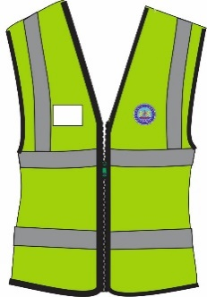 | Paramedics Jacket  (EMT Staff) | HI-VIS GREEN | 120 gsm, Hi-Vis ANSI/ISEA 107-2015 Type R Class 2  100% polyester | Reflective jacket – Hi-Vis green breathable mesh with zipper closing and reflective tape.  KENYA PORTS AUTHORITY prismatic badge on back.  KPA logo embroidered directly onto garment on chest above left
8300701043 (S)  8300701044 (M)  8300701045 (L)  8300701046 (XL)  8300701047 (XXL)  8300701048 (XXXL)  8300701049 (XXXXL) | UNF/49 |  | Theatre Scrub Clinical Officer | HOSPITAL GREEN | 145 gsm, Infection control compliant,65% Polyester 35% Cotton | Unisex scrub set. Tunic with side vents, one hip and one breast pocket.  Trousers with one side pocket, elastic drawstring waist. Concealed fly front opening. KPA logo embroidered directly onto tunic garment on chest above left the breast pocket.  Bandana style hat also with KPA logo embroidered directly onto garment front.
8300701053 (S)  8300701054 (M)  8300701055 (L)  8300701056 (XL)  8300701057 (XXL)  8300701058 (XXXL)  8300701059 (XXXXL) | UNF/53(A) |  | Working Attire Trouser Ambulance crew | LEAF GREEN with black highlights | 245 gsm, crease resist, 2/1 twill, 65% Polyester 35% Cotton | Gents trouser with front fly and button closing. Slanting side seam pockets with top stitch. Wide belt loops, side cargo pockets with flap and contrast piping on top edge. Top crease stitch on pant
8300701053 (S)  8300701054 (M)  8300701055 (L)  8300701056 (XL)  8300701057 (XXL)  8300701058 (XXXL)  8300701059 (XXXXL) | UNF/53(B) |  | Working Attire Shirt  Ambulance crew | LEAF GREEN with black highlights | 245 gsm, crease resist, 2/1 twill, 65% Polyester 35% Cotton | Men’s short sleeve shirt, with cuff. Front button fastening with placket. Shoulder tabs. Front square cut patch pockets with flaps and button closing. Shaped hem. Back yoke with action back pleats  KPA logo 6cm diameter embroidered directly onto garment on chest above left the pocket.  AMBULANCE embroidery above right pocket.
8300701060 (S)  8300701061 (M)  8300701062 (L)  8300701063 (XL)  8300701064 (XXL)  8300701065 (XXXL)  8300701066 (XXXXL) | UNF/53(C ) |  | Working Attire T-Shirt Ambulance crew | BLACK & GREEN | 65%  Polyester/35% cotton. | Classic polo shirt style.  2 colour contrast side panel with piping. Contrast colour inner placket. KPA 6cm diameter logo embroidered directly onto garment on left-side.  AMBULANCE embroidery right-side .
8300701067 (S)  8300701068 (M)  8300701069 (L)  8300701070 (XL)  8300701071 (XXL)  8300701072 (XXXL)  8300701073 (XXXXL) | UNF/53(D) |  | St. Johns Ambulance Uniform Jacket | BLACK with LEAF GREEN Highlights | 245 gsm, crease resist, 2/1 twill, 65% Polyester 35% Cotton | Long sleeve work jacket with classic collar and full length front zip fastening. Shoulder flaps with contrast fabric highlight. Two inset chest pockets with zipper fastening. KPA 6cm diameter logo embroidered directly onto garment on left and St. Johns right sides of chest respectively.
8300701067 (S)  8300701068 (M)  8300701069 (L)  8300701070 (XL)  8300701071 (XXL)  8300701072 (XXXL)  8300701073 (XXXXL) | UNF/53(E) |  | St. Johns Ambulance Uniform Trouser | LEAF GREEN with BLACK Highlights | 245 gsm, crease resist, 2/1 twill, 65% Polyester 35% Cotton | Trouser with front fly and button closing. Slanting side seam pockets with top stitch. Wide belt loops, side cargo pockets with flap and contrast piping on top edge. Top crease stitch on pant
8300701067 (S)  8300701068 (M)  8300701069 (L)  8300701070 (XL)  8300701071 (XXL)  8300701072 (XXXL)  8300701073 (XXXXL) | UNF/53(F) |  | St. Johns Ambulance Uniform Shirt | WHITE | 145 gsm, crease resist, plain weave,65% Polyester 35% Cotton | Short sleeve shirt, with cuff. Front button fastening with placket. Shoulder tabs. Front pockets with flaps and button closing. Shaped hem. Back yoke with action back pleats.  KPA 6cm diameter logo embroidered directly onto garment on left and St. Johns right sides of chest respectively.
DRIVERS & MESSENGERS
8300901001 (S)  8300901002 (M)  8300901003 (L)  8300901004 (XL)  8300901005(XXL)  8300901006 (XXXL)  8300901007 (XXXXL) | UNF/63 |  | Men drivers Suit jacket | NAVY BLUE-  Black Iris Pantone No: 19-3921TCX | 210 gsm, polyester Viscose Lycra (64/34/2) | Gents single breasted two buttoned suit jacket. Two Functional jetted pockets, top welt pocket. Double vent on back for a more contemporary look.
8300901001 (S)  8300901002 (M)  8300901003 (L)  8300901004 (XL)  8300901005(XXL)  8300901006 (XXXL)  8300901007 (XXXXL) | UNF/08(A) |  | Men Drivers Trouser | NAVY BLUE-  Black Iris Pantone No: 19-3921TCX | 210 gsm, polyester Viscose Lycra (64/34/2) | Gents classic single pleat trouser with slanted side pockets. Single welt pocket on back right side. zipper closing. Belt loops. Comfortably fit.
8300901001 (S)  8300901002 (M)  8300901003 (L)  8300901004 (XL)  8300901005(XXL)  8300901006 (XXXL)  8300901007 (XXXXL) | UNF/08(B) |  | MEN’S WORKING SHIRT | WHITE & SKY BLUE  SKY BLUE Pantone No: 18-4039TCX | 145 gsm, crease resist, plain weave,65% Polyester 35% Cotton | Men’s classic short/long sleeve shirt pocket with flap. Classic cuff closing. Front button placket. Back yoke with two knife pleats.  KPA 6cm diameter Logo embroidered directly above the pocket 6cm diameter.
8300901008 (S)  8300901009 (M)  8300901010 (L)  8300901011 (XL)  8300901012 (XXL)  8300901013 (XXXL)  8300901014 (XXXXL) | UNF/09(B) |  | Ladies Skirt | NAVY BLUE  Black Iris Pantone No: 19-3921TCX | 210 gsm, 64% Polyester 34% Viscose 2% Lycra | Ladies A-line skirt with inverted center pleat. Narrow waistband with belt loops for slim belt. Centre back seam with concealed zip and button fastening. Fully lined.
8300901008 (S)  8300901009 (M)  8300901010 (L)  8300901011 (XL)  8300901012 (XXL)  8300901013 (XXXL)  8300901014 (XXXXL) | UNF/09(A) |  | Ladies Trouser | NAVY BLUE  Black Iris Pantone No: 19-3921TCX | 210 gsm, 64% Polyester 34% Viscose 2% Lycra | Ladies straight leg trouser with elastic inset at waist. Front fly and zipper closing. Slanting side seam pockets. 7 belt loops. 1/2 lining
8300901008 (S)  8300901009 (M)  8300901010 (L)  8300901011 (XL)  8300901012 (XXL)  8300901013 (XXXL)  8300901014 (XXXXL) | UNF/09(D) |  | Ladies Blouse | WHITE  & SKY BLUE  Pantone No: 18-4039TCX | 145 gsm, crease resist, plain weave,65% Polyester 35% Cotton | Ladies open collar, short sleeve blouse. Front button fastening without placket. Front and back waist darts. Shaped hem. KPA 6cm diameter logo embroidered directly onto garment on left side of chest.
8300901008 (S)  8300901009 (M)  8300901010 (L)  8300901011 (XL)  8300901012 (XXL)  8300901013 (XXXL)  8300901014 (XXXXL) | UNF/09(C ) |  | Ladies SHORT SLEEVE Jacket | NAVY BLUE  Black Iris Pantone No: 19-3921TCX | 210 gsm, 64% Polyester 34% Viscose 2% Lycra | Ladies short sleeve collarless jacket. V-shaped neckline. Three button closing. Princess cut. Centre back seam, no vent. Shaped hem. Fully lined. KPA FLAG logo embroidered directly onto garment on left side of chest.
8300901015 (S)  8300901016 (M)  8300901017 (L)  8300901018 (XL)  8300901019 (XXL)  8300901020 (XXXL)  8300901021 (XXXXL) | UNF/64(A) |  | MEN DRIVER | NAVY BLUE  Black Iris Pantone No: 19-3921TCX | 245 gsm, crease resist, 2/1 twill, 65% Polyester 35% Cotton | Gents sleeveless jacket. Front full length zip fastening. Round shaped patch pockets with flap and Velcro fastening. Straight cut single welt pockets. Centre back seam with overlapping vent. KPA 6cm logo embroidered directly onto garment above left pocket
8300901029 (S)  8300901030 (M)  8300901031 (L)  8300901032 (XL)  8300901033 (XXL)  8300901034 (XXXL)  8300901035 (XXXXL) | UNF/65 |  | LADY HALF JACKET | NAVY BLUE-  Black Iris Pantone No: 19-3921TCX | 245 gsm, crease resist, 2/1 twill, 65% Polyester 35% Cotton | Ladies sleeveless jacket with princess dart shaping. Front full length zip. Round shaped patch pockets with angle darts for shaping and flap with Velcro fastening. In-seam pockets sewn into princess seam. Centre back seam with back vent. KPA 6cm diameter logo embroidered directly onto garment on chest above left pocket.
 |  | CORPORATE DRESS DOWN
8301101001 (S)  8301101002 (M)  8301101003 (L)  8301101004 (XL)  8301101005 (XXL)  8301101006 (XXXL)  8301101007 (XXXXL) | UNF/66(A) | 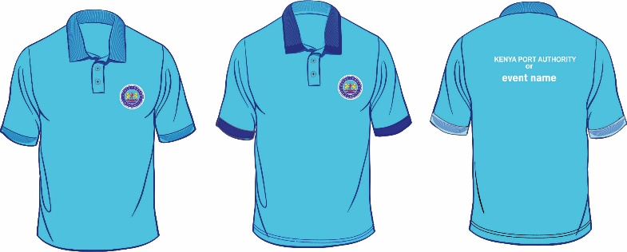 |  |  | SKY BLUE Colour  Pantone No: 18-4039TCX | Classic Polo Shirt style  with Contrast colour options KPA 6cm Logo directly embroidered on chest  Colour Pantone 306C  50%  Polyester  50% cotton.
8301101008 (S)  8301101009 (M)  8301101010 (L)  8301101011 (XL)  8301101012 (XXL)  8301101013 (XXXL)  8301101014 (XXXXL) | UNF/66(A) |  |  |  | SKY BLUE Colour and NAVY BLUE Collar and Sleeves
8301101015 (S)  8301101016 (M)  8301101017 (L)  8301101018 (XL)  8301101019 (XXL)  8301101020 (XXXL)  8301101021 (XXXXL) | UNF/66(A) | 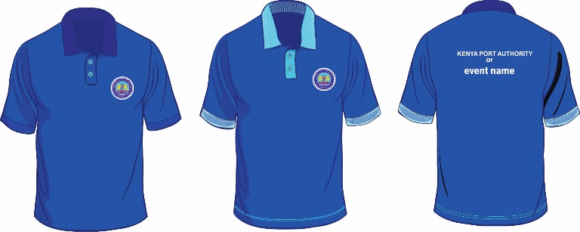 |  |  | NAVY BLUE Colour  Black Iris Pantone No: 19-3921TCX | Classic polo shirt style  with Contrast colour options KPA 6cm Logo directly embroidered on chest  Colour Pantone 306C  50%  Polyester  50% cotton.
8301101022 (S)  8301101023 (M)  8301101024 (L)  8301101025 (XL)  8301101026 (XXL)  8301101027 (XXXL)  8301101028 (XXXXL) | UNF/66(A) |  |  |  | NAVY BLUE Colour and SKY BLUE Collar and Sleeves  Black Iris Pantone No: 19-3921TCX
8301101029 (S)  8301101030 (M)  8301101031 (L)  8301101032 (XL)  8301101033 (XXL)  8301101034 (XXXL)  8301101035 (XXXXL) | UNF/66(A) | 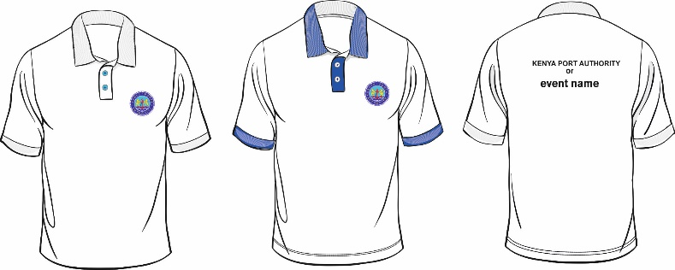 |  |  | WHITE Colour | Classic polo shirt style  with Contrast colour options KPA 6cm Logo directly embroidered on chest  Colour Pantone WHITE  50%  Polyester  50% cotton.
8301101036 (S)  8301101037 (M)  8301101038 (L)  8301101039 (XL)  8301101040 (XXL)  8301101041 (XXXL)  8301101042 (XXXXL) | UNF/66(A) |  |  |  | WHITE Colour and NAVY BLUE Collar and Sleeves
8301101064 (S)  8301101065 (M)  8301101066 (L)  8301101067 (XL)  8301101068 (XXL)  8301101069 (XXXL)  8301101070 (XXXXL) | UNF/68 | 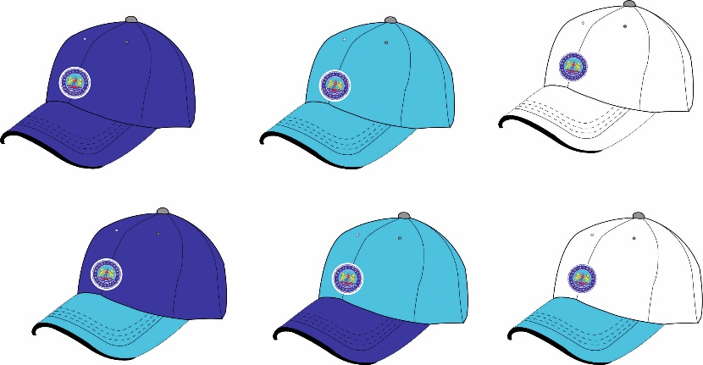 |  |  |  | NAVY BLUE Colour  Black Iris Pantone No: 19-3921TCX | 100% COTTON WOVEN TWILL CAPS  6 panel with Curved peak, and adjustable back strap. Eyelet vents. Embroidered logo.
8301101071 (S)  8301101072 (M)  8301101073 (L)  8301101074 (XL)  8301101075 (XXL)  8301101076 (XXXL)  8301101077 (XXXXL) | UNF/68 |  |  |  |  | SKY BLUE Colour  Pantone No: 18-4039TCX
8301101078 (S)  8301101079 (M)  8301101080 (L)  8301101081 (XL)  8301101082 (XXL)  8301101083 (XXXL)  8301101084 (XXXXL) | UNF/68 |  |  |  |  | WHITE Colour
8301101085 (S)  8301101086 (M)  8301101087 (L)  8301101088 (XL)  8301101089 (XXL)  8301101090 (XXXL)  8301101091 (XXXXL) | UNF/66(B) |  | Unisex Polo Shirt  (For HODs, GMs, MD & Board Members) | WHITE Colour |  | 185gsm  100% Cotton  Classic Polo shirt style with KPA logo 6.0cm directly embroidered on left chest.
8301101092 (S)  8301101093 (M)  8301101094 (L)  8301101095 (XL)  8301101096 (XXL)  8301101097 (XXXL)  8301101098 (XXXXL) | UNF/66(B) |  | Unisex Polo Shirt  (For HODs, GMs, MD & Board Members) | GREY Colour
8301101099 (S)  8301101100 (M)  8301101101 (L)  8301101102 (XL)  8301101103 (XXL)  8301101104 (XXXL)  8301101105 (XXXXL) | UNF/67(A) |  | Men’s Shirt Casual  (For HODs, GMs, MD & Board Members) | WHITE Colour |  | 185gsm  50%Polyester  50%Cotton  Classic casual shirt style with KPA logo 6cm directly embroidered on left chest
8301101106 (S)  8301101107 (M)  8301101108 (L)  8301101109 (XL)  8301101110 (XXL)  8301101111 (XXXL)  8301101112 (XXXXL) | UNF/67(B) |  | Ladies Shirt Casual  (For HODs, GMs, MD & Board Members) | WHITE Colour |  | 185gsm  50% Polyester  50% Cotton.  Classic casual shirt style with KPA logo 6cm directly embroidered on left chest

Item No | Picture | Description | Colour | Fabric Specifications (Minimum Quality) | Design Specifications
CORPORATE CHOIR
UNF/63 | 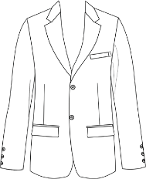 | MEN’S SUIT JACKET | NAVY BLUE  Black Iris Pantone No: 19-3921TCX | 210 gsm, polyester Viscose Lycra (64/34/2) | Gents single breasted two buttoned suit jacket. Two Functional jetted pockets, top welt pocket with a KPA Flag Lapel. Double vent on back for a more contemporary look.
UNF/08(A) | 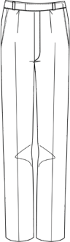 | MEN’S TROUSER | NAVY BLUE  Black Iris Pantone No: 19-3921TCX | 210 gsm, 64% Polyester  34% Viscose 2% Lycra | Gents classic single pleat trouser with slanted side pockets. Single welt pocket on back right side. zip- per closing. Belt loops. Comfortable fit.
UNF/08(B) | 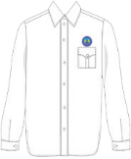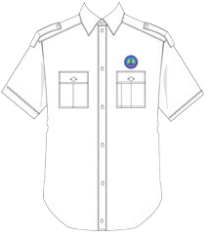 | MEN’S SHIRT | WHITE &  SKY BLUE  Pantone No: 18-4039TCX | 145 gsm, crease resist, plain weave,65% Polyes- ter 35% Cotton | Men’s classic short/long sleeve shirt with front pocket with flap and box pleat. Classic cuff closing. Front button placket. Back yoke with two knife pleats.  KPA Logo diameter 6cm embroi- dered directly 1cm above the pocket.

Item No | Picture | Description | Colour | Fabric Specifications (Minimum Quality) | Design Specifications
UNF/09(D) | 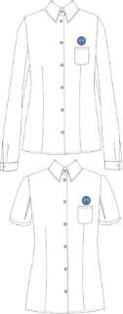 | LADIES BLOUSE | WHITE &  SKY BLUE  Pantone No: 18-4039TCX | 145 gsm, crease resist, plain weave,65% Polyes- ter 35% Cotton | Ladies long and short sleeve blouse wit front round cut patch pocket with flap and button. Classic shirt collar. Front button fastening without placket. Front and back waist darts. Shaped hem. KPA logo diameter  6cm embroidered 1cm above pocket directly on the garment.
UNF/09(B) | 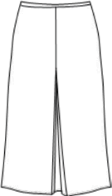 | LADIES WORKING SKIRT | NAVY BLUE  Black Iris Pantone No: 19-3921TCX | 210 gsm, 64% Polyester  34% Viscose 2% Lycra | Ladies A-line skirt with inverted center pleat. Narrow waistband with belt loops for slim belt. Centre back seam with concealed zip and button fastening. Fully lined.
UNF/09(C) | 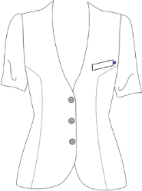 | Ladies Long Sleeve Jacket | NAVY BLUE  Black Iris Pantone No: 19-3921TCX | 210 gsm, 64% Polyester  34% Viscose 2% Lycra | Ladies Long sleeve collarless jacket. V-shaped neckline. Three button closing. Princess cut. Centre back seam, no vent. Shaped hem. Fully lined. KPA FLAG label Logo at- tached to top left pocket.
NOTE:
- The images shown in the tender document above are only for illustration purposes and should only act as a guide to branding of items
- Supply of full order will be subject to the approval of a branded physical sample (prototype) by the Uniform Contract Implementation Team (CIT). Branding elements shall be provided by the Uniform & Personal Protective Clothing Management Committee (UPPCMC) to facilitate the prototype.
- All Typeface (Berthold Akzidenz Grotesk and Verdana)
- A clear white space which is 108% larger than the KPA Emblem is mandatory whenever the KPA Emblem is printed on the KPA Deep Blue background.
- Adherence to tendering of uniforms as a complete set as provided in Appendix B.

KPA CORE COLOUR PALETTE

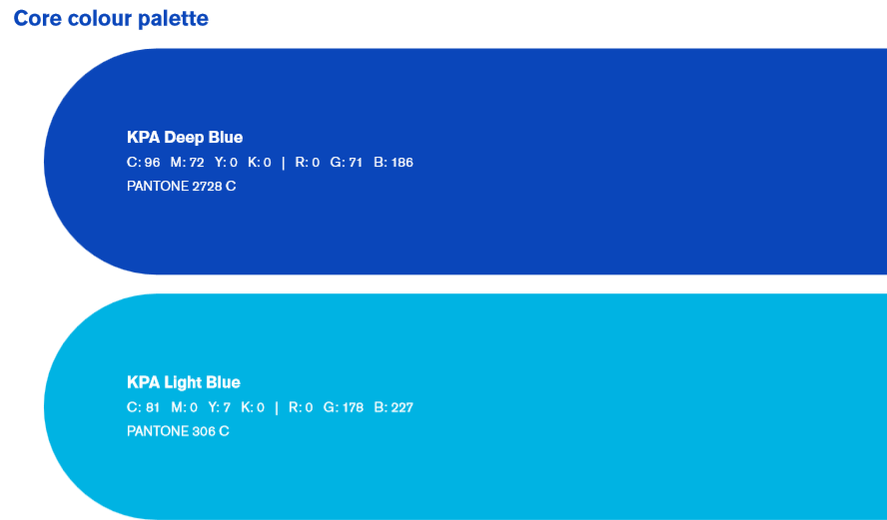
SUPPORTING COLOUR PALETTE

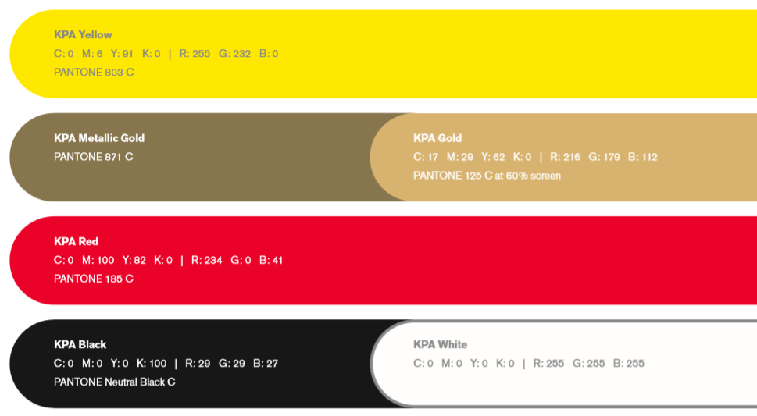

COLOUR DISTRIBUTION

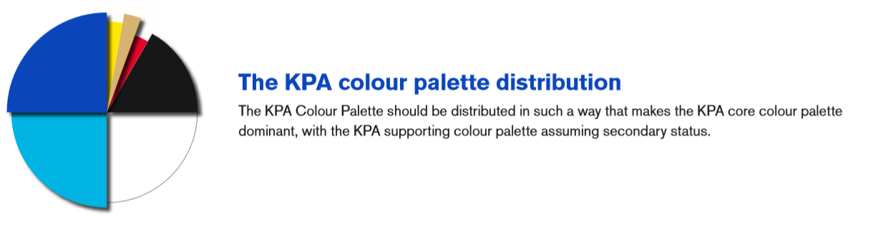

APENDIX B
UNIFORM ITEMS TO BE TENDERED AS A SET
NO. | UNIFORM NO. | ITEM DESCRIPTION
 | UNF/08(A&B) | Men’s Working Attire
 | UNF/09(A,B, C & D) | Ladies Working Attire Trouser/Skirt
 | UNF/29(A)& UNF/15(A & B) | Ceremonial Attire Men (Security)
 | UNF/29(B) & UNF/17(A,B & D) | Ceremonial Attire Ladies (Security)
 | UNF/37(A) & UNF/21(B) | Working Attire Men (Security)
 | UNF/37(B) , UNF/22(C & D) | Working Attire Ladies (Security)
 | UNF/43(A) & UNF/15(A & B) | Ceremonial Attire Gents (Fire Services)
 | UNF/43(B) & UNF/17(A,B & D) | Ceremonial Attire Ladies (Fire Services)
 | UNF/44(A & B) & UNF/15(B) | Ceremonial Attire Men (Medical)
 | UNF/45(A & B) & UNF/45(C & D) | Ceremonial Attire Ladies (Medical)
 | UNF/47 & UNF/08(A) | Tunic Nurse Male
 | UNF/48 & UNF/22(D) | Tunic Nurse Ladies
 | UNF/53D, UNF/53E,53/F | ST JOHNS Ambulance Crew
 | UNF/53(A & B) | Working attire shirt ambulance crew
 | UNF/63 & 08(A&B), UNF/64A | Men’s Suit Drivers

