Item Code | Item No | Picture | Description | Colour | Fabric Specifications (Minimum Quality) | Design Specifications | UoM
\
WORKING ATTIRE – GENERAL UNIFORMS
8300101001 | UNF/01 |  | KPA gents’ Tie | Nautical Blue Pantone No: 19-4050TCX |  | OFFICIAL TIE micro fibre.  Tie should be aprox 55” to 58” long  and 2.5” at the widest part  KPA logo of diameter 2.5cm aprox  14” to 17” from the bottom end of  the tie (the widest part) | each
  100% WOVEN
  Polyester
8300101084 | UNF/01 |  | KPA gents’ Tie | Sky Blue Pantone No. 18-4039TCX |  |  | Each
8300101002 | UNF/02 | 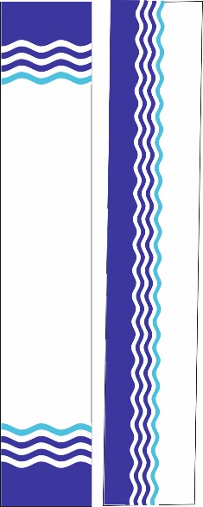 | KPA Ladies’ Scarf  Nautical blue Pantone No: 19-4050TCX Sky Blue Pantone No: 18-4039TCX | White with the KPA wave Logo | 100% silk polyester microfibre  Or  100% silk | 30cm width x 120cm length KPA wavy border should be approx 10cm wide | Each
8300101063 (S)  8300101064 (M)  8300101065 (L)  8300101066 (XL)  8300101067 (XXL)  8300101068 (XXXL)  8300101069 (XXXXL) | UNF/10(A) |  | Ladies’ Sweater | NAVY BLUE  Black Iris Pantone No.19-3921TCX | 100% Acrylic blend  400gsm | Semi-Fitted ladies button cardigan  Fine knit, with KPA logo 6cm diameter  on left chest embroidered directly onto garment. | Each
8300101070 (S)  8300101071 (M)  8300101072 (L)  8300101073 (XL)  8300101074 (XXL)  8300101075 (XXXL)  8300101076 (XXXXL) | UNF/10(B) |  | UNISEX Sleeveless sweater | NAVY BLUE  Black Iris Pantone No.19-3921TCX | 100% acrylic blend 350gsm | Classic V-neck sleeveless sweater Fine knit with KPA logo 6 cm diameter embroidered directly onto garment on chest.
8300101077 (S)  8300101078 (M)  8300101079 (L)  8300101080 (XL)  8300101081 (XXL)  8300101082 (XXXL)  8300101083 (XXXXL) | UNF/10(C ) |  | Men’s Sweater | NAVY BLUE  Black Iris Pantone No.19-3921TCX | 100% acrylic blend  400gsm | Classic long sleeve sweater with V-neck fine knitted, with KPA 6cm diameter logo on left chest embroidered directly onto garment | Each
MARINE OPERATIONS & FERRY OPERATIONS
8300201076 (L)  8300201077 (XL)  8300201078 (XXL) | UNF/06(C) | 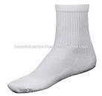  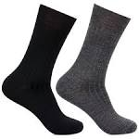 | Socks | WHITE | Cotton / Woolen | Socks cotton or woolen with elastane | Pair
8300201079 (L)  8300201080 (XL)  8300201081 (XXL) | UNF/06(C) |  | Socks | NAVY BLUE | Cotton / Woolen | Socks cotton or woolen with elastane | pair
8300201082 (L)  8300201083 (XL)  8300201084 (XXL) | UNF/06(C) |  | Socks | BLACK | Cotton / Woolen | Socks cotton or woolen with elastane | Pair
TERMINAL OPERATIONS & CONVENTIONAL CARGO OPERATIONS
8300401015 (S)  8300401016 (M)  8300401017 (L)  8300401018 (XL)  8300401019 (XXL)  8300401020 (XXXL)  8300401021 (XXXXL) | UNF/28 |  | Spray Suit | NAVY BLUE  Black Iris  Pantone No: 19-3921TCX | 100% Polyester PVC coated waterproof | Spray suit, full body cover, concealed 2 way zipper with drawstring hood.  KPA logo diameter 6CM embroidered directly onto garment on left chest  KENYA PORTS AUTHORITY prismatic badge on back in black. | each
PORT SECURITY SERVICES
8300601026 (S)  8300601027 (M)  8300601028 (L)  8300601029 (XL)  8300601030 (XXL)  8300601031 (XXXL)  8300601032 (XXXXL) | UNF/43(C) | 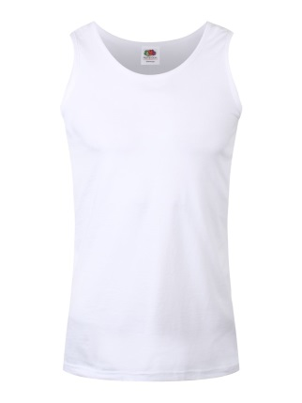 | Vest Round Neck | WHITE/ NAVY BLUE | 100% superior cotton | Round neck sleeveless vest | each
MEDICAL DEPARTMENT

8300701050 | UNF/50 |  | Apron Smocks Hospital Attendant | HOSPITAL BLUE  HOSPITAL GREEN | 65% polyester, 35% cotton, 245gsm | Smock style apron with pocket and gathering on the lower | Each
8300701051 | UNF/51 |  | Bib Apron Kitchen Hand | WHITE  ROYAL BLUE | 65% polyester, 35% cotton, 245gsm | Bib apron with large patch pocket on front. | Each
8300701052 | UNF/52 |  | Bib Apron Kitchen Hand | NATURAL | polyurethane coating | Bib apron one size,  Length 39.5” and webbing ties. | each

NOTE:
- The images shown in the tender document above are only for illustration purposes and should only act as a guide to branding of items
- Supply of full order will be subject to the approval of a branded physical sample (prototype) by the Uniform Contract Implementation Team (CIT). Branding elements shall be provided by the Uniform & Personal Protective Clothing Management Committee (UPPCMC) to facilitate the prototype.
- All Typeface (Berthold Akzidenz Grotesk and Verdana)
- A clear white space which is 108% larger than the KPA Emblem is mandatory whenever the KPA Emblem is printed on the KPA Deep Blue background.
- Adherence to tendering of uniforms as a complete set as provided in Appendix B.

KPA CORE COLOUR PALETTE

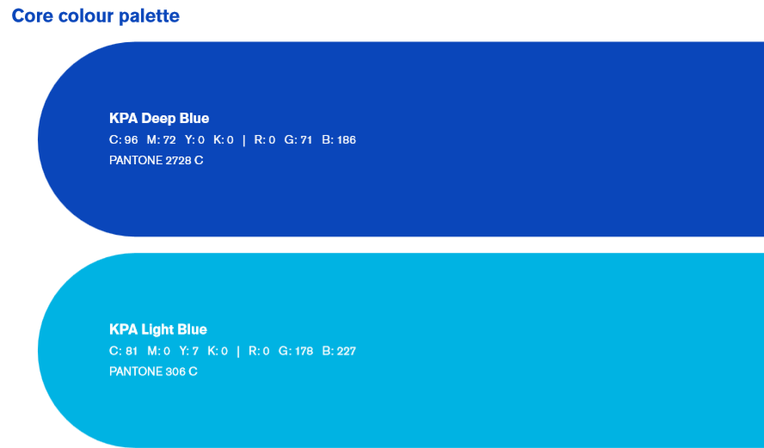
SUPPORTING COLOUR PALETTE

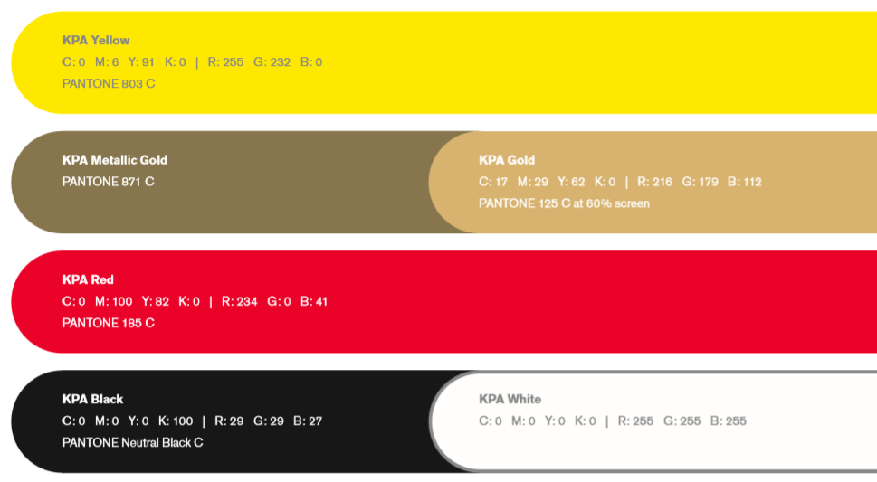

COLOUR DISTRIBUTION

