NOTE:

The CE and EN Quality Standard Specification markings must be affixed to each piece of PPE to be visible, legible and indelible throughout the expected life of the PPE and for the small items it should be marked on the packaging material.

 | Head Protection
Item Code | Item No. | Picture |  |  |  | Size |  | Items’ Description | UM |  |  | Quality Standard/  Specifications
8100101001 – white  8100101002 – blue  8100101003 – yellow  8100101004 – orange  8100101005 – green | PPE/01 | 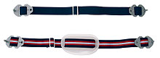 |  |  |  | STD |  | Plastic Industrial Safety Helmet White, Blue, Red, Yellow, Orange or Green.  Complete with Chin Strap and KPA Logo in indelible ink on the front | EA |  |  | - CE, EN 397 or ISO equivalent  - Tough UV stabilized HDPE shell  - Flat front  - 6-point adjustable cradle harness  - Sweatband  - Adjustable Chin strap  - Closable ventilation ports  - Must be compatible with other accessories  - With rain gutter  - Maximum weight 360g
8100102001 | PPE/02 | 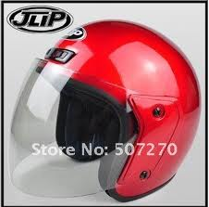 |  |  |  | STD |  | Helmet Motor Cyclist  (Crash helmet) | EA |  |  | - BS 6658:1995  - With full face clear visor
8100103001 | PPE/04 | 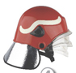 |  |  |  | STD |  | Fire Fighter Helmet Wine Red Colour | EA |  |  | - CE, EN 443:2008 or NFPA 2007 or ISO equivalent  - Extreme temperature resistance  - Radiant Heat test to 14kW/m2  - Anti-scratch & Anti-fog visor  - Aluminized carbon-fibre neck protection  - Nomex chinstrap tested to prevent skin irritations
8100103002 | PPE/05 |  |  |  |  | STD |  | Fire Fighter Hood | EA |  |  | - CE, EN 469: 1995 or ISO 11613 or equivalent.  - NFPA 1971-2013  - Natural colour
8100103003 | PPE/06 |  |  |  |  | STD |  | Face Shield and Visor | EA |  |  | - CE EN166 1.B.3.9  - To offer protection against medium energy, high speed particles, liquid droplets and molten metal  - 20cm bound visor complete with carrier to fit on to PPE/01
8100104001 | PPE/07 | 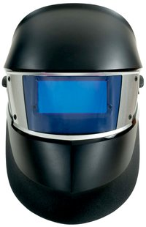 |  |  |  | STD |  | Speed Glass SL Welding Helmet | EA |  |  | - Motion sensor automatically turns ON the welding filter when you pick up the helmet, making this helmet ideal for quick welding tasks.  - Made from strong non-absorbent materials that help reduce weight  - ANSI Z87.1-2010
 | Eye Protection
8100104002 | PPE/08 | 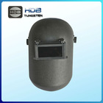 |  |  |  | STD |  | Welding Helmet Flip Front | EA |  |  | - BS1524 : 3&4, or EN166, EN169, EN175 or ISO équivalent  - Industry standard fiberglass shield with 108 x 83mm filters
8100104003 | PPE/09 | 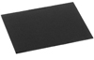 |  |  |  | STD |  | Welding Filters | EA |  |  | - CE, EN 169: 2003, ISO equivalent  - Size 108 x 83mm  - Shades 8 to 14
8100104004 | PPE/10 | 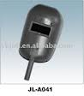 |  |  |  | STD |  | Handheld Welding Shield | EA |  |  | - Conforms to BS1524 : 3&4, or EN166, EN169, EN175 or ISO équivalent  - Industry standard Fiberglass shield with 108 x 83mm filters
8100104005 | PPE/11 | 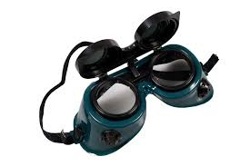 |  |  |  | STD |  | Flip - Front Welding Goggles | EA |  |  | - CE, EN -169, EN165 and EN175 or ISO équivalent  - Opaque body  - GW5 Flip up lens  - Polycarbonate anti-spatter lens  Elastic headband
8100201001 | PPE/12 | 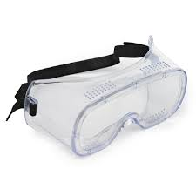 |  |  |  | STD |  | Safety Goggles/Lab Spectacles | EA |  |  | - CE, EN -166 1.B.3.4, or ISO équivalent  - To offer protection against medium energy high speed particles at extreme temperatures  - To offer protection against large dust particles, liquid droplets and molten metal.  - Lenses MUST comply to optical class1
8100202001 | PPE/13 | 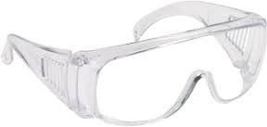 |  |  |  | STD |  | Safety Spectacles | EA |  |  | - CE EN166.1.F or ISO equivalent  - Clear polycarbonate lens and temple  - Lens offers protection against low energy high speed particles  - The optical qualities of the lens comply with the requirements of optical class 1
8100202002 | PPE/14 | 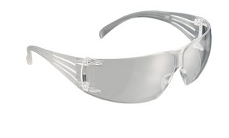 |  |  |  | STD |  | Safety Spectacles |  |  |  | - Contemporary design weighs less than 1 ounce for lightweight comfort  - Anti-fog lens coating  - High-impact-resistant lenses absorb up to 99.9% of UV radiation  - Meets the requirements of ANSI CSA Z94.3 and ANSI Z87.1-2010
8100202003 | PPE/15 | 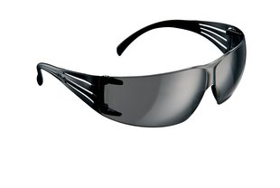 |  |  |  | STD |  | Safety Spectacles |  |  |  | - Contemporary design weighs less than 1 ounce for lightweight comfort.  - Anti-fog lens coating  - High-impact-resistant lenses absorb up to 99.9% of UV radiation  - Meets the requirements of ANSI CSA Z94.3 and ANSI Z87.1-2010
 | Ear Protection
8100301001 | PPE/16 |  |  |  |  | STD |  | Ear Defender (Muffs) | EA |  |  |  | - EN 352 - 1 2002, or ISO equivalent  - Large cups  - NRR 28.  - Can be worn over or behind the head
8100301002 | PPE/17 |  |  |  |  | STD |  | Ear Plugs | EA |  |  |  | - EN 352 - 2:2002 or ISO  equivalent  - NRR 25 dB  - Re-useable, washable corded earplugs in compact carry case
 | Respiratory Protection
8100401007 | PPE/24 |  |  |  | STD |  |  | Valved Filtering Twin Half Mask Respirators | EA |  |  |  | - CE, EN 143, EN 14387, EN140 or ISO équivalent
8100401008 | PPE/25 |  |  |  | STD |  |  | Gas Filters/Cartridge,  Acid Gas/Vapour | EA |  |  |  | - CE, EN 143871-A1
8100401009 | PPE/26 |  |  |  | STD |  |  | Dust Filters/Cartridges Dust Particles | EA |  |  |  | - CE, EN – 14387-P3SL
8100401010 | PPE/27 |  |  |  | STD |  |  | Gas Filters/Cartridges Ammonia/Methylamine | EA |  |  |  | - CE, EN – 14387-K1
8100401011 | PPE/28 |  |  |  | STD |  |  | Combined filter  Protects against gases and vapours from organic compounds with a boiling point higher than 65ºC, inorganic and acid gases and vapours, ammonia and organic ammonia derivatives and solid and liquid hazardous particles. | EA |  |  |  | - CE EN 14387  - A1B1E1K1-P3
8100401012 | PPE/29 | 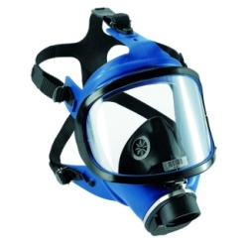 |  |  | STD |  |  | Full Face Respiratory Mask | EA |  |  |  | - CE, EN 136 class 3  - Fits a DIN 40 cannister
 | Hand Protection
8100502006 – (S)  8100502007 – (M)  8100502008 – (L)  8100502009 – (XL)  81005020010 – (XXL) | PPE/35 | 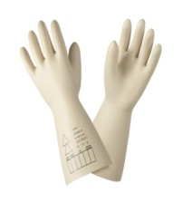 |  |  | S, M, L, XL, XXL |  |  | High Voltage Electrician Gloves | PAA |  |  |  | - CE, EN 60903 – 2003 and AC2 : 2005 or ISO équivalent  - Class 2 Insulating rubber gloves  - Length 360mm,  - Test Voltage: 30kV AC  - Working voltage: 17,000V AC
8100502016 – (S)  8100502017 – (M)  8100502018 – (L)  8100502019 – (XL)  8100502020 – (XXL) | PPE/37 | 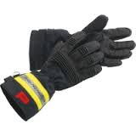 |  |  | S, M, L, XL, XXL |  |  | Fire Fighter Gloves | PAA |  |  |  | - CE, EN 659:2003, NFPA 1971 (current edition)  - Depending on material and liners specified, or ISO equivalent
 | General Protection
8100601001 – (S)  8100601002 – (M)  8100601003 – (L)  8100601004 – (XL)  8100601005 – (XXL) | PPE/38 | 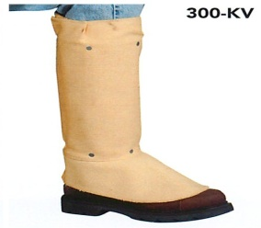 |  |  | S, M, L, XL, XXL |  |  | Shield Leggings with Spat Front & Strap | EA |  | - CE, EN 470 - 1:1995, or ISO equivalent
8100601006 – (S)  8100601007 – (M)  8100601008 – (L)  8100601009 – (XL)  81006010010 – (XXL) | PPE/39 |  |  |  | S, M, L, XL, XXL |  |  | Welders H/D Apron with Straps & Buckle Fasten | EA |  | - EN ISO 11611:2007, Manufactured from Flame retardant material, full length apron - (24 by40) inches
8100601011 | PPE/40 | 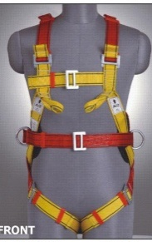 |  |  | STD |  |  | Full Body Harnesses  (Fall Arrest) | EA |  | - CE, EN 361: 2002 and EN358 : 2002 or ISO equivalent  - Minimum of four attachment points
8100601012 | PPE/41 | 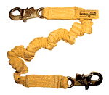 |  |  | STD |  |  | Shock Absorbing Lanyard | EA |  | - CE, EN 355:2002 or ISO equivalent, for EN 361:1997
8100601013 – (S)  8100601014 – (M)  8100601015 – (L)  8100601016 – (XL)  8100601017 – (XXL)  8100601018 – (XXXL)  8100601019 – (XXXXL) | PPE/42 | 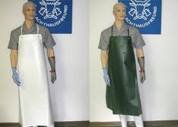 |  |  |  |  |  | PVC Apron | EA |  | - CE, EN 467: 1995 - or ISO, KEBS equivalent.
 | Marine/Diver Protection
8100701001 | PPE/46 |  |  |  |  |  | STD | Life Jacket Hi-Vis Orange Complete, Inflatable | EA |  | - EN 1S0 12402 - 3:2006  - Lightweight – Maximum 1.5kg  - 150Newton Automatic Life Jacket  - Oral backup inflation  - Outside front zip to allow easy access to the firing mechanism & gas bottle  - Fits chest 68cm -144cm
8100701002 | PPE/47 | 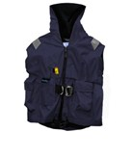 |  |  |  |  | STD | Pilots Lifejackets | EA |  | - 1S0 12402 - 3:2006  - EN 396  - Integrated 150 Newton Lifejacket  - Fully Automatic Inflation  - Oral Backup Inflation  - Manual Inflation  - Concealed Whistle  - Crotch Piece/Strap  - Two Outside Zipped Pockets  - Size fits chest  111cm – 144cm  - Weight 75kg – 137kg  - Single Layer Waterproof System  - Colour: Orange
8100701003 | PPE/48 | 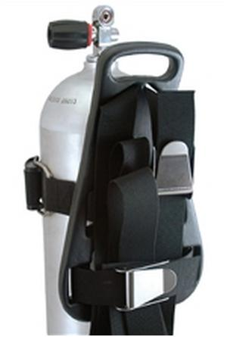 |  |  |  |  | STD | Scuba Tank Diving Cylinder, (Aluminium) Single 13 Litres Plus Back Pack/B, C, D. | EA |  | - EN 12628 or ISO equivalent or SCUBA
8100701004 | PPE/49 | 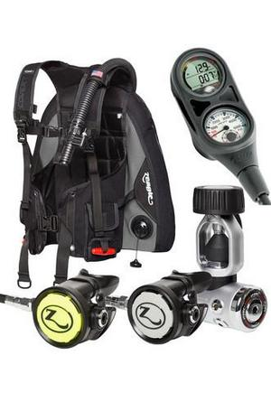 |  |  |  |  | STD | Diving Regulator (Octopus) C/W Depth Gauge, Compass, Pressure Gauge | SET |  | - EN 13949:2003 or SCUBA
8100701005 | PPE/50 | 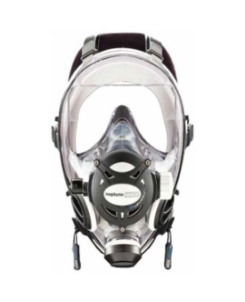 |  |  |  |  | STD | Diving Mask Full Face | EA |  | - EN 137:2006  - Nitrox compatible to 40% (the recreational limits of nitrox)  - Easily adaptable for an octopus regulator  - State-of-the-art integrated regulator  - Reduced internal volume for excellent buoyancy  - Improved visual field; visible light transfer of visor is 92%  - Premium grade silicone rubber bellows-type skirt for fit and comfort  - Durable, scratch-resistant visor  - New G. Diver exhaust valve for directing the exhaust for the best vision  - Patented 3-D equalization system for easy ear clearing  - Six strap head harness providing firm mask positioning and quick mask donning and doffing  - Easy access purge button
8100701006 | PPE/51 | 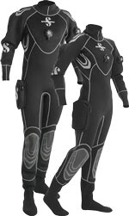 |  |  |  |  | STD | Diving Suit | SET |  | - EN 14225  - Free 5/6.5mm Hood included  - Free Dry suit Carry Bag included  - 4mm high-density neoprene maintains optimal thermal insulation but weighs 50% less and is softer than traditional dry suits  - Si-Tech balanced side-activated inlet and adjustable outlet valves  - Reversed construction rolling neoprene neck seals for watertight protection and easy donning/doffing  - Dry back zipper with exterior neoprene protection flap  - Elastic, adjustable and removable suspenders  - Convenient and roomy Utility pocket on thigh with zippered closure keeps essentials close at hand  - Durable dry back zipper with neoprene protection flap keeps water out  - Colour: Black
8100701007 | PPE/52 | 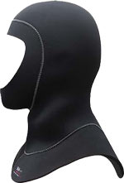 |  |  |  |  | STD | Diving Hood | EA |  | - SCUBA  - Super-Stretch - will stretch 200% more than standard neoprene  - 7mm hood/4mm broad bib  - 4mm"skin-in" face trimmable seal  - One-way flow vent to minimize air trapping  - Large bib  - Great flexibility  - COLOUR: Black  - SIZES: Small through 3X Large
8100701008 –(Size 5)  8100701009 – (Size 6)  81007010010 – (Size 7)  81007010011 – (Size 8)  81007010012 – (Size 9)  81007010013–(Size 10)  81007010014–(Size 11)  81007010015–(Size 12)  81007010016–(Size 13) | PPE/53 | 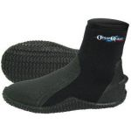 |  |  |  |  | STD | Diving Boots | PAA |  | - SCUBA  - Premium super-stretch will stretch 250% more than standard neoprene  - 4 way-stretch Titanium material for superior warmth and comfort  - No-Zip pull-on style boot  - Durable traction sole  - Heel and toe caps for maximum durability
8100701017 | PPE/54 | 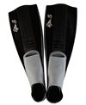 |  |  |  |  | STD | Diving Fins  (Jet Fin Type) | PAA |  | - SCUBA or DIVEX
8100701018 | PPE/55 | 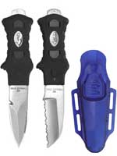 |  |  |  |  | STD | Diving Knife complete with Knife straps | EA |  | - DIVEX  - 420 Stainless Steel  - Easily attaches to BC or to leg or arm with knife straps  - Tank banging tip on handle  - Single action locking system sheath  - Blunt tip with serrated cutting edge or sharp tip with line cutter  - BLADE LENGTH: 3 1/8"  - OVERALL LENGTH: 6 ¾
8100701019 | PPE/56 | 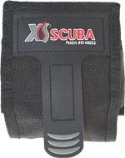 |  |  |  |  | STD | Diving Weight Belt with 4pcs ×1kg Stones | EA |  | - SCUBA  - Velcro release weight dump  - Fits any BC or weight belt with standard 2-inch webbing  - Holds up to 5lbs  - Perfect for adjusting trim  - COLOUR: Black
8100701020 | PPE/57 |  |  |  |  |  | STD | Diving Torch (Rechargeable) | EA |  | - DIVEX
8100701021 | PPE/58 |  |  |  |  |  | STD | Diving Pressure Gun | EA |  | - DIVEX
8100701022 | PPE/59 | 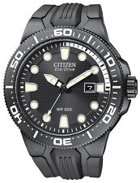 |  |  |  |  | STD | Diving Watch 50m Depth | EA |  | - DIVEX/SCUBA
8100701023 | PPE/60 | 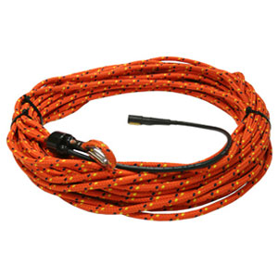 |  |  |  |  | STD | Diver Lifeline on Reel- Rope | EA |  | - DIVEX
8100701024 | PPE/61 |  |  |  |  |  | STD | Divers’ ''A'' Flag with Floater | EA |  | - DIVEX/SCUBA
8100701025 | PPE/62 | 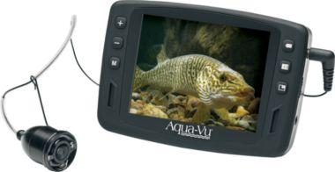 |  |  |  |  | STD | Under Water Digital Camera with Back Up Light | EA |  | - DIVEX  - Compact, handheld convenience  - 3.5" LCD color monitor  - Color camera with IR auto light sensing
 | Heat and Flame Protection
8100801001 (S)  8100801002 (M)  8100801003 (L)  8100801004 (XL)  8100801005 (XXL) | PPE/63 | 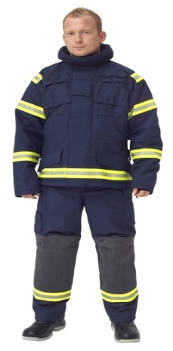 |  |  |  |  |  | Fire Fighting Suit (Coat & Trouser) with Elbow and Knee Padding inscribed “Port Fire Services” at the back | SET | - CE, EN 469:2005  - NFPA 2112-2007 or ISO équivalent  - Lightweight and breathable with Swedish trim.  - Reinforced at critical knee, elbow and seat areas to limit wear and tear  - Low maintenance
8100801006 (S)  8100801007 (M)  8100801008 (L)  8100801009 (XL)  81008010010 (XXL) | PPE/64 | 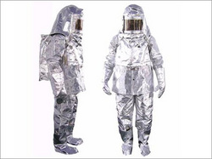 |  |  |  |  |  | Proximity Fire Fighting Suit (Coat & Trouser) |  | - CE, EN 469: 2005  - Made from aluminized glass fiber cloth with vapor / heat resistance lining  - Stitched with Kevlar thread  - It consists of hood, visor and fiber glass fireman helmet  - Coverall with BA set pouch.  - Gloves with FR & woolen lining and insulation.  - Superior quality Shoes with oil skid and heat resistance Nitrile Sole.  - Suitable for proximity fire industrial radiant heat up to 1500 deg. C.
8100802001 | PPE/65 | 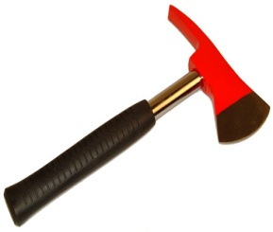 |  |  |  |  | STD | Fireman's Axe with Pouch & Leather Belt Colour Silver | EA | - NFPA (current edition) or ISO equivalent
8100801011 – (Size 5)  8100801012 – (Size 6)  8100801013 – (Size 7)  8100801014 – (Size 8)  8100801015 – (Size 9)  8100801016 – (Size 10)  8100801017 – (Size 11)  8100801018 – (Size 12)  8100801019 - (Size 13) | PPE/66 | 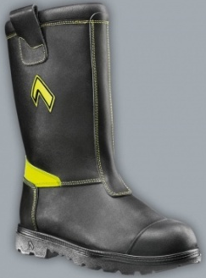 |  |  |  |  |  | Fire Fighter Boots with 2 strips Reflective Tape | PAA | - CE 0197 EN - 15090: 2012, or ISO equivalent (Has F1, F2, F3, H1, P, T, R, I, A, IS, CL, CL, CH)
8100801020 – (Size 5)  8100801021 – (Size 6)  8100801022 – (Size 7)  8100801023 – (Size 8)  8100801024 – (Size 9)  8100801025 – (Size 10)  8100801026 – (Size 11)  8100801027 – (Size 12)  8100801028 - (Size 13) | PPE/67 | 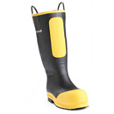 |  |  |  |  |  | Rubber Fireman's Boots | PAA | - CE, EN 345 - S 3 or NFPA 1971(current edition) or ISO equivalent
 | Foot Protection
8100901001 – (Size 5)  8100901002 – (Size 6)  8100901003 – (Size 7)  8100901004 – (Size 8)  8100901005 – (Size 9)  8100901006 – (Size 10)  8100901007 – (Size 11)  8100901008 – (Size 12)  8100901009 – (Size 13) | PPE/68 | 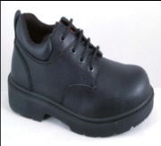 |  |  |  |  |  | Industrial Safety Shoes (Gents with laces) | PAA | - EN ISO 20345 S3 SRA 2004  - Genuine smooth leather upper for durability  - Water resistant uppers with padded collar  - Fully moulded and removable PU insole  - DD PU shock-absorbent sole  - 200 joules toe cap (EN 345)  - Chemical resistant  - Oil resistant  - Steel Midsole protection against penetration of 1,500 Newton  - Wide Fitting  - With durable inset eyelets  - Heat resistant outer sole (up to 180 deg)  - Additional reinforced side stitching for bonding  - Soft lining for comfort & sweat absorption  - Water resistant
8100901010 – (Size 4)  8100901011 – (Size 5)  8100901012 – (Size 6)  8100901013 – (Size 7)  8100901014 – (Size 8)  8100901015– (Size 9)  8100901016– (Size 10)  8100901017– (Size 11)  8100901018– (Size 12)  8100901019 – (Size 13) | PPE/69 | 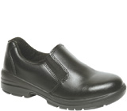 |  |  |  |  |  | Safety Shoes (Ladies with laces) | PAA | - Same as for gents shown above
8100902001 (Size 5)  8100902002 (Size 6)  8100902003 (Size 7)  8100902004 (Size 8)  8100902005 (Size 9)  8100902006 (Size 10)  8100902007 (Size 11)  8100902008 (Size 12)  8100902009 (Size 13) | PPE/70  PPE/71 | 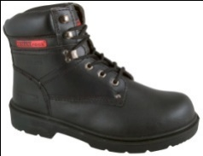  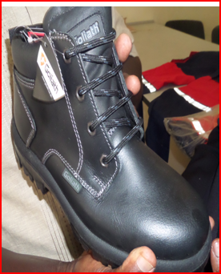 |  |  |  |  |  | Safety Boots Ladies |  | EN ISO 20345: 2004  - Genuine full grain leather upper for durability & breathability  - Extra light weight anti-slip vulcanized nitrile rubber outer sole  - Additional reinforced side stitching for bonding  - Soft lining for comfort & sweat absorption  - Corrosion resistant  - 200joules toe cap  (EN 345)  - Chemical resistant  - Oil resistant  - Steel midsole for penetration resistance of 1,500 Newton  - PU cushion insole
8100902028 (Size 5)  8100902029 (Size 6)  8100902030 (Size 7)  8100902031 (Size 8)  8100902032 (Size 9)  8100902033 (Size 10)  8100902034 (Size 11)  8100902035 (Size 12)  8100902036 (Size 13) | PPE/70  PPE/71 |  |  |  |  |  |  | Safety Boots Gents
8100902010 (Size 5)  8100902011 (Size 6)  8100902012 (Size 7)  8100902013 (Size 8)  8100902014 (Size 9)  8100902015 (Size 10)  8100902016 (Size 11)  8100902017 (Size 12)  8100902018 (Size 13) | PPE/72 | 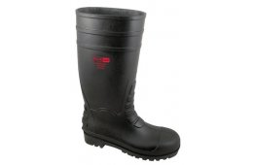 |  |  |  |  |  | Safety Gumboots | PAA | - CE, EN 20345 S5 SRC or ISO equivalent  - Waterproof  - 200 joules steel toe cap (EN 345)  - Re-inforced toe cap area for additional durability  - Oil resistant outsole  - Antistatic  - Energy absorbing cushioned heel  - Protective steel midsole  - Kickspur for easy removal  - PVC nitrile construction  - Slip-resistant to SRC.
8100902019 (Size 5)  8100902020 (Size 6)  8100902021 (Size 7)  8100902022 (Size 8)  8100902023 (Size 9)  8100902024 (Size 10)  8100902025 (Size 11)  8100902026 (Size 12)  8100902027 (Size 13) | PPE/73 |  |  |  |  |  |  | Non-Safety Rubber Gumboots  Colour-Black and White | PAA | - EN20347 or ISO 4643  - Minimum 350mm height  - Made of UV resistant uppers  - Anti-skid lug sole  - Moisture wicking inner lining  - Removable inner sole  - Metatarsal ribbing for extra protection  - Kickspur for easy removal
 | Protective Clothing
8101001022 (S)  8101001023 (M)  8101001024 (L)  8101001025 (XL)  8101001026 (XXL)  8101001027 (XXXL)  8101001028 (XXXXL) | PPE/75 |  |  | Acid Protective Overalls, with  KPA Logo in indelible ink on the left chest above the pocket. |  |  |  |  |  | - 100% Pyrovatex FR treated 350g/m2 sateen weave material with 1% negastat Anti-static yarn  - Concealed 7 stud fastening front with placket, elasicated action back for ease of movements.  - 2 stud & welcon on sleeve waist, 2 way zip  - Concealed chest pockets, knee & elbow padded  - 2 side awing self fabric pockets with trouser access  - 2 hip patch pockets with rule pocket in right leg, pen pocket on sleeve  - Breaking load warp 1840 & weft 1490N  - Tear strength warp 160N & Weft 175N  - With Retro Reflective strips Sto-Nor FR 120 tape-flame retarded for enhanced visibility engraved with KPA logo  - Fabric to conform to EN531(E2), EN470-1 and ENV50354

Item Code | Item No. | Picture |  | Size | Items’ Description
 | Respiratory Protection
8100401001 | PPE/18 | 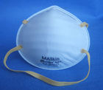 | STD |  | Nuisance Dust Masks | EA |  | - CE, EN 149: 2001, or ISO equivalent FFP  - Three categories of dust filtration are available:  1. low efficiency, FFPI (Protection Factor 14)  2. medium efficiency, FFP2 (Protection Factor 10)  3. high efficiency, FFP3 (Protection Factor 20)
8100401002 | PPE/19 | 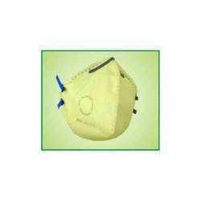 | STD |  | Fold Flat Respirators | EA |  | - CE, EN 149:2001, or ISO equivalent
8100401003 | PPE/20 | 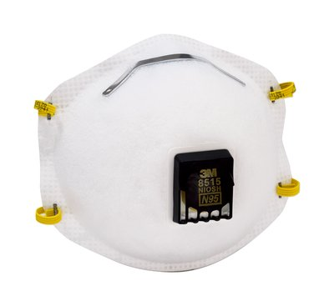 | STD |  | Welding Valved Respirator | EA |  | - Use for certain welding, soldering, metal sanding and grinding projects  - EN149-2001, FFP1/2/3  - 3M™ Cool Flow™ Valve technology for heat reduction and easier breathing  - NIOSH approved: N95
8100401004 | PPE/21 | 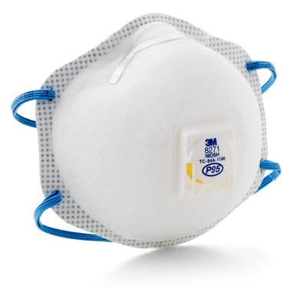 |  |  | Respirator valved for acid gases |  |  | - 3M™ Cool Flow™ Exhalation Valve helps reduce heat build-up inside the respirator  - Reduces exposure to nuisance levels of acid gases  - P95 NIOSH rating  - SKU: 70070710838 UPC: 50051138542851
8100401005 | PPW/22 | 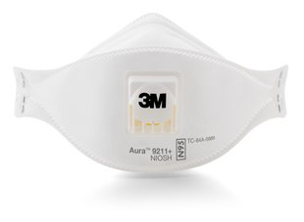 |  |  | Particulate Respirator |  |  | - Ideally suited for hot/dusty work settings that require long periods of wear N95  - Approved filtering face piece particulate respirator  - Designed to direct exhaled air away from the nose panel, helping reduce eyewear fogging  - Particulate Respirator 9211+, N95
8100401006 | PPE/23 | 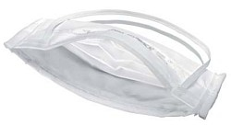 |  |  | Surgical Fold Flat Respirators | EA |  | - The N95 masks can filter particles of 0.3 microns
 | Hand Protection
8100501001 – (S)  8100501002 – (M)  8100501003 – (L)  8100501004 – (XL)  8100501005 – (XXL) | PPE/30 | 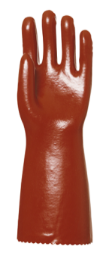 | S, M, L, XL, XXL |  | PVC Gloves for protection from organic/inorganic acid, saturated salt solutions, alkalis, aliphatic hydrocarbons, aromatically bicarbonates, ethers, aldehydes, ketones and alcohols, | PAA |  | - CE EN 374-3  - CE EN 420  - CE EN 388:4.1.2.1  - 40cm Red PVC gauntlet with cotton lining
8100501006 – (S)  8100501007 – (M)  8100501008 – (L)  8100501009 – (XL)  8100501010 – (XXL) | PPE/31 | 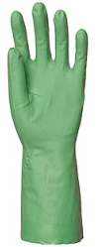 | S, M, L, XL, XXL |  | Nitrile Greaser Gloves, Oil, Greases & Solvent Resistant, | PAA |  | - CE EN 374-3  - CE EN 420  - CE EN 388:4.0.0.2  - 320mm long  - At least 0.35mm thickness
8100501011 – (S)  8100501012 – (M)  8100501013 – (L)  8100501014 – (XL)  8100501015 – (XXL) | PPE/32 | 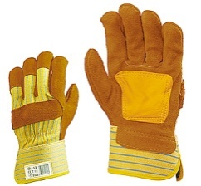 | 10 |  | Gloves Leather General Purpose, Short Arm | PAA |  | - CE, EN 388 : 3.1.2.3 and EN420, or ISO equivalent  - With re-inforced palm for extra durability
8100501016 – (S)  8100501017 – (M)  8100501018 – (L)  8100501019 – (XL)  8100501020 – (XXL) | PPE/33 |  | S, M, L, XL, XXL |  | Gloves Leather General Purpose, Long Arm, Sharp Edges Protection, Heavy Duty Leather ''Rigger Gloves'' | PAA |  | - CE, EN 388:1994, ISO or équivalent
8100502001 – (S)  8100502002 – (M)  8100502003 – (L)  8100502004 – (XL)  8100502005 – (XXL) | PPE/34 |  | S, M, L, XL, XXL |  | Gloves Welders Gauntlet | PAA |  | - CE, EN 12477 or EN407, ISO or équivalent  - Material: split cow leather  - Cuff: split, 15 cm  - Interior: thick lining  Sewing yarn: Kevlar
8100502011 – (S)  8100502012 – (M)  8100502013 – (L)  8100502014 – (XL)  8100502015 – (XXL) | PPE/36 |  | S, M, L, XL, XXL |  | Heavyweight Industrial Rubber Gloves 18” Offers Acid & Chemical resistant | PAA |  | - CE, EN 374 & 388 or ISO equivalent,  - Minimum weight 265g  - Minimum thickness 2.8mm  - Beaded cuff

