 | Item No | Picture |  | Description | Colour |  | UoM | Price Inclusive of Levy and VAT
WORKING ATTIRE – GENERAL UNIFORMS
8300101003 (S)  8300101004 (M)  8300101005 (L)  8300101006 (XL)  8300101007 (XXL)  8300101008 (XXXL)  8300101009 (XXXXL) | UNF/03(A) | 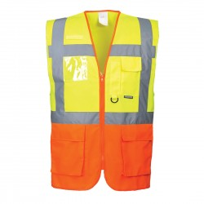 |  | HI-VIS Retro – Reflective Safety Jacket (Customized for Executive Officers) | Two tone colour combinations of LIME YELLOW and ORANGE |  | Each
8300101092 (S)  8300101093 (M)  8300101094 (L)  8300101095 (XL)  8300101096 (XXL)  8300101097 (XXXL)  8300101098 (XXXXL | UNF/03(B) | 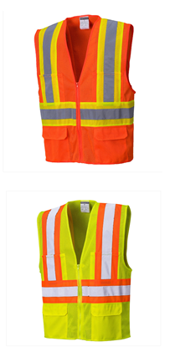 |  | HI-VIS Retro – Reflective Safety Jacket  (All Other Staff) | ORANGE (Union) |  | Each
 | UNF/03(B) |  |  | HI-VIS Retro – Reflective Safety Jacket  (All Other Staff) | LIME GREEN  (Managers) |  | Each
8300101010(S)  8300101011(M)  8300101012(L)  8300101013(XL)  8300101014(XXL)  8300101015(XXXL)  8300101016(XXXXL) | UNF/04(A) | 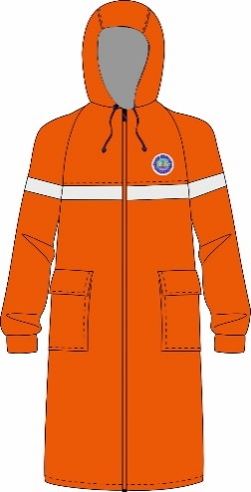 |  | Raincoat  (All other Staff) | SAFETY ORANGE |  | Each
8300101100(S)  8300101101(M)  8300101102(L)  8300101103(XL)  8300101104(XXL)  8300101105(XXXL)  8300101106(XXXXL) | UNF/04(B) |  |  | Raincoat  (Security staff) | NAVY BLUE |  | Each
8300101017(S)  8300101018(M)  8300101019(L)  8300101020(XL)  8300101021(XXL)  8300101022(XXXL)  8300101023(XXXXL) | UNF/05 |  |  | Overcoat  (Dust coat) | WHITE |  | Each
8300101033 (Size 4)  8300101034 (Size 5)  8300101035 (Size 6)  8300101036 (Size 7)  8300101037 (Size 8)  8300101038 (Size 9)  8300101039 (Size 10)  8300101040 (Size 11)  8300101041 (Size 12) | UNF/6(A) | 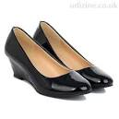 |  | Leather Shoes Ladies | OXFORD BLACK |  | Each
8300101024 (Size 5)  8300101025 (Size 6)  8300101026 (Size 7)  8300101027 (Size 8)  8300101028 (Size 9)  8300101029 (Size 10)  8300101030 (Size 11)  8300101031 (Size 12)  8300101032 (Size 13) | UNF/06(B) | 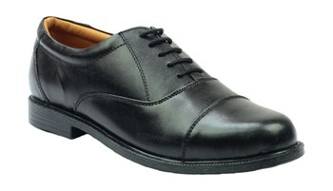 |  | Leather Shoes Gents | OXFORD BLACK |  | Each
8300101042 (S)  8300101043 (M)  8300101044 (L)  8300101045 (XL)  8300101046(XXL)  8300101047 (XXXL)  8300101048 (XXXXL) | UNF/07 | 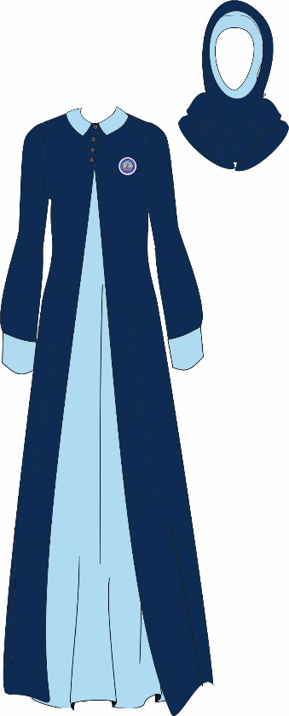 |  |  | NAVY BLUE  (Black Iris Pantone No. 19-3921  SKY BLUE  Pantone No. 18-4039TCX |  | Each
8300101049 (S)  8300101050 (M)  8300101051 (L)  8300101052 (XL)  8300101053 (XXL)  8300101054 (XXXL)  8300101055 (XXXXL) | UNF/08(A) |  |  | Men's Working Trouser | NAVY BLUE  Black Iris Pantone No.19-3921TCX |  | Set A  (Trouser+Short sleeved Shirt)
8300101049 (S)  8300101050 (M)  8300101051 (L)  8300101052 (XL)  8300101053 (XXL)  8300101054 (XXXL)  8300101055 (XXXXL) | UNF/08(B) |  |  | Men's Working Shirt  (Excluding Pilots & Tug Master) | WHITE & SKY BLUE  Pantone No.18-4039TCX |  | Set B  (Trouser+Long sleeved Shirt)
8300101056 (S)  8300101057 (M)  8300101058 (L)  8300101059 (XL  8300101060 (XXL)  8300101061 (XXXL)  8300101062 (XXXXL) | UNF/09(C ) |  |  | Ladies Short Sleeve Jacket | NAVY BLUE  Pantone  19-3921TCX |  | Set A  Ladies Short Sleeve Jacket +Short sleeved Ladies Blouse+ Ladies Working Skirt
8300101056 (S)  8300101057 (M)  8300101058 (L)  8300101059 (XL  8300101060 (XXL)  8300101061 (XXXL)  8300101062 (XXXXL) | UNF/09(D) |  |  | Ladies Blouse | WHITE  & SKY BLUE  Pantone No.18-4039TCX |  | Set B  Long sleeved Ladies Blouse+ Ladies Working Skirt
8300101056 (S)  8300101057 (M)  8300101058 (L)  8300101059 (XL  8300101060 (XXL)  8300101061 (XXXL)  8300101062 (XXXXL) | UNF/09(B) |  |  | Ladies Working Skirt | NAVY BLUE  Pantone No.19-3921TCX |  | Set C  Long sleeved Ladies Blouse+ Ladies Working Trouser
8300101056 (S)  8300101057 (M)  8300101058 (L)  8300101059 (XL  8300101060 (XXL)  8300101061 (XXXL)  8300101062 (XXXXL) | UNF/09(A) |  |  | Ladies Working Trouser | NAVY BLUE  Black Iris Pantone No.19-3921TCX |  | Set D  Ladies Short Sleeve Jacket +Short sleeved Ladies Blouse+ Ladies Working Trouser
8300301015 (S)  8300301016 (M)  8300301017 (L)  8300301018 (XL)  8300301019 (XXL)  8300301020 (XXXL)  8300301021 (XXXXL) | UNF/11(A) |  |  | Heavy Reinforced Pullover | NAVY BLUE  Black Iris Pantone No.19-3921TCX |  | Each
8300201001 (6)  8300201002 (6.25)  8300201003 (6.5)  8300201004 (7)  8300201005 (7.25)  8300201006 (7.5)  8300201007 (8) | UNF/12(A) | 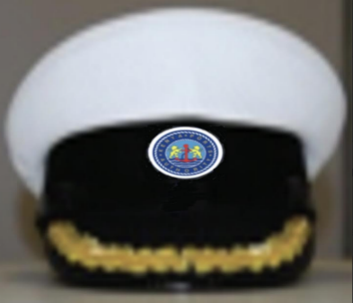 |  | Ceremonial Peak Cap Pilots and Marine Chief Engineer | WHITE |  | Each
8300201085 (6)  8300201086 (6.25)  8300201087 (6.5)  8300201088 (7)  8300201089 (7.25)  8300201090 (7.5)  8300201091 (8) | UNF/12(B) | 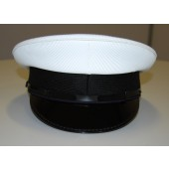 |  | Ceremonial Peak Cap Tug Masters, Coxswain and Trainee Pilots | WHITE |  | Each
8300201028 (6)  8300201029 (6.25)  8300201030 (6.5)  8300201031 (7)  8300201032 (7.25)  8300201033 (7.5) | UNF/12(C ) |  |  | Ceremonial Cap Sailor | WHITE |  | Each
8300201092 | UNF/14(A) | 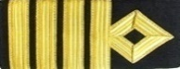 |  | Harbour Master, Pilots | 4 Gold Bars |  | Pair
 | UNF/14(A) |  |  | Marine Chief Engineer |  |  | Pair
8300201093 (S)  8300201094 (M)  8300201095 (L)  8300201096 (XL)  8300201097 (XXL)  8300201098 (XXXL)  8300201099 (XXXXL) | UNF/15(A) |  |  | Ceremonial Trouser Men’s Pilot | NAVY BLUE SERGE  Black Iris Pantone No: 19-3921TCX |  | Set
8300201093 (S)  8300201094 (M)  8300201095 (L)  8300201096 (XL)  8300201097 (XXL)  8300201098 (XXXL)  8300201099 (XXXXL) | UNF/15((B) |  |  | Ceremonial Shirt Men's Pilot | WHITE |  | Set
8300201093 (S)  8300201094 (M)  8300201095 (L)  8300201096 (XL)  8300201097 (XXL)  8300201098 (XXXL)  8300201099 (XXXXL) | UNF/15(C ) |  |  | Ceremonial Jacket Men's Pilot | NAVY BLUE SERGE Black Iris Pantone No: 19-3921TCX |  | Set
8300201014 (S)  8300201015 (M)  8300201016 (L)  8300201017 (XL)  8300201018 (XXL)  8300201019 (XXXL)  8300201020 (XXXXL) | UNF/16(B) | 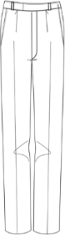 |  | Demi-Official Bush Jacket Men’s’ Pilots | WHITE |  | Set
8300201014 (S)  8300201015 (M)  8300201016 (L)  8300201017 (XL)  8300201018 (XXL)  8300201019 (XXXL)  8300201020 (XXXXL)  8300201014 (S)  8300201015 (M)  8300201016 (L)  8300201017 (XL)  8300201018 (XXL)  8300201019 (XXXL)  8300201020 (XXXXL | UNF/16(A) |  |  | Demi-Official Trouser Men’s Pilots | WHITE |  | Set
 | UNF/18(B) |  |  | Ceremonial Shirt  Sailor | WHITE with Royal blue  Capella |  | Set
8300201021 (S)  8300201022 (M)  8300201023 (L)  8300201024 (XL)  8300201025 (XXL)  8300201026 (XXXL)  8300201027 (XXXXL | UNF/18(A) |  |  | Ceremonial Trouser for  Sailor | WHITE |  | Set
8300201021 (S)
8300201022 (M)
8300201023 (L)
8300201024 (XL)
8300201025 (XXL)
8300201026 (XXXL)
8300201027 (XXXXL)
8300201034 (S)  8300201035 (M)  8300201036 (L)  8300201037 (XL)  8300201038 (XXL)  8300201039 (XXXL)  8300201040 (XXXXL) | UNF/17(C ) |  |  | Ceremonial Jacket Ladies Pilot | NAVY BLUE SERGE  Black Iris Pantone No. 19-3921TCX |  | Set A  Ceremonial Jacket Ladies Pilot + Ceremonial  Skirt Ladies Pilot+ Ceremonial  Shirt Ladies’
8300201034 (S)  8300201035 (M)  8300201036 (L)  8300201037 (XL)  8300201038 (XXL)  8300201039 (XXXL)  8300201040 (XXXXL) | UNF/17(A) |  |  | Ceremonial  Skirt Ladies Pilot | NAVY BLUE SERGE  Black Iris Pantone No. 19-3921TCX
8300201034 (S)  8300201035 (M)  8300201036 (L)  8300201037 (XL)  8300201038 (XXL)  8300201039 (XXXL)  8300201040 (XXXXL) | UNF/17(B) |  |  | Ceremonial  Trouser Ladies Pilot | NAVY BLUE SERGE  Black Iris Pantone No. 19-3921TCX |  | Set B  Ceremonial Jacket Ladies Pilot + Ceremonial  Trouser Ladies Pilot+ Ceremonial  Shirt Ladies’
8300201034 (S)  8300201035 (M)  8300201036 (L)  8300201037 (XL)  8300201038 (XXL)  8300201039 (XXXL)  8300201040 (XXXXL) | UNF/17(D) |  |  | Ceremonial  Shirt Ladies’ | WHITE
8300201041 (S)  8300201042 (M)  8300201043 (L)  8300201044 (XL)  8300201045 (XXL)  8300201046 (XXXL)  8300201047 (XXXXL) | UNF/19(A) |  |  | Working Attire Trouser Men’s Pilot and Tug master | NAVY BLUE  BLACK  GREY |  | Set
8300201041 (S)  8300201042 (M)  8300201043 (L)  8300201044 (XL)  8300201045 (XXL)  8300201046 (XXXL)  8300201047 (XXXXL) | UNF/19(B) |  |  | Working Attire Shirt Men’s Pilot and Tug Master | WHITE |  | Set
 | UNF/20(B) |  |  | Working Attire Shirt Ladies’ Pilot and Tugmaster | WHITE |  | Set
8300201048 (S)  8300201049 (M)  8300201050 (L)  8300201051 (XL)  8300201052 (XXL)  8300201053 (XXXL)  8300201054 (XXXXL) | UNF/20(A) |  |  | Working Attire Trouser Ladies Pilot and Tug master | NAVY BLUE SERGE  BLACK  GREY |  | Set
8300201055 (S)  8300201056 (M)  8300201057 (L)  8300201058 (XL)  8300201059(XXL)  8300201060 (XXXL)  8300201061 (XXXXL) | UNF/21(A) |  |  | Working Attire Trouser Men’s (marine operations excluding pilots & tug master) | NAVY BLUE with ORANGE highlights |  | Set
8300201055 (S)  8300201056 (M)  8300201057 (L)  8300201058 (XL)  8300201059(XXL)  8300201060 (XXXL)  8300201061 (XXXXL) | UNF/08(B) |  |  | Working Attire Shirt Men’s (marine operations excluding pilots & tug master) | SKY BLUE |  | Set
8300201062 (S)  8300201063 (M)  8300201064 (L)  8300201065 (XL)  8300201066(XXL)  8300201067 (XXXL)  8300201068 (XXXXL) | UNF/22(A) |  |  | Working Attire Trouser Ladies’ (marine operations excluding pilots & tug master) | NAVY BLUE with ORANGE highlights |  | Set
8300201062 (S)  8300201063 (M)  8300201064 (L)  8300201065 (XL)  8300201066(XXL)  8300201067 (XXXL)  8300201068 (XXXXL) | UNF/08(C ) |  |  | Working Attire Shirt Ladies’ (marine operations excluding pilots & tug master) | SKY BLUE  Pantone No. 18-4039TCX |  | Set
8300201069 (S)  8300201070(M)  8300201071 (L)  8300201072 (XL)  8300201073 (XXL)  8300201074 (XXXL)  8300201075 (XXXXL) | UNF/23 |  |  | Foul Weather Jacket and Trouser  Tug-Master  Coxswain  Sailor | ORANGE |  | Each
8300201062 (S)  8300201063 (M)  8300201064 (L)  8300201065 (XL)  8300201066(XXL)  8300201067 (XXXL)  8300201068 (XXXXL) | UNF/08( C) |  |  | Ladies working Shirt | SKY BLUE  Pantone No. 18-4039TCX |  | Set
8300201055 (S)  8300201056 (M)  8300201057 (L)  8300201058 (XL)  8300201059(XXL)  8300201060 (XXXL)  8300201061 (XXXXL) | UNF/22(A) |  |  | Working Attire Trouser Ladies’ | NAVY BLUE with ORANGE highlights |  | Set
8300301001 (S)  8300301002 (M)  8300301003 (L)  8300301004 (XL)  8300301005 (XXL)  8300301006 (XXXL)  8300301007 (XXXXL) | UNF/24(A) |  |  | OVERALL MEN’S | ORANGE  with SKYBLUE Highlights |  | Each
8300301008 (S)  8300301009 (M)  8300301010 (L)  8300301011 (XL)  8300301012 (XXL)  8300301013 (XXXL)  8300301014 (XXXXL) | UNF/26(B) |  |  | WORK WEAR LADIE’S | ORANGE with SKYBLUE Highlights |  | Set
8300301089 (S)  8300301090 (M)  8300301091 (L)  8300301092 (XL)  8300301093 (XXL)  8300301094 (XXXL)  8300301095 (XXXXL) | UNF/25(A) | 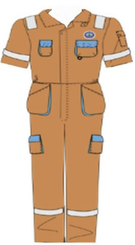 |  | OVERALL LADIES  Marine Operations | ORANGE  with SKYBLUE Highlights |  | Each
8300301036 (S)  8300301037 (M)  8300301038 (L)  8300301039 (XL)  8300301040 (XXL)  8300301041 (XXXL)  8300301042 (XXXXL) | UNF/24(A) |  |  | OVERALL MEN’S | ORANGE  with SKYBLUE Highlights |  | Each
8300301043 (S)  8300301044 (M)  8300301045 (L)  8300301046 (XL)  8300301047 (XXL)  8300301048 (XXXL)  8300301049 (XXXXL) | UNF/24(B) |  |  | OVERALL MEN’S | NAVY BLUE with SKYBLUE Highlights |  | Each
8300301050 (S)  8300301051 (M)  8300301052 (L)  8300301053 (XL)  8300301054 (XXL)  8300301055 (XXXL)  8300301056 (XXXXL) | UNF/24(C ) |  |  | OVERALL MEN’S | NAVY BLUE with KHAKI Highlights |  | Each
8300301050 (S)  8300301051 (M)  8300301052 (L)  8300301053 (XL)  8300301054 (XXL)  8300301055 (XXXL)  8300301056 (XXXXL) | UNF/24(D) |  |  | OVERALL MEN’S | WHITE |  | Each
8300401001 (S)  8300401002 (M)  8300401003 (L)  8300401004 (XL)  8300401005 (XXL)  8300401006 (XXXL)  8300401007 (XXXXL) | UNF/27 |  |  | Men’s Plain T-shirt | WHITE |  | Each
8300401008 (S)  8300401009 (M)  8300401010 (L)  8300401011 (XL)  8300401012 (XXL)  8300401013 (XXXL)  8300401014 (XXXXL) | UNF/26(A) |  |  | WORK WEAR MEN’S | NAVY BLUE with KHAKI Highlights |  | Set
8300301064 (S)  8300301065 (M)  8300301066 (L)  8300301067 (XL)  8300301068 (XXL)  8300301069 (XXXL)  8300301070 (XXXXL) | UNF/25(B) |  |  | WORK WEAR LADIE’S | ORANGE WITH SKYBLUE HIGHLIGHT |  | Set
8300201055 (S)  8300201056 (M)  8300201057 (L)  8300201058 (XL)  8300201059(XXL)  8300201060 (XXXL)  8300201061 (XXXXL) | UNF/21(D) |  |  | Working Attire Men’s Trouser | NAVY BLUE with ORANGE highlights  NAVY BLUE with KHAKI Highlights |  | Set
8300201062 (S)  8300201063 (M)  8300201064 (L)  8300201065 (XL)  8300201066(XXL)  8300201067 (XXXL)  8300201068 (XXXXL)  8300201055 (S)  8300201056 (M)  8300201057 (L)  8300201058 (XL)  8300201059(XXL)  8300201060 (XXXL)  8300201061 (XXXXL) | UNF/08(B) |  |  | Working Attire Men’s Shirt | SKY BLUE |  | Set
8300201062 (S)  8300201063 (M)  8300201064 (L)  8300201065 (XL)  8300201066(XXL)  8300201067 (XXXL)  8300201068 (XXXXL | UNF/22(A) |  |  | Working Attire Ladies’ Trouser | NAVY BLUE with ORANGE Highlights  NAVY BLUE with KHAKI Highlight |  | Set
8300201062 (S)  8300201063 (M)  8300201064 (L)  8300201065 (XL)  8300201066(XXL)  8300201067 (XXXL)  8300201068 (XXXXL) | UNF/08(C ) |  |  | Ladies’ Working Shirt (excluding pilots & tug master) | SKY BLUE  Pantone No: 18-4039TCX |  | Set
8300501001 (S)  8300501002 (M)  8300501003 (L)  8300501004 (XL)  8300501005 (XXL)  8300501006 (XXXL)  8300501007 (XXXXL | UNF/29(A) |  |  | Ceremonial Jacket  Men's | NAVY BLUE SERGE  Black Iris Pantone No: 19-3921TCX |  | Set
 | UNF/15(A) |  |  | Ceremonial Trouser Men's | NAVY BLUE SERGE  Black Iris Pantone No: 19-3921TCX |  | Set
8300501001 (S)  8300501002 (M)  8300501003 (L)  8300501004 (XL)  8300501005 (XXL)  8300501006 (XXXL)  8300501007 (XXXXL  8300501001 (S)  8300501002 (M)  8300501003 (L)  8300501004 (XL)  8300501005 (XXL)  8300501006 (XXXL)  8300501007 (XXXXL | UNF/15(B) |  |  | Ceremonial Shirt  Men's | WHITE |  | Set
8300501008 (6)  8300501009 (6.25)  8300501010 (6.5)  8300501011 (7)  8300501012 (7.25)  8300501013 (7.5)  8300501014 (8) | UNF/30(A) |  |  | Ceremonial Peak Cap | NAVY BLUE SERGE  Black Iris Pantone No: 19-3921TCX |  | Each
8300501068 (6)  8300501069 (6.25)  8300501070 (6.5)  8300501071 (7)  8300501072 (7.25)  8300501073 (7.5)  8300501074 (8) | UNF/30(B) |  |  |  | NAVY BLUE SERGE  Black Iris Pantone No: 19-3921TCX |  | Each
8300501089 (6)  8300501091 (6.25)  8300501092 (6.5)  8300501093 (7)  8300501094 (7.25)  8300501095 (7.5)  8300501096 (8) | UNF/30(C) |  |  | Ceremonial Peak Cap | NAVY BLUE SERGE  Black Iris Pantone No: 19-3921TCX |  | Each
8300501075 (L)  8300501076 (XL)  8300501077 (XXL)  8300501078 (XXXL)  8300501079 (XXXXL) | UNF/31 | 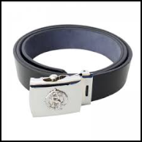 |  | Ceremonial Belt |  |  | Each
8300501015 | UNF/32 (A) | 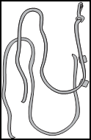 |  | Ceremonial Lanyard | KPA brand colours. |  | Each
8300501090 | UNF/32 (C) | 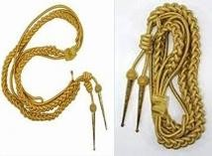 |  | Ceremonial Lanyard | SILVER |  | Each
8300501016 (S)  8300501017 (M)  8300501018 (L)  8300501019 (XL)  8300501020 (XXL)  8300501021 (XXXL)  8300501022 (XXXXL) | UNF/29(B) | 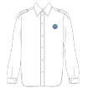 |  | Ceremonial Jacket  Ladies’ | NAVY BLUE SERGE  Black Iris Pantone No: 19-3921TCX |  | Set
8300501016 (S)  8300501017 (M)  8300501018 (L)  8300501019 (XL)  8300501020 (XXL)  8300501021 (XXXL)  8300501022 (XXXXL) | UNF/17(D) |  |  | Ceremonial Shirt Ladies’ | WHITE |  | Set
8300501016 (S)  8300501017 (M)  8300501018 (L)  8300501019 (XL)  8300501020 (XXL)  8300501021 (XXXL)  8300501022 (XXXXL) | UNF/17(B) |  |  | Ceremonial Trouser  Ladies | NAVY BLUE SERGE  Black Iris Pantone No: 19-3921TCX
8300501016 (S)  8300501017 (M)  8300501018 (L)  8300501019 (XL)  8300501020 (XXL)  8300501021 (XXXL)  8300501022 (XXXXL) | UNF/17(A) |  |  | Ceremonial  Ladies’ Skirt | NAVY BLUE SERGE  Black Iris Pantone No: 19-3921TCX
8300501080 | UNF/33 | 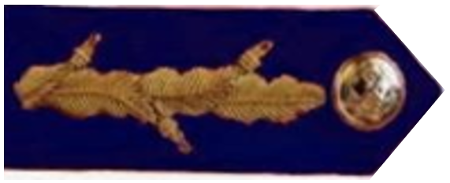   |  | SHOULDER GEORGETTE | NAVY BLUE with gold decoration |  | Pair
8300501082 | UNF/34 (A) | 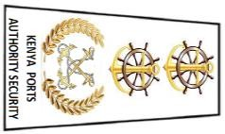 |  | RANK SHOULDER BADGE | NAVY BLUE material with gold decorations (Working wear)  Aluminum Golden crossed anchors surrounded by a laurel wreath, surmounted by two nautical  emblems with golden anchor (Ceremonial) |  | Pair
8300501083 | UNF/34 (B) |  |  | RANK SHOULDER BADGE | NAVY BLUE material with gold decorations (Working wear)  Aluminum Golden crossed anchors surrounded by a laurel wreath, surmounted by one golden military pattern star and nautical emblems with golden anchor (Ceremonial) |  | Pair
8300501084 | UNF/34 (C) |  |  | RANK SHOULDER BADGE | NAVY BLUE material with gold decorations (Working wear)  Aluminum Golden crossed anchors surrounded by a laurel wreath, surmounted by two golden military pattern stars  (Ceremonial) |  | Pair
8300501085 | UNF/34 (D) |  |  | RANK SHOULDER BADGE | NAVY BLUE material with gold decorations (Working wear)  Two Aluminum Golden military pattern stars, surmounted by one nautical emblem with  golden anchor (Ceremonial) |  | Pair
8300501086 | UNF/34 (E) |  |  | RANK SHOULDER BADGE | NAVY BLUE material with gold decorations (Working wear)  Three Aluminium Golden military pattern stars (Ceremonial) |  | Pair
8300501087 | UNF/34 (F) | 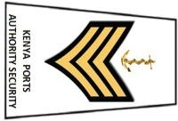 |  | RANK SHOULDER BADGE | NAVY BLUE material with gold decorations (Working wear)  Three worsted gold aluminium chevrons, surmounted by one golden anchor (Ceremonial) |  | Pair
8300501088 | UNF/34 (G) | 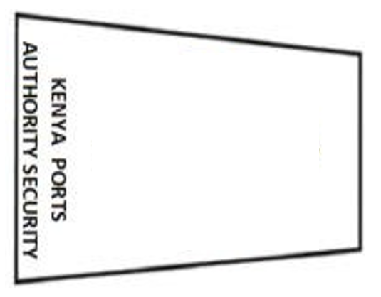 |  | RANK SHOULDER BADGE | NAVY BLUE material without any decorations (Working wear)  Nothing for (Ceremonial) |  | Pair
8300301015 (S)  8300301016 (M)  8300301017 (L)  8300301018 (XL)  8300301019 (XXL)  8300301020 (XXXL)  8300301021 (XXXXL) | UNF/11(B) | 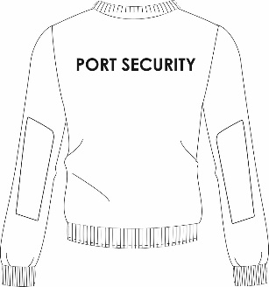 |  | Unisex Pullover | NAVY BLUE  Black Iris Pantone No: 19-3921TCX |  | Each
8300301024 (5)  8300301025 (6)  8300301026 (7)  8300301027 (8)  8300301028 (9)  8300301029 (10)  8300301030 (11)  8300301031 (12)  8300301032 (13) | UNF/35 | 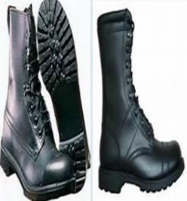 |  | Working Boot Gents’ | BLACK |  | Pair
8300301033 (4)  8300301034 (5)  8300301035 (6)  8300301036 (7)  8300301037 (8)  8300301038 (9)  8300301039 (10)  8300301040 (11)  8300301041 (12) | UNF/36 | 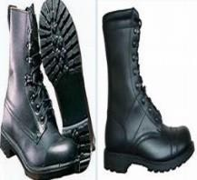 |  | Working Boot Ladies’ | BLACK |  | Pair
8300101100 (S)  8300101101 (M)  8300101102 (L)  8300101103 (XL)  8300101104 (XXL)  8300101105 (XXXL)  8300101106 (XXXXL) | UNF/04(B) |  |  | Port Security High Visibility Unisex raincoat working attire | NAVY BLUE  Black Iris Pantone No: 19-3921TCX |  | Each
8300201055 (S)  8300201056 (M)  8300201057 (L)  8300201058 (XL)  8300201059(XXL)  8300201060 (XXXL)  8300201061 (XXXXL)  8300201055 (S)  8300201056 (M)  8300201057 (L)  8300201058 (XL)  8300201059(XXL)  8300201060 (XXXL)  8300201061 (XXXXL) | UNF/37(A)  UNF/21(B) | 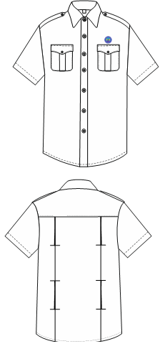  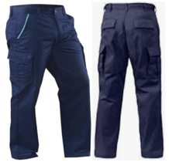 |  | Port Security Men working attire shirt men’s  Port Security Working Trouser | SKY BLUE  Pantone No: 18-4039TCX  NAVY BLUE with SKY BLUE Highlights  Black Iris Pantone No: 19-3921TCX |  | Set
8300301071 (L)  8300301072 (XL)  8300301073 (XXL)  8300301074 (XXXL) | UNF/38 | 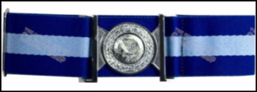 |  | Working Attire Belt | NAVY & SKY BLUE |  | Each
8300301075 (6)  8300301076 (6.25)  8300301077 (6.5)  8300301078 (7)  8300301079 (7.25)  8300301080 (7.5)  8300301081 (8) | UNF/39 |  |  | Working Attire Beret | Navy blue  Black Iris Pantone No: 19-3921TCX |  | Each
8300301082 (S)  8300301083 (M)  8300301084 (L)  8300301085 (XL)  8300301086 (XXL)  8300301087 (XXXL)  8300301088 (XXXXL) | UNF/40 |  |  | Endurance Weather Jacket | HI-VIS ORANGE & NAVY BLUE |  | Each
8300201062 (S)  8300201063 (M)  8300201064 (L)  8300201065 (XL)  8300201066(XXL)  8300201067 (XXXL)  8300201068 (XXXXL)  8300201062 (S)  8300201063 (M)  8300201064 (L)  8300201065 (XL)  8300201066(XXL)  8300201067 (XXXL)  8300201068 (XXXXL)  8300201062 (S)  8300201063 (M)  8300201064 (L)  8300201065 (XL)  8300201066(XXL)  8300201067 (XXXL)  8300201068 (XXXXL) | UNF/22(C)  UNF/37(B)  UNF/22(D) | 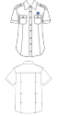 |  | Ladies’ Trouser  Ladies’ Blouse  Ladies’ Shirt | NAVY BLUE with SKY BLUE Highlights  Black Iris Pantone No: 19-3921TCX  SKY BLUE  Pantone No: 18-4039TCX  NAVY BLUE with SKY BLUE Highlights  Black Iris Pantone No: 19-3921TCX |  | Set A  Ladies’ Trouser + Ladies’ Blouse  Set B  Skirt + Blouse
8300601008 (6)  8300601009 (6.25)  8300601010 (6.5)  8300601011 (7)  8300601012 (7.25)  8300601013 (7.5)  8300601014 (8) | UNF/41(B) |  |  | Ceremonial Peak Cap | NAVY BLUE  Black Iris Pantone No: 19-3921TCX |  | Each
8300601001 (S)  8300601002 (M)  8300601003 (L)  8300601004 (XL)  8300601005 (XXL)  8300601006 (XXXL)  8300601007 (XXXXL) | UNF/15(A) |  |  | Ceremonial Trouser Men's | NAVY BLUE SERGE  Black Iris Pantone No: 19-3921TCX |  | Set
 | UNF/43(A) |  |  | Ceremonial Jacket  Men's | NAVY BLUE SERGE  Black Iris Pantone No: 19-3921TCX |  | Set
8300601001 (S)  8300601002 (M)  8300601003 (L)  8300601004 (XL)  8300601005 (XXL)  8300601006 (XXXL)  8300601007 (XXXXL)  8300601001 (S)  8300601002 (M)  8300601003 (L)  8300601004 (XL)  8300601005 (XXL)  8300601006 (XXXL)  8300601007 (XXXXL) | UNF/15(B) |  |  | Ceremonial Shirt  Men's | WHITE |  | Set
8300601008 (6)  8300601009 (6.25)  8300601010 (6.5)  8300601011 (7)  8300601012 (7.25)  8300601013 (7.5)  8300601014 (8) | UNF/41(A) | 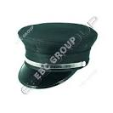 |  | Ceremonial Peak Cap | NAVY BLUE  Black Iris Pantone No: 19-3921TCX |  | Each
8300601015 (L)  8300601016 (XL)  8300601017 (XXL)  8300601018 (XXXL) | UNF/42 |  |  | Ceremonial Belt |  |  | Each
 | UNF/43(B) |  |  | Ceremonial  Jacket Ladies’ | NAVY BLUE SERGE  Black Iris Pantone No: 19-3921TCX
8300601019 (S)  8300601020 (M)  8300601021 (L)  8300601022 (XL)  8300601023 (XXL)  8300601024 (XXXL)  8300601025 (XXXXL) | UNF/17(D) |  |  | Ceremonial  Shirt Ladies’ | WHITE |  | Set A  + Ceremonial  Tunic Ladies’ Ceremonial  Shirt Ladies’ + Ceremonial  Trouser Ladies’
8300601019 (S)  8300601020 (M)  8300601021 (L)  8300601022 (XL)  8300601023 (XXL)  8300601024 (XXXL)  8300601025 (XXXXL) | UNF/17(B) |  |  | Ceremonial  Trouser Ladies’ | NAVY BLUE SERGE  Black Iris Pantone No: 19-3921TCX |  | Set B  + Ceremonial  Tunic Ladies’ Ceremonial  Shirt Ladies’ + Ceremonial  Skirt
8300601019 (S)  8300601020 (M)  8300601021 (L)  8300601022 (XL)  8300601023 (XXL)  8300601024 (XXXL)  8300601025 (XXXXL)  8300601019 (S)  8300601020 (M)  8300601021 (L)  8300601022 (XL)  8300601023 (XXL)  8300601024 (XXXL)  8300601025 (XXXXL) | UNF/17(A) |  |  | Ceremonial Skirt  Ladies’ | NAVY BLUE SERGE  Black Iris Pantone No: 19-3921TCX
8300201062 (S)  8300201063 (M)  8300201064 (L)  8300201065 (XL)  8300201066(XXL)  8300201067 (XXXL)  8300201068 (XXXXL | UNF/22( C) | 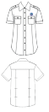 |  | Working Attire Trouser Ladies’ | NAVY BLUE with RED Highlights  Black Iris Pantone No: 19-3921TCX |  | Set A  Shirt+Trouser
8300201062 (S)  8300201063 (M)  8300201064 (L)  8300201065 (XL)  8300201066(XXL)  8300201067 (XXXL)  8300201068 (XXXXL) | UNF/22( C) |  |  | Working Attire Skirt Ladies’ | NAVY BLUE with RED Highlights  Black Iris Pantone No: 19-3921TCX |  | Set B  Shirt +skirt
8300201062 (S)  8300201063 (M)  8300201064 (L)  8300201065 (XL)  8300201066(XXL)  8300201067 (XXXL)  8300201068 (XXXXL) | UNF/37(B) |  |  | Working Attire Shirt Ladies’ | SKY BLUE  Pantone No: 18-4039TCX |  | Set B  Shirt +skirt
8300201055 (S)  8300201056 (M)  8300201057 (L)  8300201058 (XL)  8300201059 (XXL)  8300201060 (XXXL)  8300201061 (XXXXL) | UNF/37(A) |  |  | Working Attire Shirt Men’s | SKY BLUE & WHITE  Pantone No: 18-4039TCX |  | Set
8300201055 (S)  8300201056 (M)  8300201057 (L)  8300201058 (XL)  8300201059 (XXL)  8300201060 (XXXL)  8300201061 (XXXXL) | UNF/21( C) |  |  | Working Attire Trouser Men’s | NAVY BLUE with RED highlight  Black Iris Pantone No: 19-3921TCX |  | Set
8300701001 (S)  8300701002 (M)  8300701003 (L)  8300701004 (XL)  8300701005 (XXL)  8300701006 (XXXL)  8300701007 (XXXXL | UNF/44(A) |  |  | Ceremonial Jacket Mens’ | - GREY  Chief Nursing Officer  - NAVY BLUE  Senior Nursing Officer |  | Set
8300701001 (S)  8300701002 (M)  8300701003 (L)  8300701004 (XL)  8300701005 (XXL)  8300701006 (XXXL)  8300701007 (XXXXL) | UNF/44(B) |  |  | Ceremonial Trouser Mens’ | - GREY-  Chief Nursing Officer  - NAVY BLUE- Senior Nursing Officer |  | Set
8300701001 (S)  8300701002 (M)  8300701003 (L)  8300701004 (XL)  8300701005 (XXL)  8300701006 (XXXL)  8300701007 (XXXXL) | UNF/15(B) |  |  | Ceremonial Shirt Mens’ | WHITE |  | Set
8300701008 (S)  8300701009 (M)  8300701010 (L)  8300701011 (XL)  8300701012 (XXL)  8300701013 (XXXL)  8300701014 (XXXXL) | UNF/45  (A&B) |  |  | Ceremonial Jacket Ladies  Ceremonial Skirt Ladies’ | - GREY-  Chief Nursing Officer  - NAVY BLUE- Senior Nursing Officer |  | Set
8300701008 (S)  8300701009 (M)  8300701010 (L)  8300701011 (XL)  8300701012 (XXL)  8300701013 (XXXL)  8300701014 (XXXXL) | UNF/45(C ) |  |  | Ceremonial Ladies Blouse | WHITE  & SKY BLUE  Pantone No: 18-4039TCX |  | Set
8300901001 (S)  8300901002 (M)  8300901003 (L)  8300901004 (XL)  8300901005(XXL)  8300901006 (XXXL)  8300901007 (XXXXL) | UNF/45(D) |  |  | Ceremonial Trouser Ladies’ | - GREY-  Chief Nursing Officer  - NAVY BLUE- Senior Nursing Officer |  | Set
8300701015 (S)  8300701016 (M)  8300701017 (L)  8300701018 (XL)  8300701019 (XXL)  8300701020 (XXXL)  8300701021 (XXXXL) | UNF/46(A) |  |  | Lab Coat Ladies’ | WHITE |  | Each
8300701022 (S)  8300701023 (M)  8300701024 (L)  8300701025 (XL)  8300701026 (XXL)  8300701027 (XXXL)  8300701028 (XXXXL) | UNF/46(B) |  |  | Lab Coat Men’s | WHITE |  | Each
8300701029 (S)  8300701030 (M)  8300701031 (L)  8300701032 (XL)  8300701033 (XXL)  8300701034 (XXXL)  8300701035 (XXXXL) | UNF/47 |  |  | Working Attire Tunic Nurse Male | WHITE, with Navy Blue piping |  | Set
8300701029 (S)  8300701030 (M)  8300701031 (L)  8300701032 (XL)  8300701033 (XXL)  8300701034 (XXXL)  8300701035 (XXXXL) | UNF/19(A) |  |  | Working Attire Trouser Nurse Male | NAVY BLUE  Black Iris Pantone No: 19-3921TCX |  | Set
8300701036 (S)  8300701037 (M)  8300701038 (L)  8300701039 (XL)  8300701040 (XXL)  8300701041 (XXXL)  8300701042 (XXXXL) | UNF/20(A) |  |  | Working Attire Trouser Nurse Female | NAVY BLUE  Black Iris Pantone No: 19-3921TCX |  | Set
8300701036 (S)  8300701037 (M)  8300701038 (L)  8300701039 (XL)  8300701040 (XXL)  8300701041 (XXXL)  8300701042 (XXXXL) | UNF/22(D) |  |  | Working Attire Skirt Nurse Female | NAVY BLUE  Black Iris Pantone No: 19-3921TCX |  | Set
8300701036 (S)  8300701037 (M)  8300701038 (L)  8300701039 (XL)  8300701040 (XXL)  8300701041 (XXXL)  8300701042 (XXXXL) | UNF/48 |  |  | Working Attire Tunic Nurse Female | WHITE, with Navy Blue piping |  | Set
8300101107 (S)  8300101108 (M)  8300101109 (L)  8300101110 (XL)  8300101111 (XXL)  8300101112 (XXXL)  8300101113 (XXXXL | UNF/03(C ) | 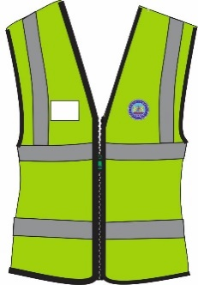 |  | Paramedics Jacket  (EMT Staff) | HI-VIS GREEN |  | Each
8300701043 (S)  8300701044 (M)  8300701045 (L)  8300701046 (XL)  8300701047 (XXL)  8300701048 (XXXL)  8300701049 (XXXXL) | UNF/49 |  |  | Theatre Scrub Clinical Officer | HOSPITAL GREEN |  | Set
8300701053 (S)  8300701054 (M)  8300701055 (L)  8300701056 (XL)  8300701057 (XXL)  8300701058 (XXXL)  8300701059 (XXXXL) | UNF/53(A) |  |  | Working Attire Trouser Ambulance crew | LEAF GREEN with black highlights |  | Set
8300701053 (S)  8300701054 (M)  8300701055 (L)  8300701056 (XL)  8300701057 (XXL)  8300701058 (XXXL)  8300701059 (XXXXL) | UNF/53(B) |  |  | Working Attire Shirt  Ambulance crew | LEAF GREEN with black highlights |  | Set
8300701060 (S)  8300701061 (M)  8300701062 (L)  8300701063 (XL)  8300701064 (XXL)  8300701065 (XXXL)  8300701066 (XXXXL) | UNF/53(C ) |  |  | Working Attire T-Shirt Ambulance crew | BLACK & GREEN |  | Each
8300701067 (S)  8300701068 (M)  8300701069 (L)  8300701070 (XL)  8300701071 (XXL)  8300701072 (XXXL)  8300701073 (XXXXL) | UNF/53(D) |  |  | St. Johns Ambulance Uniform Jacket | BLACK with LEAF GREEN Highlights |  | Each
8300701067 (S)  8300701068 (M)  8300701069 (L)  8300701070 (XL)  8300701071 (XXL)  8300701072 (XXXL)  8300701073 (XXXXL) | UNF/53(E) |  |  | St. Johns Ambulance Uniform Trouser | LEAF GREEN with BLACK Highlights |  | Set
8300701067 (S)  8300701068 (M)  8300701069 (L)  8300701070 (XL)  8300701071 (XXL)  8300701072 (XXXL)  8300701073 (XXXXL) | UNF/53(F) |  |  | St. Johns Ambulance Uniform Shirt | WHITE |  | Set
8300901001 (S)  8300901002 (M)  8300901003 (L)  8300901004 (XL)  8300901005(XXL)  8300901006 (XXXL)  8300901007 (XXXXL) | UNF/63 |  |  | Men drivers Suit jacket | NAVY BLUE-  Black Iris Pantone No: 19-3921TCX |  | Set
8300901001 (S)  8300901002 (M)  8300901003 (L)  8300901004 (XL)  8300901005(XXL)  8300901006 (XXXL)  8300901007 (XXXXL) | UNF/08(A) |  |  | Men Drivers Trouser | NAVY BLUE-  Black Iris Pantone No: 19-3921TCX |  | Set
 | UNF/08(B) |  |  | MEN’S WORKING SHIRT | WHITE & SKY BLUE  SKY BLUE Pantone No: 18-4039TCX |  | Set
8300901008 (S)  8300901009 (M)  8300901010 (L)  8300901011 (XL)  8300901012 (XXL)  8300901013 (XXXL)  8300901014 (XXXXL) | UNF/09(B) |  |  | Ladies Skirt | NAVY BLUE  Black Iris Pantone No: 19-3921TCX |  | Set
8300901008 (S)  8300901009 (M)  8300901010 (L)  8300901011 (XL)  8300901012 (XXL)  8300901013 (XXXL)  8300901014 (XXXXL) | UNF/09(A) |  |  | Ladies Trouser | NAVY BLUE  Black Iris Pantone No: 19-3921TCX |  | Set
8300901008 (S)  8300901009 (M)  8300901010 (L)  8300901011 (XL)  8300901012 (XXL)  8300901013 (XXXL)  8300901014 (XXXXL) | UNF/09(D) |  |  | Ladies Blouse | WHITE  & SKY BLUE  Pantone No: 18-4039TCX |  | Set
 | UNF/09(C ) |  |  | Ladies SHORT SLEEVE Jacket | NAVY BLUE  Black Iris Pantone No: 19-3921TCX |  | Set
8300901015 (S)  8300901016 (M)  8300901017 (L)  8300901018 (XL)  8300901019 (XXL)  8300901020 (XXXL)  8300901021 (XXXXL) | UNF/64(A) |  |  | MEN DRIVER | NAVY BLUE  Black Iris Pantone No: 19-3921TCX |  | Each
8300901029 (S)  8300901030 (M)  8300901031 (L)  8300901032 (XL)  8300901033 (XXL)  8300901034 (XXXL)  8300901035 (XXXXL) | UNF/65 |  |  | LADY HALF JACKET | NAVY BLUE-  Black Iris Pantone No: 19-3921TCX |  | Each
 |  | CORPORATE DRESS DOWN
8301101001 (S)  8301101002 (M)  8301101003 (L)  8301101004 (XL)  8301101005 (XXL)  8301101006 (XXXL)  8301101007 (XXXXL) | UNF/66(A) | 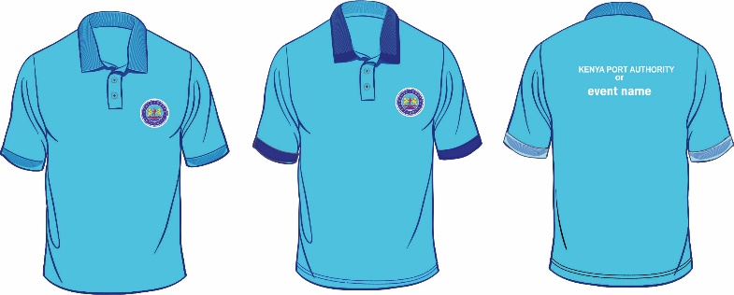 | SKY BLUE Colour and NAVY BLUE Collar and Sleeves |  |  | SKY BLUE Colour  Pantone No: 18-4039TCX  Each | Each
 | UNF/66(A) | 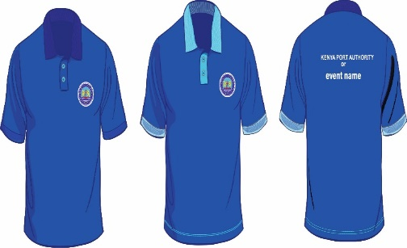 | NAVY BLUE Colour  Black Iris Pantone No: 19-3921TCX |  |  | NAVY BLUE Colour and SKY BLUE Collar and Sleeves  Black Iris Pantone No: 19-3921TCX | Each
  8301101008 (S)
  8301101009 (M)
  8301101010 (L)
  8301101011 (XL)
  8301101012 (XXL)
  8301101013 (XXXL)
  8301101014 (XXXXL)
  8301101015 (S)
  8301101016 (M)
  8301101017 (L)
  8301101018 (XL)
  8301101019 (XXL)
  8301101020 (XXXL)
  8301101021 (XXXXL)
  8301101022 (S)
  8301101023 (M)
  8301101024 (L)
  8301101025 (XL)
  8301101026 (XXL)
  8301101027 (XXXL)
  8301101028 (XXXXL)
 | UNF/66(A) | 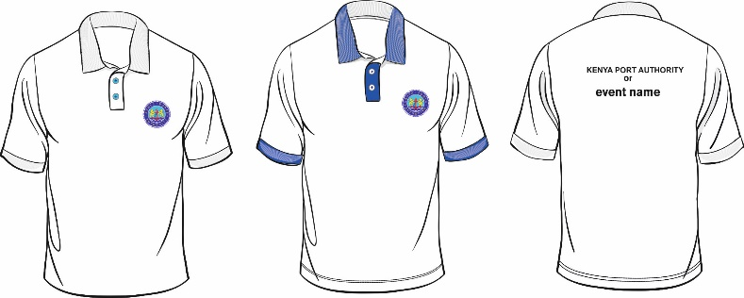 | WHITE Colour |  |  | WHITE Colour and NAVY BLUE Collar and Sleeves | Each
  8301101029 (S)
  8301101030 (M)
  8301101031 (L)
  8301101032 (XL)
  8301101033 (XXL)
  8301101034 (XXXL)
  8301101035 (XXXXL)
  8301101036 (S)
  8301101037 (M)
  8301101038 (L)
  8301101039 (XL)
  8301101040 (XXL)
  8301101041 (XXXL)
  8301101042 (XXXXL)
 | UNF/68 | 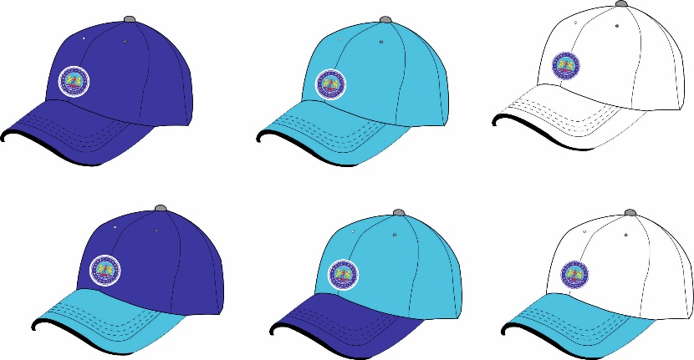 | NAVY BLUE Colour  SKY BLUE Colour  WHITE Colour |  |  | Black Iris Pantone No: 19-3921TCX Pantone No: 18-4039TCX | Each
  8301101064 (S)
  8301101065 (M)
  8301101066 (L)
  8301101067 (XL)
  8301101068 (XXL)
  8301101069 (XXXL)
  8301101070 (XXXXL)
  8301101071 (S)
  8301101072 (M)
  8301101073 (L)
  8301101074 (XL)
  8301101075 (XXL)
  8301101076 (XXXL)
  8301101077 (XXXXL)
  8301101078 (S)
  8301101079 (M)
  8301101080 (L)
  8301101081 (XL)
  8301101082 (XXL)
  8301101083 (XXXL)
  8301101084 (XXXXL)
 | UNF/66(B) |  |  | Unisex Polo Shirt  (For HODs, GMs, MD & Board Members) | WHITE Colour |  | Each
  8301101085 (S)
  8301101086 (M)
  8301101087 (L)
  8301101088 (XL)
  8301101089 (XXL)
  8301101090 (XXXL)
  8301101091 (XXXXL)
  8301101092 (S)
  8301101093 (M)
  8301101094 (L)
  8301101095 (XL)
  8301101096 (XXL)
  8301101097 (XXXL)
  8301101098 (XXXXL)
 | UNF/67(A) |  |  | Men’s Shirt Casual  (For HODs, GMs, MD & Board Members) | WHITE Colour |  | Each
 | UNF/67(B) |  |  | Ladies Shirt Casual  (For HODs, GMs, MD & Board Members) | WHITE Colour |  | Each
  8301101099 (S)
  8301101100 (M)
  8301101101 (L)
  8301101102 (XL)
  8301101103 (XXL)
  8301101104 (XXXL)
  8301101105 (XXXXL)
  8301101106 (S)
  8301101107 (M)
  8301101108 (L)
  8301101109 (XL)
  8301101110 (XXL)
  8301101111 (XXXL)
  8301101112 (XXXXL)

NOTE:
- The images shown in the tender document above are only for illustration purposes and should only act as a guide to branding of items
- Supply of full order will be subject to the approval of a branded physical sample (prototype) by the Uniform Contract Implementation Team (CIT). Branding elements shall be provided by the Uniform & Personal Protective Clothing Management Committee (UPPCMC) to facilitate the prototype.
- All Typeface (Berthold Akzidenz Grotesk and Verdana)
- A clear white space which is 108% larger than the KPA Emblem is mandatory whenever the KPA Emblem is printed on the KPA Deep Blue background.
- Adherence to tendering of uniforms as a complete set as provided in Appendix B.

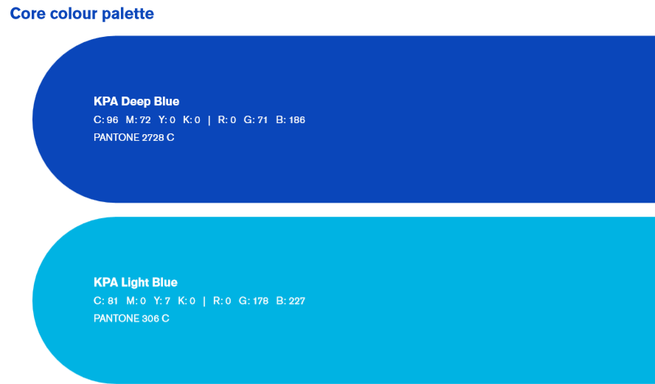
SUPPORTING COLOUR PALETTE

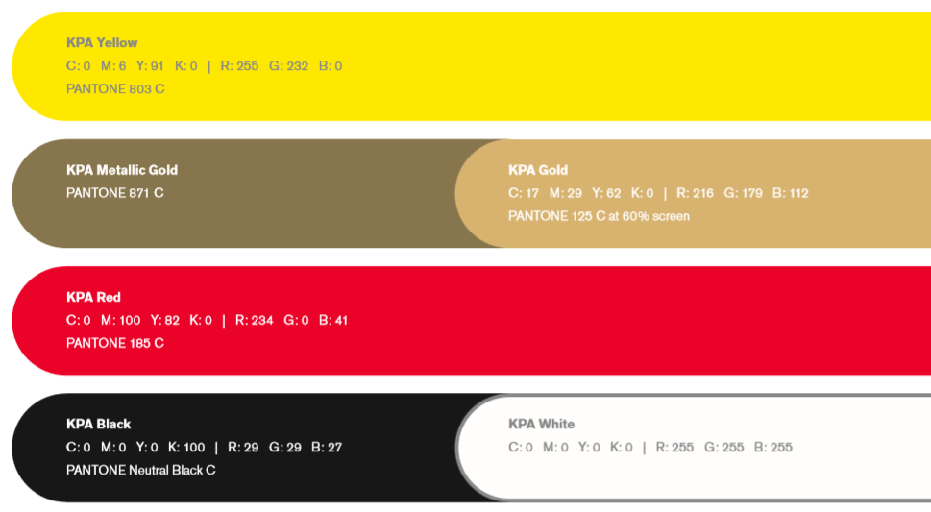

COLOUR DISTRIBUTION

