NOTE:

The CE and EN Quality Standard Specification markings must be affixed to each piece of PPE to be visible, legible and indelible throughout the expected life of the PPE and for the small items it should be marked on the packaging material.

 | Head Protection
Item Code | Item No. | Picture |  |  |  | Size |  | Items’ Description | UM |  |  | Price Inclusive of Levy and VAT
8100101001 – white  8100101002 – blue  8100101003 – yellow  8100101004 – orange  8100101005 – green | PPE/01 | 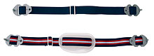 |  |  |  | STD |  | Plastic Industrial Safety Helmet White, Blue, Red, Yellow, Orange or Green.  Complete with Chin Strap and KPA Logo in indelible ink on the front | EA
8100102001 | PPE/02 | 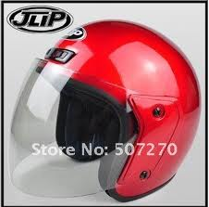 |  |  |  | STD |  | Helmet Motor Cyclist  (Crash helmet) | EA
8100103001 | PPE/04 | 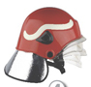 |  |  |  | STD |  | Fire Fighter Helmet Wine Red Colour | EA
8100103002 | PPE/05 |  |  |  |  | STD |  | Fire Fighter Hood | EA
8100103003 | PPE/06 |  |  |  |  | STD |  | Face Shield and Visor | EA
8100104001 | PPE/07 | 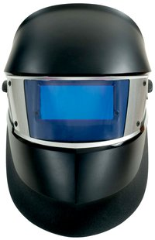 |  |  |  | STD |  | Speed Glass SL Welding Helmet | EA
 | Eye Protection
8100104002 | PPE/08 | 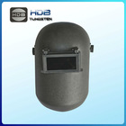 |  |  |  | STD |  | Welding Helmet Flip Front | EA
8100104003 | PPE/09 | 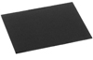 |  |  |  | STD |  | Welding Filters | EA
8100104004 | PPE/10 | 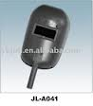 |  |  |  | STD |  | Handheld Welding Shield | EA
8100104005 | PPE/11 | 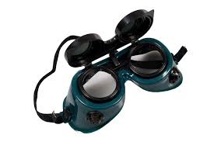 |  |  |  | STD |  | Flip - Front Welding Goggles | EA
8100201001 | PPE/12 | 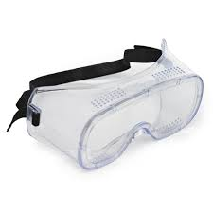 |  |  |  | STD |  | Safety Goggles/Lab Spectacles | EA
8100202001 | PPE/13 | 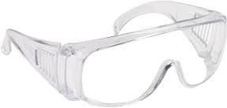 |  |  |  | STD |  | Safety Spectacles | EA
8100202002 | PPE/14 | 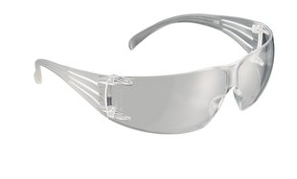 |  |  |  | STD |  | Safety Spectacles
8100202003 | PPE/15 | 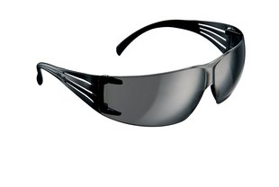 |  |  |  | STD |  | Safety Spectacles
 | Ear Protection
8100301001 | PPE/16 |  |  |  |  | STD |  | Ear Defender (Muffs) | EA
8100301002 | PPE/17 |  |  |  |  | STD |  | Ear Plugs | EA
 | Respiratory Protection
8100401007 | PPE/24 |  |  |  | STD |  |  | Valved Filtering Twin Half Mask Respirators | EA
8100401008 | PPE/25 |  |  |  | STD |  |  | Gas Filters/Cartridge,  Acid Gas/Vapour | EA
8100401009 | PPE/26 |  |  |  | STD |  |  | Dust Filters/Cartridges Dust Particles | EA
8100401010 | PPE/27 |  |  |  | STD |  |  | Gas Filters/Cartridges Ammonia/Methylamine | EA
8100401011 | PPE/28 |  |  |  | STD |  |  | Combined filter  Protects against gases and vapours from organic compounds with a boiling point higher than 65ºC, inorganic and acid gases and vapours, ammonia and organic ammonia derivatives and solid and liquid hazardous particles. | EA
8100401012 | PPE/29 | 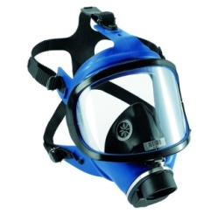 |  |  | STD |  |  | Full Face Respiratory Mask | EA
8100502006 – (S)  8100502007 – (M)  8100502008 – (L)  8100502009 – (XL)  81005020010 – (XXL) | PPE/35 | 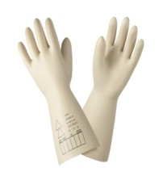 |  |  | S, M, L, XL, XXL |  |  | High Voltage Electrician Gloves | PAA
8100502016 – (S)  8100502017 – (M)  8100502018 – (L)  8100502019 – (XL)  8100502020 – (XXL) | PPE/37 | 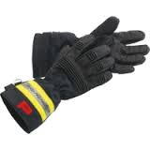 |  |  | S, M, L, XL, XXL |  |  | Fire Fighter Gloves | PAA
 | General Protection
8100601001 – (S)  8100601002 – (M)  8100601003 – (L)  8100601004 – (XL)  8100601005 – (XXL) | PPE/38 | 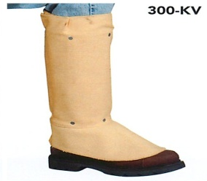 |  |  | S, M, L, XL, XXL |  |  | Shield Leggings with Spat Front & Strap | EA
8100601006 – (S)  8100601007 – (M)  8100601008 – (L)  8100601009 – (XL)  81006010010 – (XXL) | PPE/39 |  |  |  | S, M, L, XL, XXL |  |  | Welders H/D Apron with Straps & Buckle Fasten | EA
8100601011 | PPE/40 | 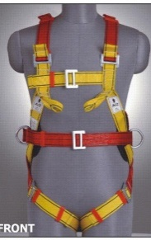 |  |  | STD |  |  | Full Body Harnesses  (Fall Arrest) | EA
8100601012 | PPE/41 | 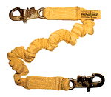 |  |  | STD |  |  | Shock Absorbing Lanyard | EA
8100601013 – (S)  8100601014 – (M)  8100601015 – (L)  8100601016 – (XL)  8100601017 – (XXL)  8100601018 – (XXXL)  8100601019 – (XXXXL) | PPE/42 | 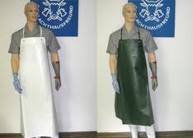 |  |  |  |  |  | PVC Apron | EA
 | Marine/Diver Protection
8100701001 | PPE/46 |  |  |  |  |  | STD | Life Jacket Hi-Vis Orange Complete, Inflatable | EA
8100701002 | PPE/47 | 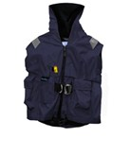 |  |  |  |  | STD | Pilots Lifejackets | EA
8100701003 | PPE/48 | 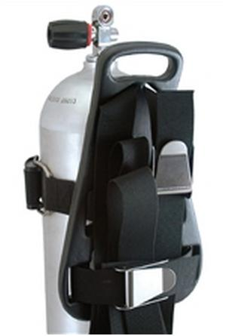 |  |  |  |  | STD | Scuba Tank Diving Cylinder, (Aluminium) Single 13 Litres Plus Back Pack/B, C, D. | EA
8100701004 | PPE/49 | 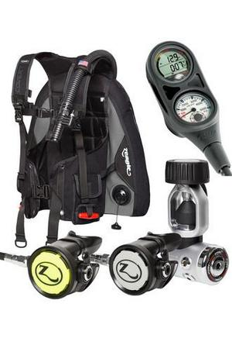 |  |  |  |  | STD | Diving Regulator (Octopus) C/W Depth Gauge, Compass, Pressure Gauge | SET
8100701005 | PPE/50 | 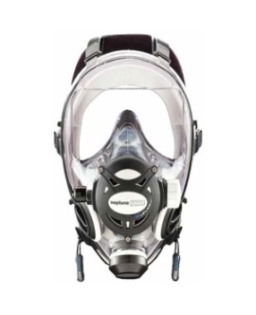 |  |  |  |  | STD | Diving Mask Full Face | EA
8100701006 | PPE/51 | 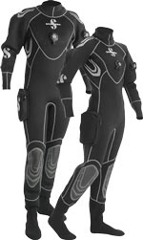 |  |  |  |  | STD | Diving Suit | SET
8100701007 | PPE/52 | 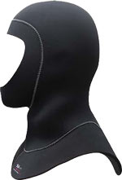 |  |  |  |  | STD | Diving Hood | EA
8100701008 –(Size 5)  8100701009 – (Size 6)  81007010010 – (Size 7)  81007010011 – (Size 8)  81007010012 – (Size 9)  81007010013–(Size 10)  81007010014–(Size 11)  81007010015–(Size 12)  81007010016–(Size 13) | PPE/53 | 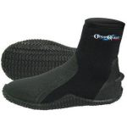 |  |  |  |  | STD | Diving Boots | PAA
8100701017 | PPE/54 | 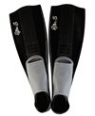 |  |  |  |  | STD | Diving Fins  (Jet Fin Type) | PAA
8100701018 | PPE/55 | 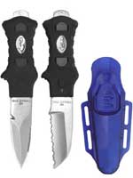 |  |  |  |  | STD | Diving Knife complete with Knife straps | EA
8100701019 | PPE/56 | 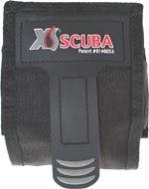 |  |  |  |  | STD | Diving Weight Belt with 4pcs ×1kg Stones | EA
8100701020 | PPE/57 |  |  |  |  |  | STD | Diving Torch (Rechargeable) | EA
8100701021 | PPE/58 |  |  |  |  |  | STD | Diving Pressure Gun | EA
8100701022 | PPE/59 | 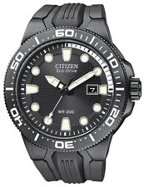 |  |  |  |  | STD | Diving Watch 50m Depth | EA
8100701023 | PPE/60 | 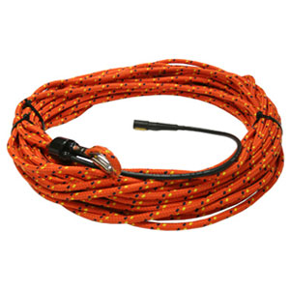 |  |  |  |  | STD | Diver Lifeline on Reel- Rope | EA
8100701024 | PPE/61 |  |  |  |  |  | STD | Divers’ ''A'' Flag with Floater | EA
8100701025 | PPE/62 | 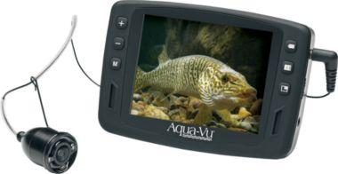 |  |  |  |  | STD | Under Water Digital Camera with Back Up Light | EA
 | Heat and Flame Protection
8100801001 (S)  8100801002 (M)  8100801003 (L)  8100801004 (XL)  8100801005 (XXL) | PPE/63 | 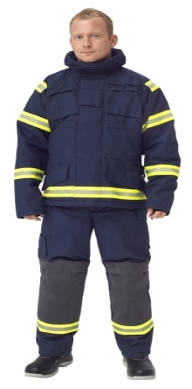 |  |  |  |  |  | Fire Fighting Suit (Coat & Trouser) with Elbow and Knee Padding inscribed “Port Fire Services” at the back | SET
8100801006 (S)  8100801007 (M)  8100801008 (L)  8100801009 (XL)  81008010010 (XXL) | PPE/64 | 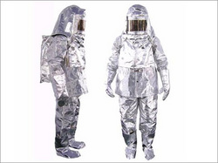 |  |  |  |  |  | Proximity Fire Fighting Suit (Coat & Trouser)
8100802001 | PPE/65 | 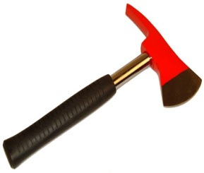 |  |  |  |  | STD | Fireman's Axe with Pouch & Leather Belt Colour Silver | EA
8100801011 – (Size 5)  8100801012 – (Size 6)  8100801013 – (Size 7)  8100801014 – (Size 8)  8100801015 – (Size 9)  8100801016 – (Size 10)  8100801017 – (Size 11)  8100801018 – (Size 12)  8100801019 - (Size 13) | PPE/66 | 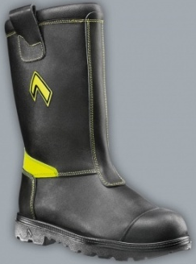 |  |  |  |  |  | Fire Fighter Boots with 2 strips Reflective Tape | PAA
8100801020 – (Size 5)  8100801021 – (Size 6)  8100801022 – (Size 7)  8100801023 – (Size 8)  8100801024 – (Size 9)  8100801025 – (Size 10)  8100801026 – (Size 11)  8100801027 – (Size 12)  8100801028 - (Size 13) | PPE/67 | 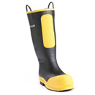 |  |  |  |  |  | Rubber Fireman's Boots | PAA
 | Foot Protection
8100901001 – (Size 5)  8100901002 – (Size 6)  8100901003 – (Size 7)  8100901004 – (Size 8)  8100901005 – (Size 9)  8100901006 – (Size 10)  8100901007 – (Size 11)  8100901008 – (Size 12)  8100901009 – (Size 13) | PPE/68 | 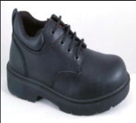 |  |  |  |  |  | Industrial Safety Shoes (Gents with laces) | PAA
8100901010 – (Size 4)  8100901011 – (Size 5)  8100901012 – (Size 6)  8100901013 – (Size 7)  8100901014 – (Size 8)  8100901015– (Size 9)  8100901016– (Size 10)  8100901017– (Size 11)  8100901018– (Size 12)  8100901019 – (Size 13) | PPE/69 | 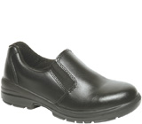 |  |  |  |  |  | Safety Shoes (Ladies with laces) | PAA
8100902001 (Size 5)  8100902002 (Size 6)  8100902003 (Size 7)  8100902004 (Size 8)  8100902005 (Size 9)  8100902006 (Size 10)  8100902007 (Size 11)  8100902008 (Size 12)  8100902009 (Size 13) | PPE/70  PPE/71 | 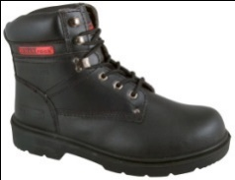  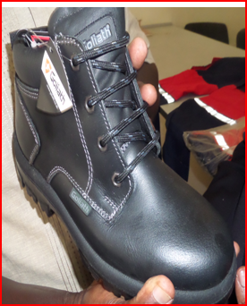 |  |  |  |  |  | Safety Boots Ladies
8100902028 (Size 5)  8100902029 (Size 6)  8100902030 (Size 7)  8100902031 (Size 8)  8100902032 (Size 9)  8100902033 (Size 10)  8100902034 (Size 11)  8100902035 (Size 12)  8100902036 (Size 13) | PPE/70  PPE/71 |  |  |  |  |  |  | Safety Boots Gents
8100902010 (Size 5)  8100902011 (Size 6)  8100902012 (Size 7)  8100902013 (Size 8)  8100902014 (Size 9)  8100902015 (Size 10)  8100902016 (Size 11)  8100902017 (Size 12)  8100902018 (Size 13) | PPE/72 | 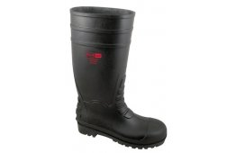 |  |  |  |  |  | Safety Gumboots | PAA
8100902019 (Size 5)  8100902020 (Size 6)  8100902021 (Size 7)  8100902022 (Size 8)  8100902023 (Size 9)  8100902024 (Size 10)  8100902025 (Size 11)  8100902026 (Size 12)  8100902027 (Size 13) | PPE/73 |  |  |  |  |  |  | Non-Safety Rubber Gumboots  Colour-Black and White | PAA
 | Protective Clothing
8101001022 (S)  8101001023 (M)  8101001024 (L)  8101001025 (XL)  8101001026 (XXL)  8101001027 (XXXL)  8101001028 (XXXXL) | PPE/75 | 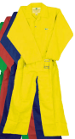 |  | Acid Protective Overalls, with  KPA Logo in indelible ink on the left chest above the pocket.

Item Code | Item No. | Picture |  | Size | Items’ Description
 | Respiratory Protection
8100401001 | PPE/18 | 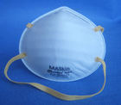 | STD |  | Nuisance Dust Masks | EA
8100401002 | PPE/19 | 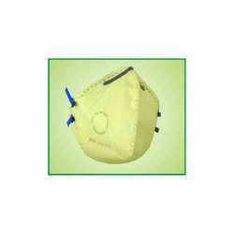 | STD |  | Fold Flat Respirators | EA
8100401003 | PPE/20 | 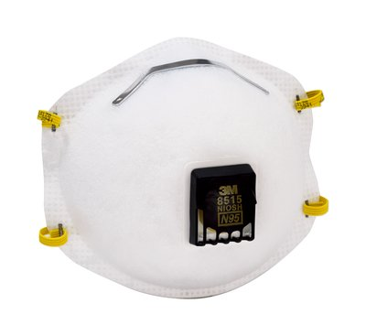 | STD |  | Welding Valved Respirator | EA
8100401004 | PPE/21 | 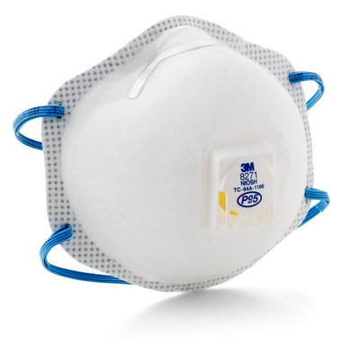 |  |  | Respirator valved for acid gases
8100401005 | PPW/22 | 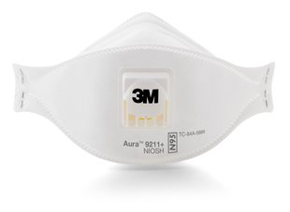 |  |  | Particulate Respirator
8100401006 | PPE/23 | 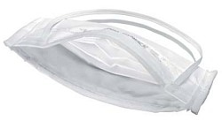 |  |  | Surgical Fold Flat Respirators | EA
8100501001 – (S)  8100501002 – (M)  8100501003 – (L)  8100501004 – (XL)  8100501005 – (XXL) | PPE/30 | 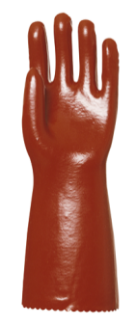 | S, M, L, XL, XXL |  | PVC Gloves for protection from organic/inorganic acid, saturated salt solutions, alkalis, aliphatic hydrocarbons, aromatically bicarbonates, ethers, aldehydes, ketones and alcohols, | PAA
8100501006 – (S)  8100501007 – (M)  8100501008 – (L)  8100501009 – (XL)  8100501010 – (XXL) | PPE/31 | 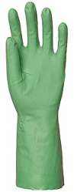 | S, M, L, XL, XXL |  | Nitrile Greaser Gloves, Oil, Greases & Solvent Resistant, | PAA
8100501011 – (S)  8100501012 – (M)  8100501013 – (L)  8100501014 – (XL)  8100501015 – (XXL) | PPE/32 | 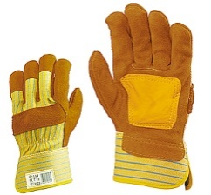 | 10 |  | Gloves Leather General Purpose, Short Arm | PAA
8100501016 – (S)  8100501017 – (M)  8100501018 – (L)  8100501019 – (XL)  8100501020 – (XXL) | PPE/33 |  | S, M, L, XL, XXL |  | Gloves Leather General Purpose, Long Arm, Sharp Edges Protection, Heavy Duty Leather ''Rigger Gloves'' | PAA
8100502001 – (S)  8100502002 – (M)  8100502003 – (L)  8100502004 – (XL)  8100502005 – (XXL) | PPE/34 | 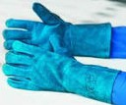 | S, M, L, XL, XXL |  | Gloves Welders Gauntlet | PAA
8100502011 – (S)  8100502012 – (M)  8100502013 – (L)  8100502014 – (XL)  8100502015 – (XXL) | PPE/36 |  | S, M, L, XL, XXL |  | Heavyweight Industrial Rubber Gloves 18” Offers Acid & Chemical resistant | PAA

